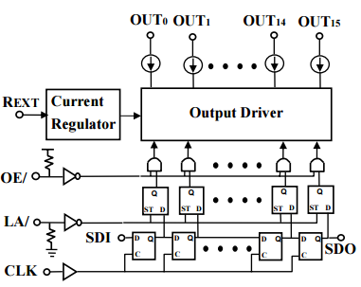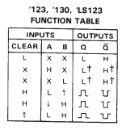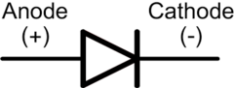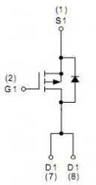

4.60ms

**74123**

**2 x 74138**

**APM4953**

**2026DB**

**74245**

140 Outputs x 2 rows

16 Rows

3 bits (RGB) x 2 rows

**5V**

A

B

D

C

OE-

LAT-

CLK

All inputs

RGB

Enable