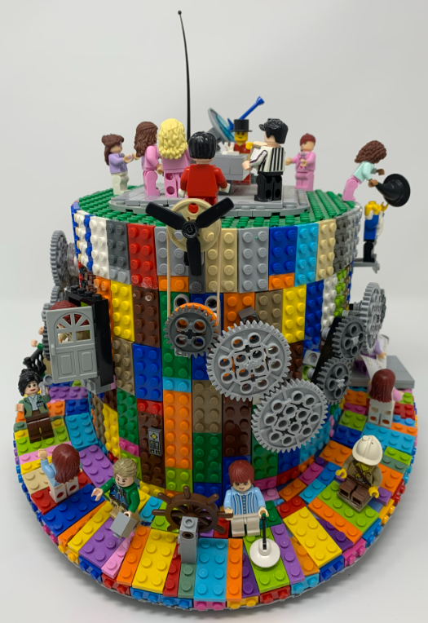

**The LEGO Hat**

**https://github.com/topherCantrell/LegoHat**



**The LEGO Hat**

**https://github.com/topherCantrell/LegoHat**



**The LEGO Hat**

**https://github.com/topherCantrell/LegoHat**



**The LEGO Hat**

**https://github.com/topherCantrell/LegoHat**



**The LEGO Hat**

**https://github.com/topherCantrell/LegoHat**



**The LEGO Hat**

**https://github.com/topherCantrell/LegoHat**



**The LEGO Hat**

**https://github.com/topherCantrell/LegoHat**



**The LEGO Hat**

**https://github.com/topherCantrell/LegoHat**



**The LEGO Hat**

**https://github.com/topherCantrell/LegoHat**



**The LEGO Hat**

**https://github.com/topherCantrell/LegoHat**