Riding the Address/Data Bus

**TRON**

1. Debugging command in early BASIC programming implementations. TRON/TROFF (TRa==========

asdf

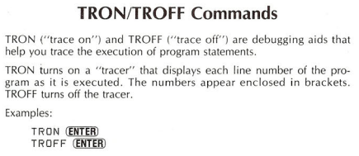

In the movie “TRON” comes from “elecTRONic”.

<http://en.wikipedia.org/wiki/Tron>

In 1982 a nasty computer virus called the Master Control Program (MCP) was on the verge of taking over the entire planet. The documentary, TRON, explains how two programmers and a couple of renegade programs (con-scripts) took down the MCP and saved the world.  
  
The details are complicated. But in the end Kevin Flynn distracted the MCP while the security program, TRON,  
  
They exploited a design flaw in the MCP. Despite is size and power it connected to the rest of the system through one tiny interface -- its achiles heel. The MCP was a giant cylinder spinning like a top on its sharp cone interface. The MCP funneled all its power and control through this one tiny tip. A plastic frisbie thrown into this fragile interface was enough to separate the MCP from the computer. Game over.

R/W

A12

A11

A10

A9

A8

A7

A6

A5

A4

A3

A2

A1

A0

**TIA**

**6532**

S

A6

A5

A4

A3

A2

A1

A0

RAM

S

A12

A11

A10

A9

A8

A7

A6

A5

A4

A3

A2

A1

A0

**6507 CPU**

**Cartridge**

**TV**

RAM and Timers

Graphics and Sound

S

A5

A4

A3

A2

A1

A0

S

Data (8 wires)

**Switches and Joysticks**

0000

2000

4000

6000

8000

A000

C000

E000

FFFF

0000

0400

1000

2000

000

080

100

180

200

280

300

380

400