Chapter 2

Atari 2600

There is nothing particularly exciting about address line A12. He lives an uneventful life concealed in the shadows of his big brothers A13, A14, and A15. They are the ones who do the heaving decoding on the address bus. We often see A15 working alone to neatly cleave the address space into two 32K blocks – one for RAM and one for ROM. Or we find the three significant siblings driving a 74138 3-to-8 decoder. Together they partition the address space into eight blocks of 8K addresses each. Eight blocks are plenty of decoding for RAMs, ROMs, and I/O devices.

Poor address line A12? He is an awkward middle child down at the 4K divider. He might rarely be called in to divide an 8K block into two pieces. But more often you will find A12 and his smaller brothers serving as indexes within a chip selected by the upper lines. Got an 8K RAM or ROM? Then you will certainly need A12.

But I/O devices are where all the excitement is, and those chips never have enough addresses to need A12. Poor A12 is stuck minding the internal RAM and ROM while the little brothers and sisters are talking to the cool external ports. In fact, the littlest sibling A0 is the center of attention. She part of every address access.

All that changed in 1977 when Atari released the Atari2600.

The 6502 was a $25. The 6507 was a reduced cost/functionality. The 6507 and the RIOT chip together for $12. The 6507 drops the upper 3 address lines. Total address space is 8K, with our hero A12 as the top dog.

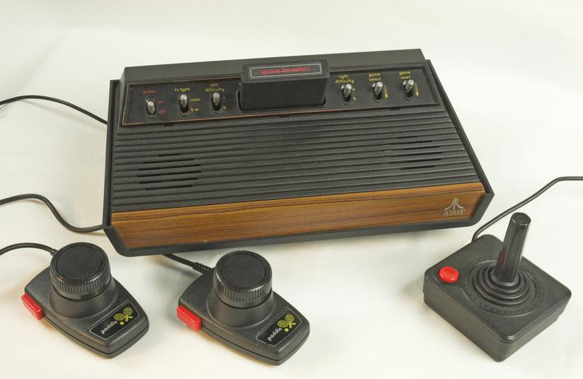

https://en.wikipedia.org/wiki/Atari_2600

We saw the R.I.O.T. chip in the last chapter. We’ll look at the TIA chip in the next chapter and write some graphics. But here we’ll run the Atari2600 headless (no TV) and twiddle some I/O lines – just our friend the RIOT.

Video provides a powerful way to help you prove your point. When you click Online Video, you can paste in the embed code for the video you want to add. You can also type a keyword to search online for the video that best fits your document.

To make your document look professionally produced, Word provides header, footer, cover page, and text box designs that complement each other. For example, you can add a matching cover page, header, and sidebar. Click Insert and then choose the elements you want from the different galleries.

Themes and styles also help keep your document coordinated. When you click Design and choose a new Theme, the pictures, charts, and SmartArt graphics change to match your new theme. When you apply styles, your headings change to match the new theme.

Save time in Word with new buttons that show up where you need them. To change the way a picture fits in your document, click it and a button for layout options appears next to it. When you work on a table, click where you want to add a row or a column, and then click the plus sign.

Reading is easier, too, in the new Reading view. You can collapse parts of the document and focus on the text you want. If you need to stop reading before you reach the end, Word remembers where you left off - even on another device.

Video provides a powerful way to help you prove your point. When you click Online Video, you can paste in the embed code for the video you want to add. You can also type a keyword to search online for the video that best fits your document.

To make your document look professionally produced, Word provides header, footer, cover page, and text box designs that complement each other. For example, you can add a matching cover page, header, and sidebar. Click Insert and then choose the elements you want from the different galleries.

Themes and styles also help keep your document coordinated. When you click Design and choose a new Theme, the pictures, charts, and SmartArt graphics change to match your new theme. When you apply styles, your headings change to match the new theme.

Save time in Word with new buttons that show up where you need them. To change the way a picture fits in your document, click it and a button for layout options appears next to it. When you work on a table, click where you want to add a row or a column, and then click the plus sign.

Reading is easier, too, in the new Reading view. You can collapse parts of the document and focus on the text you want. If you need to stop reading before you reach the end, Word remembers where you left off - even on another device.

Video provides a powerful way to help you prove your point. When you click Online Video, you can paste in the embed code for the video you want to add. You can also type a keyword to search online for the video that best fits your document.

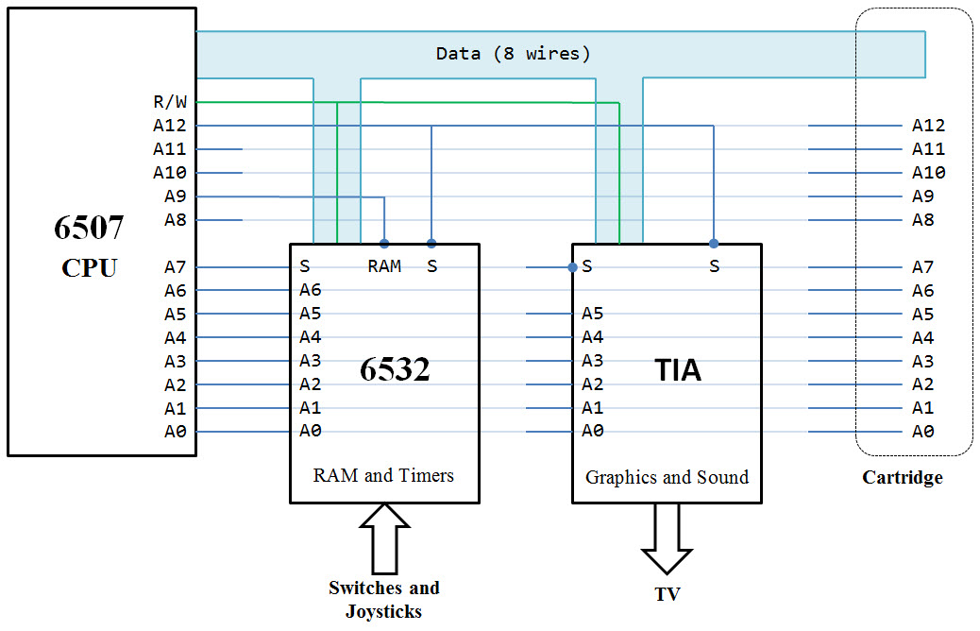

To make your document look professionally produced, Word provides header, footer, cover page, and text box designs that complement each other. For example, you can add a matching cover page, header, and sidebar. Click Insert and then choose the elements you want from the different galleries.

Themes and styles also help keep your document coordinated. When you click Design and choose a new Theme, the pictures, charts, and SmartArt graphics change to match your new theme. When you apply styles, your headings change to match the new theme.

Save time in Word with new buttons that show up where you need them. To change the way a picture fits in your document, click it and a button for layout options appears next to it. When you work on a table, click where you want to add a row or a column, and then click the plus sign.

Reading is easier, too, in the new Reading view. You can collapse parts of the document and focus on the text you want. If you need to stop reading before you reach the end, Word remembers where you left off - even on another device.

Video provides a powerful way to help you prove your point. When you click Online Video, you can paste in the embed code for the video you want to add. You can also type a keyword to search online for the video that best fits your document.

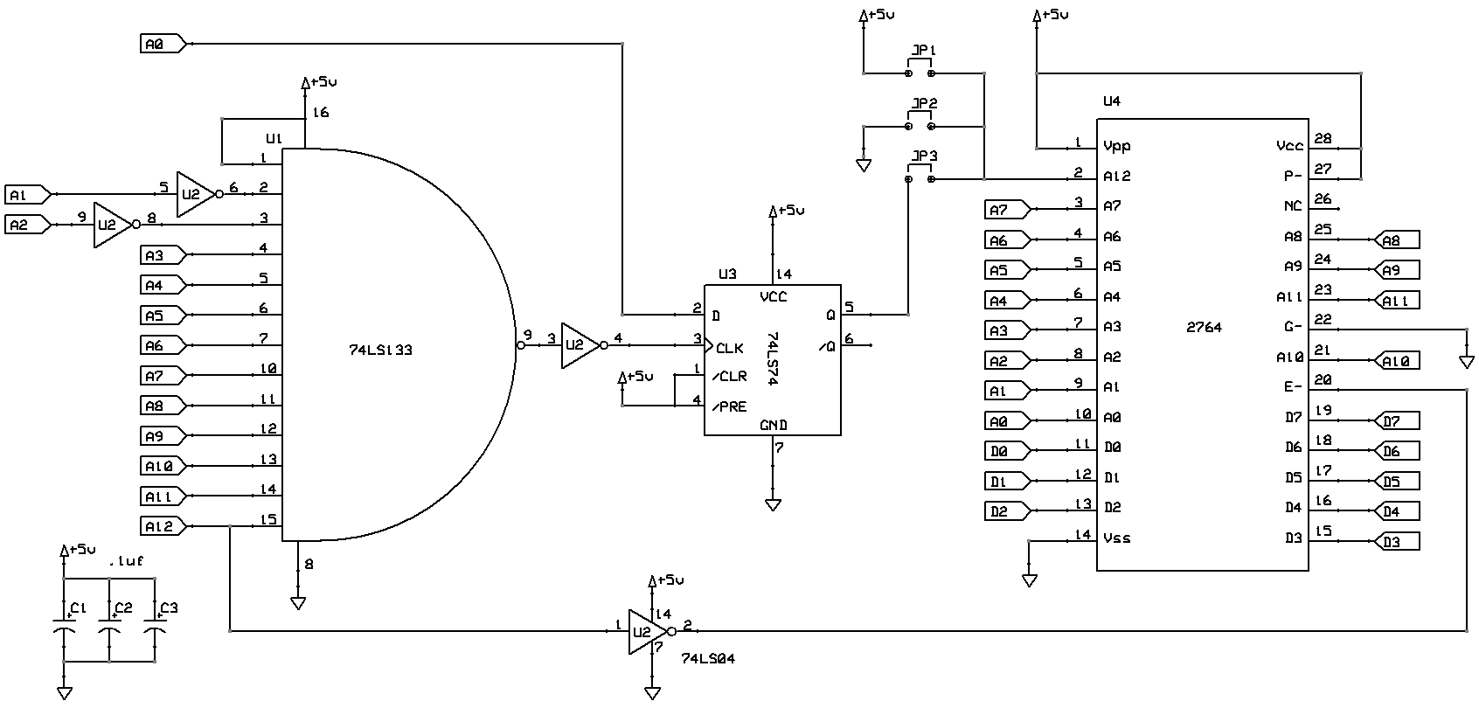To make your document look professionally produced, Word provides header, footer, cover page, and text box designs that complement each other. For example, you can add a matching cover page, header, and sidebar. Click Insert and then choose the elements you want from the different galleries.

Themes and styles also help keep your document coordinated. When you click Design and choose a new Theme, the pictures, charts, and SmartArt graphics change to match your new theme. When you apply styles, your headings change to match the new theme.

Save time in Word with new buttons that show up where you need them. To change the way a picture fits in your document, click it and a button for layout options appears next to it. When you work on a table, click where you want to add a row or a column, and then click the plus sign.

Reading is easier, too, in the new Reading view. You can collapse parts of the document and focus on the text you want. If you need to stop reading before you reach the end, Word remembers where you left off - even on another device.