Some Assembly Required

Computer systems are surprisingly simple. A computer is little more than a collection of hardware modules connected to one another through a central communication pipe: the address/data bus. One module communicates with another by broadcasting a numeric address on the address bus and then reading or writing a single data value from or to the data bus. All the modules connected to the pipe listen to the conversation, but only the device mapped to the given address responds.
One special module, the Central Processing Unit (CPU), initiates every communication on the address/data bus. All the other modules on the bus are passive listeners that simply respond to requests from the CPU. Figure 1.1 below shows a typical computer system with typical hardware devices game-programmers might deal with.
The size of the address/data bus greatly affects the performance of the computer. The more wires (bits) there are in the data bus, the more data the CPU can move with one operation. The more wires (bits) there are in the address bus, the more hardware the CPU can talk to. The CPUs we will use in this book use 8-bit data busses and 16-bit address busses. Thus these CPUs see hardware as an array of 2¹⁶ = 65536 = 64*1024 = 64K different locations with each location holding a number between 0 and 2⁸ -1 = 255.
RAM hardware devices provide large chunks of locations that remember the last value written by the CPU. These locations hold their values as long as the hardware has power or until the CPU changes them. ROM devices, on the other hand, provide large chunks of locations that have fixed values. ROM often holds the CPUs starting program.
Joysticks and buttons are typically mapped to individual bits of a single read-only location. A black-and-white screen display device interfaces to the CPU like RAM, but each bit in the memory maps to a pixel on the screen. Sound hardware might present three different addressable locations that give frequency values to three different tone generators.
All these diverse devices – from joysticks to graphics screens to memory – all look the same to the CPU. Ultimately every device is a set of addressable values that can be read and/or written. For the CPU, dealing with different types of hardware is always: read a number from this location, write a number to that location. As a programmer, you must become intimately familiar with all the hardware devices in your target computer and what the individual bits of each addressable location mean!
You must learn to think like the CPU in terms of moving data back and forth on the address/data bus. The best way to do that is to walk around in the CPU’s shoes. We’ll start by popping the CPU out of the computer and plugging you in!

Address Bus
Data
Bus
ROM
RAM
A
X
Y
Flags
SP
PC
Math
Processing
Execution
Processing
Interrupt Processing
Sound
Video
Inputs
CPU
Hardware
Figure 1.1 Overview of a Computer System

The CPU Simulator
The tools directory on the CD contains a generic computer simulator that we will be using in this chapter. The simulator includes various types of hardware devices and CPUs that you can mix and match the simulator. You can even write your own hardware modules and CPU emulators to run in the tool. See Appendix B for complete documentation on using and extending the simulator package.
The simulator reads an XML file that describes what modules to use and how the modules are mapped to the address/data bus. The 01_SomeAssemblyRequired directory on the CD contains XML configurations for a fictitious computer that will host our first game. Here are the hardware details defined in the XML file:
- 1K (1024 bytes) of RAM at locations 0x0000 – 0x03FF
- Keyboard input mapped to location 0xD000
- Random-number generator mapped to location 0xC000
- 32x8 character text display mapped to locations 0x2000 – 0x20FF
Follow the instructions that accompany the CD to copy the GPOE environment to your computer’s hard-drive. Bring up a command prompt and issue the following commands to launch the simulator:

set CLASSPATH=c:\gpoe\tools
cd \gpoe\tools\01_SomeAssemblyRequired
java simulator.CPU –config CPUA.xml

The simulator window shown in Figure 1.2 allows you to read/write every possible address in the modeled system. Only 16 locations are visible in the scroll-window at a time, but you can page through the address space with the left and right arrows. You can enter an address manually and press the “Show” button.

Number Bases
Humans use ten symbols (we have ten fingers) to represent numeric values: 0,1,2,3,4,5,6,7,8,9. In school we learned to write large numbers with only ten symbols by using a convention of carry-overs. If we run out of symbols while we are counting, we start over with ‘0’ and write the number ‘1’ to the left indicating that we cycled through the set of symbols one time. If we run out of symbols again, we bump the leading ‘1’ to a ‘2’ to indicate we cycled through two times. Our number system of ten symbols is called “base ten”, or the “decimal” system, but it’s not the only number system we can use.
Suppose we had been born with four fingers and had learned to count with only four symbols: 0,1,2,3. Our counting convention would be the same except we would carry-over after 3. Counting to nine would go like this: 1,2,3 … and now we carry over to indicate that we ran out of digits. 10,11,12,13 … and we carry again to indicate two cycles through the digits. Finishing up: 20,21. Looking at that number, we read two-cycles-of-four plus one more, or two times four plus one equals nine. A number written in a system with only four symbols written in “base four.”
Computers have two fingers. Counting to nine with only two digits, 0 and 1, looks like this: 1, 10, 11, 100, 101, 110, 111, 1000, 1001. If you only use two digits, you are counting in “base two” or “binary”.
Writing numbers out in binary is a little cumbersome since there are eight bits in a byte. Instead we often write computer values in yet another base, “base 16” or “hexadecimal” where we count with 16 digits: 0,1,2,3,4,5,6,7,8,9,A,B,D,C,E,F (we run out of number symbols and have to use letters). Counting to twenty-seven means we go all the way through nine “9” and then ten “A” and then eleven “B”, up through fifteen “F” and then we have to carry-over a ‘1’. The value twenty-seven in hexadecimal is “1B”. That’s one-cycle-of-sixteen plus eleven more.
The WINDOWS calculator does a good job of converting between binary, hex, and decimal. Select the “scientific” mode under “View” to bring up the base selection radio buttons. The calculator will convert the output number whenever you change bases.
In this book, a “0x” at the beginning of a number indicates the number is written in hex. A leading “0b” indicates the number is written in binary. Thus the numbers 0xA4, 0b10100100, and 164 all represent the same numerical value.

Try poking around the memory map. You can freely change the locations from 0x0000 to 0x03FF. That’s where the RAM is mapped. Most of the other locations in the 64K memory do not map to any hardware device and will resist your attempts to change them.
Now do a “Show” at location 0x2080. Notice that it and all surrounding locations are filled with the value 0x20. These locations are within the address range mapped to the text display. Any value you write to this area will appear as a character on the screen.
The text display interprets the byte values as ASCII characters. ASCII is an agreed-upon table that maps English characters (letters, numbers, and symbols) to numeric values. The value 0x4C happens to be the uppercase letter ‘L’. The value 0x20 is the ASCII code for a space, and the screen starts out blanked with spaces. You can do a quick web search for “ASCII Table” to find a chart of the characters and their values.

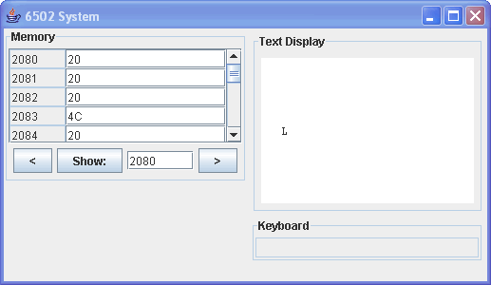
Figure 1.2 Poking at the Hardware [Screen1-1.gif]

The display’s memory starts with location 0x2000 mapping to the upper left-hand corner of the screen. The next location, 0x2001, maps to the second character on the top row of the screen and so on from left to right and top to bottom until you get to location 0x20FF, which is the bottom right-hand corner of the screen.
Game programmers do a lot of screen-location calculations, and the simulator is a good place to get some practice. Try writing the text “Hello World” to the center of the display by putting the right ASCII values in the right memory locations.
Note that the screen does not have an exact “center” row. There are eight rows, four on top and four on bottom, with the dividing line of the screen falling perfectly between the 4th and 5th row. We’ll settle for the 4th row, which means we’ll skip 3 full rows of memory locations from the start of the hardware’s memory. Each row has 32 characters on it. Our target row starts at location 0x2000 + 32*3 = 0x2060 (note the mixture of decimal and hexadecimal numbers).
We want the text centered on the 4th row, which means we want an equal number of spaces on each side of “Hello World”. The message takes 11 characters on the row. 32-11 leaves us with 21 characters … 10 on one side and 11 on the other. We’ll put the ten spaces on the left side giving us the memory location for the ‘H’ as 0x2000+32*3+10 = 0x206A. We start by writing 0x48 (ASCII for ‘H’) to location 0x206A.
The simulated keyboard is mapped to a single location 0xD000. This is a read-only location that returns the ASCII value of the key typed at the virtual keyboard. Click on the keyboard box in the simulator GUI and type a few keys. The hardware buffers up the keys and gives you the left most key every time you read location 0xD000. Enter the location 0xD000 in the memory window and click “Show” repeatedly to pull the keys out of the buffer.
There is a random number generator mapped to location 0xC000. Every time you read this location you will get a random number between 0x00 and 0xFF. Random numbers, text input, text output … we have all the hardware for a game! But first we need a CPU.

The 6502 CPU
The CPU follows a sequence of pre-recorded instructions. It fetches these instructions one after the other from the address/data bus. If the CPU reads the value 0x10 from memory it does one thing. If it reads 0x56 it does something else. As a programmer, you must know exactly what things the CPU is capable of doing. Let’s add a very old and reliable CPU to the XML: the 6502. We’ll bump into this processor again and again in later chapters when we get to the Atari 2600, Nintendo Entertainment System, and Commodore 64.

java simulator.CPU –config CPUB.xml

The GUI window shown in Figure 1.3 now includes the 6502 general purpose registers A, X, and Y. These are 8-bit memory locations used to hold temporary values. You can change them at any time in the simulator.
There is also a 16 bit register called the “Program Counter”, or “PC”, that tells the CPU where to get the next instruction to execute. When you launch the simulator, the PC is set to location 0. Put the value 0xA9 in location 0 and 0x22 in location 1. Congratulations! You’ve written your first program!

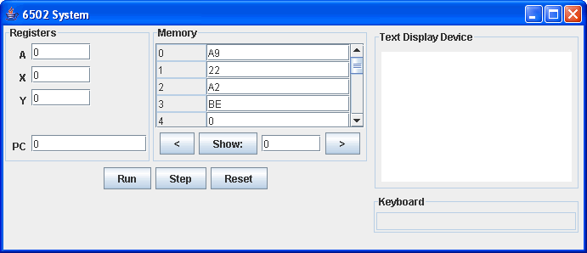
Figure 1.3 6502 Processor Added to the Simulator [Screen1-2.gif]

When you press the “Step” button the simulator will execute the very next instruction. The CPU reads the value 0xA9 from location 0x0000 and bumps the PC to location 0x0001. It interprets the 0xA9 value as “move the value at the program counter to the A register”. It then loads the value from location 0x0001 and puts it in the A register and increments the PC to location 0x0002.
Try poking the values 0xA2 and 0xBE in locations 0x0002 and 0x0003. The CPU interprets 0xA2 as “move the value at the program counter to the X register. We usually drop the long description for an operation and use a shorter notation. In this case, we say 0xA2 means “LDX #0xBE”. The “LDX” stands for “LoaD X” and the “#0xBE” indicates the value 0xBE is stored immediately after the instruction byte 0xA2 in program memory. The shortcut makes our discussions easier and our programs smaller.

Moving Data
The following table shows the basic instructions to move data back and forth between memory and the registers. The first column shows the byte-values that the CPU understands. The second column shows shorthand notation (mnemonic). The last column is a description of what the command does. See Appendix A for a detailed list of all 6502 instructions.

A9 nn | LDA #nn | Load register A with the immediate value nn
A2 nn | LDX #nn | Load register X with the immediate value nn
A0 nn | LDY #nn | Load register Y with the immediate value nn
AD bb aa | LDA aabb | Load A with value in memory location aabb
AE bb aa | LDX aabb | Load X with value in memory location aabb
AC bb aa | LDY aabb | Load Y with value in memory location aabb
8D bb aa | STA aabb | Store register A to memory location aabb
8E bb aa | STX aabb | Store register X to memory location aabb
8C bb aa | STY aabb | Store register Y to memory location aabb
Figure 1.4 Basic Data-Moving Instructions

Remember that the address has 16 wires (bits) and thus memory addresses in these instructions is 2 bytes long. These addresses are stored with the least-significant-byte first followed by the most significant byte. Other CPUs store the most-significant-byte first. Values that are stored big-end first are easier to read in a listing, but the 6502 is little-endian. We must remember to swap the address bytes around. For instance, if we want to load the A register with the value stored at location 0x6422, the instruction would be three consecutive bytes: 0xAD, 0x22, and 0x64.
Now you can actually write a program to put “Hello World” in the center of the screen. Using an ASCII table and the data-moving instructions from the table above, you should be able to poke values in memory starting at location 0 and then “Step” the simulator through the program.
The following program listing shows the first part of the program. The first column on each row is the address of the instruction in memory. Next comes the bytes of the instructions themselves. These are what you type into memory in the simulator. The remainder of the row is the mnemonic of the instruction and a comment after the “;”.

0000 A9 48 LDA #0x48 ; H
0002 9D 6A 20 STA 0x206A
0005 A9 65 LDA #0x65 ; e
0007 9D 6B 20 STA 0x206B
000A A9 6C LDA #0x6C ; l
000C 9D 6C 20 STA 0x206C
...
Figure 1.5 Three Letters Worth of the HelloWorld Program

It takes two bytes to load a constant into A and then another three bytes to get the instruction into screen memory. Your program should be 11*5 = 55 bytes long. You can see how tedious it is to hand-code a program even as simple as this. Fortunately, there is a much easier way to generate the bytes for the CPU to understand.

The NAIL Assembler
An assembler is a program that converts human-readable mnemonics into CPU-readable bytes. The program reads a file you create with a text editor like WINDOWS Notepad and cranks out a binary file for use in your target computer system. The GPOE tools directory contains the Nail assembler that we will use for all the programs in this book. Appendix B contains the detailed user guide, but the format of the assembly file is very intuitive. Figure 1.6 shows our HelloWorld program in the HelloWorld.asm text file from the 01_SomeAssemblyRequired directory.
The assembler reads the assembly file one line at a time. Everything after a semicolon on a line is a comment that the assembler ignores. An entire line can be a comment, and you can use empty lines for visual separation. For that matter, you can sprinkle white spaces liberally in a program to make it more readable.
A mnemonic that starts with a period is a special directive to the assembler. The “.PROCESSOR” directive tells the Nail assembler which CPU the program is for. The “.EQU” directive is used to assign a numerical value to a text label. The assembler will replace the text label with the numeric value in the rest of the program.
In Figure 1.6 we use the “ScreenMemory” label instead of the 0x2000 constant. Notice how we coded in the calculation for the starting point of the text in screen memory. The assembler will do all the math for you. Also note how the assembler will convert characters to ASCII codes.

.PROCESSOR 6502

.EQU ScreenMemory = 0x2000

.EQU OurStart = ScreenMemory + 32*3 + 10

0x0000: ; This is where the resulting code lives in memory

LDA #0x48 ; ASCII code for 'H'
STA 0x206A ; Memory location

LDA #'e' ; Let the assembler convert
STA OurStart+1 ; Let the assembler do the math

LDA #'l'
STA OurStart+2

LDA #'l'
STA OurStart+3

LDA #'o'
STA OurStart+4

Figure 1.6 Hello World Program (HelloWorld.asm)

The following command runs the assembler tool on the HelloWorld program. Note that the caption for all code listings in this book includes the name of the code file. You will find “HelloWorld.asm” in the 01_SomeAssemblyRequired directory.

java assembler.Nail HelloWorld.asm

The assembler produces two output files in the same directory: a binary file containing the raw bytes needed by the CPU and a listing file that shows the mnemonics and bytes in human-readable form similar to Figure 1.5. We will use the binary file to make game ROMs in future chapters. But the listing file is invaluable for seeing exactly where your code and data map to memory in the assembled program.
You can load the listing file in the simulator with the following command:

java simulator.CPU –config CPUB.xml HelloWorld.lst

Figure 1.7 shows the HelloWorld listing running in the simulator. The green bar in the listing window highlights the next instruction to be executed. As you step through the program, the green highlighter follows the Program Counter.
Take some time to experiment with the tool chain. Try changing the code and reassembling it. Change the message, and notice how easy it is to relocate the message just by changing the equates at the top of the program file. You can press the “Reset” button in the simulator to reload the changed listing file.

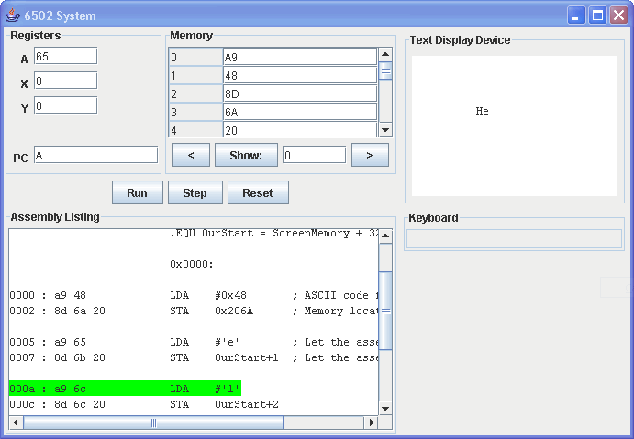
Figure 1.7 HelloWorld Lising in the Simulator [Sscreen1-3.gif]

Arithmetic Logic Unit
The 6502 supports a small set of math and logic operations that are typical of most CPUs. Operations involve only one or two values at a time. If two values are involved in an operation, the limited processor circuitry requires one of the values to be in the A register. As you will discover, it can be tricky getting values into the right position to be operated on!
Addition and subtraction function as you would expect with the A register always on the left side of the math symbol. The second value comes from a memory address or from an immediate constant in the program. The result replaces the value in the A register.
If the numbers you are adding are large enough the result may overflow the 8-bit capacity of the A register. In that case, a special flag called the “Carry Flag” is set to 1 meaning that a 1 carried over from the last operation (a little experimentation shows that the carry-over is at most 1). If the addition did not carry, then the flag is set to zero.
The 6502’s addition instruction, ADC, is an “add-with-carry” that always adds in the carry from the previous operation. This is great for cascading additions together for 16 or 32 bit numbers, but you have to remember to clear the Carry Flag before the first operation with the CLC (CLear Carry) instruction.
Subtraction uses the Carry Flag as a “Borrow Flag” to indicate an arithmetic underflow. But the flag meaning is opposite from what you might expect, and opposite from the other processors we will use in this book. The Carry/Borrow Flag is set to 1 to indicate there is NO borrow. If there is a borrow, the flag is set to ZERO. Be sure to set the Carry/Borrow flag to 1 with SEC (SEt Carry) before subtracting with SBC, “subtract with borrow” if you want a “pure” subtraction.
The 6502 supports three logical operations: AND, OR, and EOR (Exclusive-OR). These operations work by comparing individual bits of the values. For instance, the result of AND is only a one if both values have a 1 in the target bit position. Figure 1.8 below demonstrates the three logic operations.
0110 A (before)
0011 #3
0010 A (after)
AND #3
0110 A (before)
0011 #3
0111 A (after)
OR #3
0110 A (before)
0011 #3
0101 A (after)
EOR #3

Figure 1.8 Logic Operations

The 6502 supports multiplying and dividing by the number 2 via operations that shift a value left or right one place. In base 10, we multiply (and divide) by 10 by shifting everything to the left (or right) one place and tacking on a zero … so it is with multiplying (and dividing) by 2 in base 2. It is easy enough to code up a more generic multiply/divide routine using shifts and adds/subtracts.
The Carry Flag and several other single bit status flags are lumped together into a single 8-bit “Flags” register. Most of them are useful in tracking what happened in the last math operation. The Zero (Z) flag, for instance, is set to 1 if the last math operation produced a zero result. The Negative (N) flag is a copy of the upper-most-significant bit of the result. The rarely used Overflow (V) flag is a carry/borrow indicator from bit 6 to 7, which is useful when dealing with 2’s compliment numbers. In the next section we will see how the CPU uses these result-flags to make program decisions.

Program Flow
A program would be very trivial if it flowed straight through from start to finish. In real life the CPU occasionally jumps forward over a block of code it has decided to skip, and it jumps backwards to repeat a block of code in a loop.
The 6502 implements a small set of conditional branches that test different flag bits and either change the program counter to a new value or leave it alone. The BCS, for instance, is “Branch if Carry flag is Set”. If the last math operation set the carry flag to one, this instruction will take the CPU to a new location. Otherwise the CPU continues on its way to the very next instruction. The BCC, “Branch if Carry flag is Clear”, changes the program counter if the carry flag is zero. There is a pair of branch instructions for each flag: C, Z, N, and V.
Program flow decisions in a program are usually made by comparison. If A is 35, go here. If X is greater than or equal to the value stored in location 0x2100 go somewhere else. Comparison means subtraction, so we would first subtract 35 from the A register with one instruction. The next instruction would be a BZS “Branch Zero Set” to where we wanted the CPU to go. The Zero Flag would be set only if the two values subtracted are the same. In fact, this is so common that the BZS instruction has been renamed to BEQ, or “Branch if Equal”. Similarly BZC is BNE, or “Branch if Not Equal”.
The problem with using subtraction to compare is that it changes the value in the A register. The 6502 implements a true CMP comparison instruction that performs the subtraction and sets the flags, but the result is discarded without affecting the A register. And there are CPX and CPY instructions to compare values in X and Y respectively. The compare instructions do not use an incoming borrow which means you don’t have to worry about setting the Carry flag before a comparison.
Let’s write a program snippet to convert and ASCII character (read from our keyboard hardware) to binary. In other words, if the user typed ‘0’ our program would produce a 0. If the user typed ‘9’ our program would produce 9. And if the user typed ‘A’ through ‘F’ our program would produce 10 through 15. Thus we are converting a hex key to its numerical equivalent.
Fortunately the codes for ‘0’ through ‘9’ are in ascending order in the ASCII table starting at 48. If the input key is in this range, we need only subtract 48 to get the correct value. The codes for ‘A’ through ‘Z’ are in ascending order starting at 65. We want ‘A’ to map to 10, and we need only subtract 55 to convert keys in this range. The only tough part of our code will be figuring out which of these two ranges the input key is in. Figure 1.9 shows a possible implementation (line numbers have been added to the figure for discussion, but they do not appear in the actual assembly file).

1: .PROCESSOR 6502
2:
3: 0x0000:
4:
5: CMP #'A'
6: BCC ItIsNumeric
7:
8: SEC
9: SBC #55
10: JMP Done
11:
12: ItIsNumeric:
13: SEC
14: SBC #48
15:
16: Done:
Figure 1.9 ASCII to Numeric Conversion (guess.1.asm)
The program assumes that the input key is in the A register. Line 5 determines if which of the two possible ranges the number is in. On line 6, if the carry-flag is clear we know that there WAS a borrow, which means that A was less than ‘A’ and we jump to another part of the program … a location labeled “ItIsNumeric:”. Otherwise we assume the value is in the letter-range, and we subtract off our 55 constant. Notice the JMP “jump” instruction that changes the PC unconditionally to the “Done:” location. At the “ItIsNumeric:” label we subtract off the 48 constant and fall into the “Done:” label. Thus the program enters at the top with the key in the A registers and ends up, one way or the other, at the “Done:” label.
Figure 1.10 below shows the program running in the simulator.

java assembler.Nail guess.1.asm
java simulator.CPU -config CPUC.xml guess.1.lst

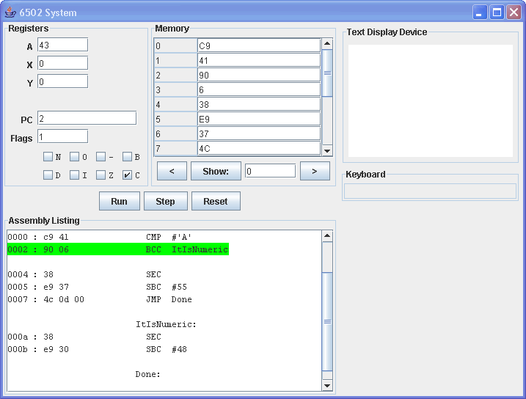

Figure 1.10 Flags in the Simulator [Screen1-4.gif]
Notice in CPUC.xml that the flags have been turned on. You can click on any of the flags anytime to toggle its value. Before you step into this program be sure to set the A register to an ASCII key value like 0x43 for ‘C’. As you step through the program watch how the flags change. After the first comparison, for instance, the Carry flag will be set indicating there was no borrow. The value 0x43 is not less than 0x41 ‘A’.
This program assumes that the value in the A register is in one of the two ranges ‘0’ through ‘9’ or ‘A’ through ‘F’. We will use another piece of code to verify that a key is in fact valid before attempting the conversion. See if you can write that code before proceeding to the next section.

Subroutines
When you are writing programs, you will find yourself using useful blocks of code over and over. A general-purpose multiply function, for instance, might get used in several places within a single program and then over and over in other programs.
You usually don't want to copy the assembly lines and paste them into all the different places you need it. Instead you need a mechanism to tell the CPU: stop what you are doing, jump over here and execute this piece of code, and then come right back to the next instruction. The tricky part of the process is knowing how to get from the subroutine.
The 6502 (indeed all modern processors) implements a stack-pointer to make subroutines possible. Much like the Program Counter, the Stack Pointer is a memory address the CPU uses to find the next location of data. Special “push” instructions store a byte of data at the stack location and the stack pointer is automatically decremented. The “pull” (often called “pop”) instructions first increment the stack pointer and then fetch the byte from the stack. Thus data is retrieved from the stack in last-in-first-out order.
The 6502 JSR “Jump to SubRoutine” instruction works like the JMP jump instruction except that the address of the next instruction after the jump is pushed onto the stack. To get back to the calling code, the subroutine ends with the RTS “ReTurn from Subroutine” which pulls the address from the stack and stuffs it in the Program Counter.
The stack allows subroutines to call other subroutines which can call other subroutines. The return path unwinds naturally back to the top level of code. The C language places all of a subroutine’s local temporary variables on the stack as well. Unfortunately the 6502 has limited support for keeping data on the stack. You can push and pull the A register with PHA/PLA, and you can push and pull the flags with PHP/PLP, and that’s it!
The stack pointer on the 6502 is only 8 bits wide. The register’s value is the lower half of the memory address. The upper half is always 0x01. Thus the stack is limited to 256 bytes between addresses 0x0100 and 0x01FF – again, not very high-level-language friendly.

Programs are a collection of subroutines that call one another. Some of these subroutines are very general-purpose and you’ll add them to your tool chest of functions to use in other applications. Some subroutines you’ll get from other programmers either as shareware or as purchased libraries.
You should keep your eye opens for reusable code when you are writing programs. Ask yourself how you can make the routine more general. Imagine, for instance, you are writing a screen-clearing function. Your first thought might be to code the function to fill screen memory with the constant 32 (ASCII for a space) because that’s what you need at the moment. But future programs might want to fill the screen with a different ASCII code. A more generic screen-filling function would expect the ASCII value to be passed in the A register.
Let’s start writing a library of I/O functions for our simulated computer. These building blocks will form the foundation of our game for this chapter. First, let’s write the HexKeyToValue function from the last section. We’ll also add the IsHexKey function to verify that a key pressed on the keyboard is a valid hexadecimal digit.
1: .PROCESSOR 6502
2:
3: 0xF800:
4: main:
5:
6: LDX #0xFF
7: TXS
8:
9: LDA #'0'
10: JSR ASCIItoBinary
11:
12: LDA #'F'
13: JSR ASCIItoBinary
14:
15: JMP main
16:
17: ;---------------------
18: ASCIItoBinary:
19:
20: CMP #'A'
21: BCC ItIsNumeric
22:
23: SEC
24: SBC #55
25:
26: ItIsNumeric:
27:
28: SEC
29: SBC #'0'
30:
31: RTS
32:
33: ;---------------------
34: 0xFFFA:
35: .WORD 0x0000 ; NMI vector (not used)
36: .WORD main ; Reset vector (start of program)
37: .WORD 0x0000 ; IRQ vector
Figure 1.11 ASCIItoBinary subroutine (guess.2a.asm)

There are some new features in Figure 1.11. On line 3 we have moved the code starting point out of RAM to a new ROM area at the end of the memory map. RAM is precious, and we want our program to survive power cycles – ROM is the right place for our code.
Lines 6 and 7 load the stack-pointer with the value 0xFF. Remember the stack builds downward through memory by decrementing with each push. There is no 6502 instruction to load the SP register directly with a constant. Instead, you have to put the value in X and then transfer X to the SP. It’s not something you do very often, and the designers didn’t waste circuitry on flexible instructions to manipulate the stack pointer.
Lines 31 through 34 define a number of “vectors” that the 6502 is hard-coded to use. When the CPU is first powered up, or when the reset line is asserted, the processor loads the two-byte address at location 0xFFFC and stuffs it into the program counter. This is how you tell the CPU where your program starts. The label “main” is defined on line 4 of the listing, and the assembler converts the “.WORD” directive on line 33 into two bytes: 0x00 and 0xF8 since “main” is at address 0xF800 in the final assembly. The other two vectors tell the CPU where to go with certain “interrupt” conditions. We’ll use these vectors in later chapters, but for now we’ll set them to 0. The simulator will never use them.
The DecodeASCII subroutine begins on line 15 with the label. The code is exactly as we wrote earlier except that line 28 returns to the caller with the RTS instruction. The “main” routine in the program is a “test harness” that calls the DecodeASCII function with a couple of different values. Figure 1.12 below shows the program loaded into the simulator. The CPU.xml file adds the SP register to the display and maps in the ROM area at the end of the memory map. We’ll use this hardware configuration for the remainder of the chapter. Take a moment and step through the program and watch the stack pointer change with subroutine calls.

java assembler.Nail guess.2a.asm
java simulator.CPU -config CPU.xml guess.2a.lst

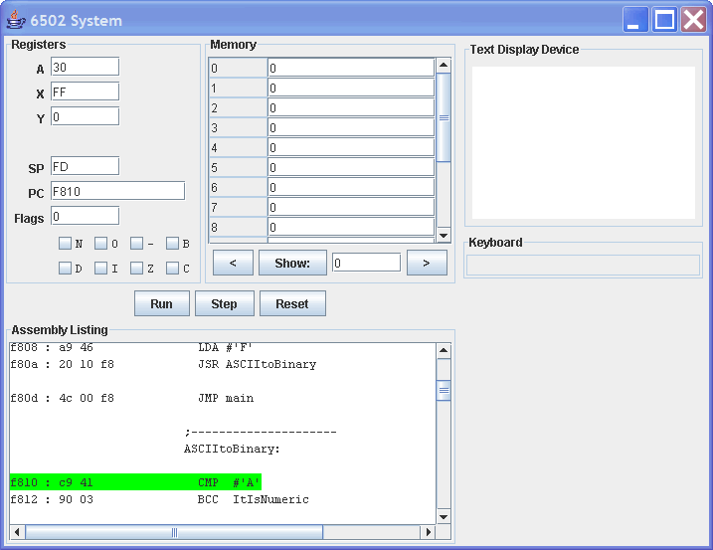
Figure 1.12 Subroutines in the Simulator [Screen1-5.gif]

Now for the routine to determine if a value read from the keyboard is a valid hexadecimal key or not. Figure 1.13 below shows one possible implementation.

1: main:
2: LDA #'.'
3: JSR IsValidHexKey
4: LDA #'0'
5: JSR IsValidHexKey
6: LDA #'9'
7: JSR IsValidHexKey
8: LDA #'A'
9: JSR IsValidHexKey
10: LDA #'a'
11: JSR IsValidHexKey
12: JMP main
13:
14: ;---------------------
15: IsValidHexKey:
16:
17: CMP #'0'
18: BCC NoGood
19: CMP #'9'+1
20: BCC Good
21:
22: CMP #'A'
23: BCC NoGood
24: CMP #'F'+1
25: BCC Good
26:
27: CMP #'a'
28: BCC NoGood
29: CMP #'f'+1
30: BCC GoodLower
31:
32: NoGood:
33: LDA #0
34: Good:
35: RTS
36:
37: GoodLower:
38: SEC
39: SBC #('a'-'A')
40: RTS
41:
42: SEC
43: SBC #'0'
44:
45: RTS
Figure 1.13 IsValidHexKey Subroutine (guess.2b.asm)

The subroutine has two basic exit points: NoGood and Good. The function returns 0 in the A register if the key is bad. Otherwise, the function returns the original key in A. This code even goes one step farther and converts lower case ‘a’ through ‘f’ to uppercase on line 39.
If you find the conditional logic in this listing difficult to follow you not alone! One of the hardest tasks in assembly programming is thinking up conditional program flow to implement complex comparison expressions. In the next chapter we’ll use a cool preprocessing tool that manages the entire task for you! You simply inject natural C-like flow constructs directly into the assembly and the tool will produce the conditional jump instructions for you.

Indexing (Arrays)
All of the load/store instructions we have discussed so far target fixed memory addresses that are built into the program at compile-time. These absolute-address instructions are necessary and are used to access hardware registers and program variables. But you would find it difficult to code something as simple as a ClearScreen routine without something a little more flexible. Try it!
CPUs offer a variety of addressing modes that let you use a processor register to hold the address of a target memory location. Instead of going to get “location 0x1000” your program can go get “the location whose address is in X”. When expressed in high-level language terms: “the location pointed to by X”. When you look at code written this way you can’t tell exactly where the target location will be. The target address is calculated at runtime.
Another common addressing mode allows you to use a register and a constant value added together to get the target location. This constant is stored as immediate data in the program. Instead of going to get “location 0x1000” your program can go get “the location 0x1000 plus the value of X”. Note that the other addressing modes we have seen are special cases of this one. If X is 0 you get just the absolute-address mode. If the constant is 0 you get the pure pointer mode.
The 6502 registers are only 8-bits wide. Their use as pure pointers is limited. But both X and Y can be used effectively when added to a constant value. Many (but not all) 6502 instructions that move data to/from memory can include a register offset tacked onto the constant address with a comma. For instance, the first instruction below pulls a byte from the location “X+0x1000” and the second instruction stores the value to location “Y+0x3000”.

LDA 0x1000,X
STA 0x3000,Y

The screen memory in our simulator is only 256 bytes long. To clear the screen we need to loop X (or Y) from 0 to 255 and add the offset to the start of screen memory. It looks something like this:

1: ClearScreen:
2: LDX #0
3: CS_1:
4: STA HW_TextDisplay,X
5: INX
6: BNE CS_1
7: RTS
Figure 1.14 ClearScreen Subroutine (guess.3.asm)
The constant HW_TextDisplay is equated to the screen’s hardware as we did earlier. This makes our program easier to read, and the assembler fills in the value for us. Notice the new INX instruction on line 6. This adds one to (increments) the X register and sets the Zero flag if the register wraps back around to 0. Thus this routine loops from 0 back to 0 (256 iterations) storing whatever is in A to the offset in screen memory. To clear the text screen simply set A to 32 (ASCII for space) and call this subroutine.
We can use a similar looping technique shown in Figure 1.15 to print messages on the screen. This time we will use Y as the screen offset and X as the offset within the message. We move bytes from the message to the screen and increment both offsets by one at each iteration. The trick is to know when to stop. In this program we mark then end of the message with a trailing zero. This is a common technique used in C to make character “strings”. Characters stored this way are also called null-terminated character arrays.

1: main:
2: LDA #' '
3: JSR ClearScreen
4:
5: LDY #32*4
6: LDX #MESSAGES_3 - MESSAGES
7: JSR PrintMessage
8:
9: Done:
10: JMP Done
11:
12: PrintMessage:
13: LDA MESSAGES,X
14: BEQ PM_Out
15: STA HW_TextDisplay,Y
16: INX
17: INY
18: JMP PrintMessage
19: PM_Out:
20: RTS
21:
22: MESSAGES:
23: .BYTE "Hello World!",0
24: MESSAGES_2:
25: .BYTE "How are you?",0
26: MESSAGES_3:
27: .BYTE "I am fine.",0
Figure 1.15 PrintMessage Subroutine (guess.3.asm)
The assembler manages sequences of characters for you. On line 23, for instance, the .BYTE directive tells the assembler to take each value (separated by commas) and store it in the program area at the current location. It turns sequences of characters in quotes into individual ASCII codes – one byte per character. Thus line 23 creates 12 bytes of ASCII codes followed by a zero
To print a message on the screen you simply put the screen offset in the Y and the message offset in X and call the PrintMessage subroutine. The routine first loads the next byte from the message on line 13. If the byte is 0 (line 14) then the routine exits. Otherwise the byte is stored to the screen (line 15) and both offsets are incremented (lines 16 and 17).
Notice that the messages area has several strings. You can use the assembler to calculate the offset to the desired message for you. On line 6 the assembler subtracts the address of MESSAGE from MESSAGE_3 to get the correct offset.
Now that we can print messages from the keyboard we need a way to read values from the keyboard. Figure 1.16 below shows a pair of routines that read a hex byte from the keyboard echoing the digits on the screen.

1: .EQU HW_Keyboard = 0xD000
2: .EQU RAM_Temp = 0
3:
4: 0xF800:
5: main:
6:
7: JMP main
8:
9: InputDigit:
10: LDA HW_TextDisplay,Y
11: CMP #'?'
12: BEQ ID_Cursor1
13: LDA #'?'
14: JMP ID_Cursor2
15: ID_Cursor1:
16: LDA #' '
17: ID_Cursor2:
18: STA HW_TextDisplay,Y
19: LDA HW_Keyboard
20: JSR IsValidHexKey
21: CMP #0
22: BEQ InputDigit
23: STA HW_TextDisplay,Y
24: RTS
25:
26: InputByte:
27: JSR InputDigit
28:
29: JSR ASCIItoBinary
30: ASL A
31: ASL A
32: ASL A
33: ASL A
34: STA RAM_Temp
35:
36: INY
37: JSR InputDigit
38: JSR ASCIItoBinary
39: ORA RAM_Temp
40: RTS
Figure 1.16 Input Subroutines (guess.4.asm)
The InputDigit routine reads a single hex byte from the keyboard echoing it on the screen at the offset passed to the routine in the Y register. Lines 10 through 18 implement a blinking cursor at the screen offset. Each pass through the loop while waiting for a digit the character at the cursor alternates between a space and a question mark.
Line 19 reads the value from the keyboard (the hardware returns zero if nothing has been pressed). Line 20 calls our routine from earlier to see if the digit is a valid hex character. If the digit is not valid, the key is ignored and loop continues to blink the cursor. Otherwise the valid digit is echoed over the cursor (line 23).
The InputByte routine calls the InputDigit twice. The return from the first call is the upper 4 bits of the byte, and lines 30 through 34 shift the upper digit into position and hangs onto it in RAM location 0 (equated on line 2). The result from the second call is ORed into the final result on line 39.

The Guessing Game Challenge
Now we have a nice library of functions for our simulated computer system. We can clear the screen and print messages with ClearScreen and PrintMessage. And we can read a hex byte from the keyboard with InputByte. We also have a random-number generator in hardware. Believe it or not, these simple routines are the basic building blocks for the “Hello World” of video games – the classic Guessing Game.
The game goes like this. This computer thinks of a number (a random number) and then asks you to guess it. If you don’t guess it, the computer tells you “higher” or “lower” and you continue to home in on the computer’s value with guess after guess. The guess.4.asm file contains all the library functions we have developed in this chapter. See if you can code up a working game to play in the simulator before reading on to my solution.

The Guessing Game Solution
The first step is to plan all the messages to be printed on the screen during game-play. We’ll need an introduction message to print at the top of the screen. A one line string like “I have a number from 00 to FF.” will work nicely. We’ll also need a prompt to print on the screen to tell the user to input a number – something like “Guess:”. And we’ll need “Higher” and “Lower” to give feedback to the user. Finally, we’ll need a congratulations message. The message “You got it! Press any key ...” congratulates and gives instructions to play again.

1: MESSAGES:
2: .BYTE "I have a number from 00 to FF.",0
3: MESSAGES_GUESS:
4: .BYTE "Guess:",0
5: MESSAGES_GOT_IT:
6: .BYTE "You got it! Press any key ...",0
7: MESSAGES_HIGHER:
8: .BYTE "Higher!",0
9: MESSAGES_LOWER:
10: .BYTE "Lower!",0
Figure 1.17 Guessing Game messages (guess.5.asm)
The game logic is shown below in Figure 1.18. We need another RAM location to store the computer’s number. Lines 17 through 24 get the random number, clear the screen, and print the header message.
Line 26 begins the game loop. The loop prints “Guess:” on the second screen line and then inputs the players guess at screen offset 39, which is just to the right of the prompt. Line 34 stores the players guess in RAM, and then the logic clears the screen.
Lines 41, 42, and 43 compare the player’s guess and continues processing in one of three places: G_Win if the values match, G_Higher if the computer’s number is higher, or the flow falls through to G_Lower if the computer’s number is lower.
In each case, the proper message is printed on the screen. If the player guesses it, the logic waits for any key (lines 58 through 60) and returns. Otherwise the loop continues again with another guess.

1: .EQU HW_TextDisplay = 0x2000
2: .EQU HW_Keyboard = 0xD000
3: .EQU HW_Random = 0xC000
4:
5: .EQU RAM_MyNumber = 0
6: .EQU RAM_Temp = 1
7:
8:
9: 0xF800:
10: main:
11:
12: JSR Game
13:
14: JMP main
15:
16: Game:
17: LDA HW_Random
18: STA RAM_MyNumber
19: LDA #32
20: JSR ClearScreen
21:
22: LDX #0
23: LDY #0
24: JSR PrintMessage
25:
26: GuessLoop:
27: LDX #(MESSAGES_GUESS - MESSAGES)
28: LDY #32
29: JSR PrintMessage
30:
31: LDY #39
32: JSR InputByte
33:
34: STA RAM_Temp
35: LDA #32
36: JSR ClearScreen
37: LDA RAM_Temp
38:
39: LDY #0
40:
41: CMP RAM_MyNumber
42: BEQ G_Win
43: BCC G_Higher
44:
45: G_Lower:
46: LDX #(MESSAGES_LOWER - MESSAGES)
47: JMP G_Cont
48: G_Higher:
49: LDX #(MESSAGES_HIGHER - MESSAGES)
50: G_Cont:
51: JSR PrintMessage
52: JMP GuessLoop
53:
54: G_Win:
55: LDX #(MESSAGES_GOT_IT - MESSAGES)
56: JSR PrintMessage
57:
58: G_Wait:
59: LDA HW_Keyboard
60: BEQ G_Wait
61:
62: RTS
Figure 1.18 Guessing Game logic (guess.5.asm)
You might have coded the RTS on line 62 to be a JMP back to Game instead. I decided to make one play of the game a subroutine instead of making the whole thing an infinite loop. Why? Truthfully it was force of habit from decades of making routines. But the habit was formed for good reason.
In the future there might be a whole suite of games with a master loop allowing the user to pick a game. Thus each game would be a subroutine and after each game the player would be returned to the main menu to pick another game. Here the main routine simply calls the game in an infinite loop on lines 10 through 14.
And just because I can defend my choice doesn’t mean it was the right one. An infinite loop in main is easier to read and produces shorter program code, and it uses less stack RAM. Would it really be that difficult to change the code a bit in the future when we write a game menu? We will spend a lot of time in future chapters planning code for reuse. There are no hard and fast rules, and you may feel differently than I do about the decisions we will make. It is less like science and more like fortune telling trying to foresee what the future will bring. In the end you will develop your own programming style and paradigm. We might speak to the computer in the same language, but your “accent” might be different than mine.
You will also be surprised how much emotions count in design decisions: ideas are like children that we birth and take pride in and defend even when they are proven wrong. Programs are more like paintings than machinery … masterpieces that carry our soul with every brush (key) stroke. Take pride in your work, but don’t be afraid to learn other techniques even if you don’t like them.

Game On
Now it is your turn to enhance the Guessing Game. The GPOE website (http://gpoe.net) is a great place to post your improvements and exchange ideas with other game programmers. Here are some suggestions to get you started

- Instead of just printing “Higher” or “Lower”, include the last guess like this: “Higher than 7F !” or “Lower than 20 !”.

- Modify the code to track a guess-count for each round. Report this count as the score at the end of the round.

- Rather than erase the screen after each guess, scroll the game text down the screen allowing the player to see the recent guesses.

- Enhance the keyboard input routine to require pressing ENTER after the input (a more familiar computer interface). Allow backspaces to correct errors.

- Make the guess range larger. Try playing with a two-byte number.

- Ask for the player’s name at the beginning of the game and print more personalized prompts like this: “Lower, Chris!”

- Allow the player to select the game’s base. In addition to “hex”, allow for “binary” and “octal”. For a real challenge, implement “decimal” mode.

- Try switching game roles. Have the player think of a number and let the game do the guessing.

References
- Links to the 6502 world … instructions and processor details

Revision Thoughts
Need to say that we are just touching the surface of the 6502. See the references for deeper learning on the 6502 instructions and processor. Plenty of assembly programming guides on the web.

Re-write ALL code to use the “A=4” mnemonics. The goal is to factor out as much commonality between assembly flavors as possible. Then the switch between CPUs is minor. The discussion on assembly needs to talk about the different mnemonics … maybe the introduction.

