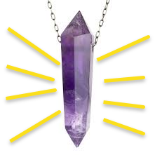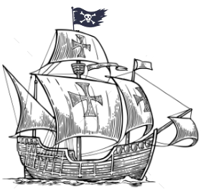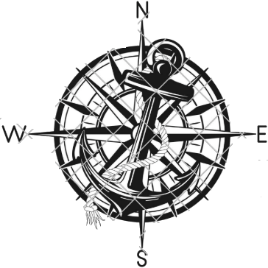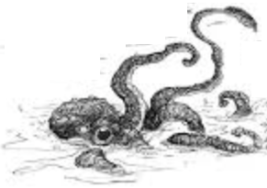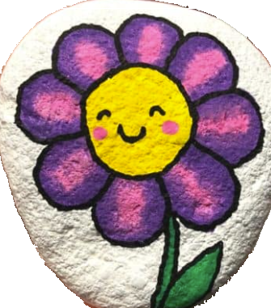
Hazel’s list of things they took with them. Whirled eas NF
- Violin
- Barel of Rum
- Dinghy of Rotten Apples
- Barel of Flour
- Painted Rock
Backer’s island clues
This is Backer’s font and his writing style.
Music and rum tamed the monster.
Used the crystal to get the rest of the map.
I fell overboard. ?dropped food?
George Town
Breeze Tavern
Ask for Brandy
Point Paul
Pelican Pub
Red Snapper
Kingston
Red Clam Inn
Smoked Oysters
San Fernando
Miranda’s Place
Salted Perch
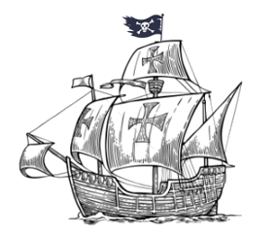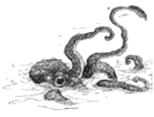
Tortuga
Ghost Isles
Antilles
Kingston
East Morgan
June 16, 1743.
Set sail at dawn on
Used the flour to
scare the pirates.
Used the crystal to
get the map.
Survived the
Painted rock
for the crystal.
Violin and apples
for the monster.
Pelican Pub
Catfish
Red Clam Inn
Smoked Oysters
The Rusty Anchor
Ask for Brandy
storm.
The Sandbar
Salted Perch
Eighteen-eighths to wipe the slates,
and Lori joined the crew.
Saint John
TODO: Clues to finding the treasure on the island.
TODO: List of things to bring
- Barel of flour
- Cask of RUM
- Violin
- Dingy of rotten apples
- 5.11-ounce painted rock
- 18 pieces of eight
Chronos

