Exercise 5: Swing Chat

# Cork Board UI

You now have two Cork Board clients: a console application and a web application. In this exercise you will create a third interface – a Swing application. The Swing UI is the key exercise here; you may embed the cork board server object within the application.

A better (optional) approach would be for the Swing client to talk to the RMI server remotely. Then you can launch multiple swing clients.

# Exercise

My web chat design is shown below. Your Swing client should have the same basic functionality as your web client, but the look and feel may be completely different. Be creative!

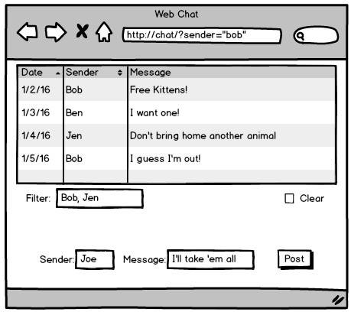

Optional:

* Use a JTable to display the posted messages.
* Launch all three of your clients (console, web, and swing) with a single remote RMI server and post messages among all three.