Exercise 3: Cats and Dogs

# Pet Daycare

You’ve been hired by the Cats and Dogs Daycare to create a database and the Java code to talk to it. For the first rollout you need only create a single table that hold customer information.

# Exercise

1. Create a database table with the following columns (pick the appropriate types):
   1. Customer name
   2. Number of cats owned
   3. Number of dogs owned
2. Write a SQL script to create the database from scratch and populate it with a few example customers.
3. Create the POJO “Customer.java”.
4. Create the “CustomerDAO.java” database code.
5. Create “CustomerDAOTest.java” to test CustomerDAO with JUnit.
6. Write an application that returns the following information from the database:
   1. List all customers with only cats or only dogs (not both).
   2. List all customers with more than six cats.
   3. List all customers with more than ten pets.
7. Send me your SQL and code.

# Optional

* 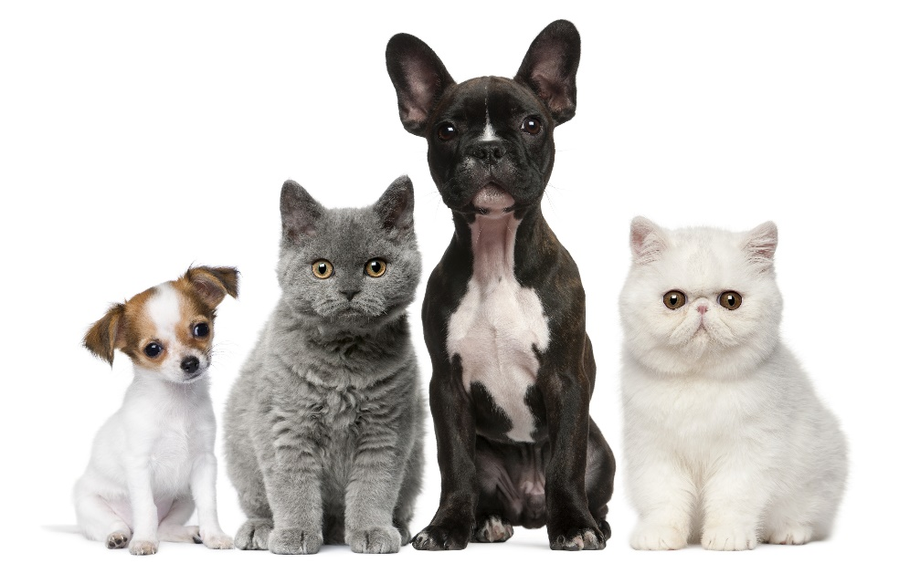Create a command-line application that takes the magic numbers in step 6 above.