Exercise 5: Web Chat

# Cork Board UI

Remember the Cork Board exercise? You have a simple object that manages a list of messages. You are going to add a web front end for this object allowing users to communicate with each other using their browsers.

# Exercise

The web user should be able to activate the basic functions of the CorkBoard:

* See a list of messages
* Post a new message to the board

You can be as creative as you like. All you really need is one request handler to generate a single HTML page with one form.

Your page might look something like this:

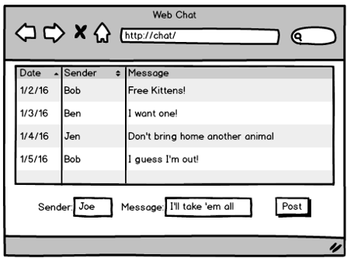

# Hints

Start with the handler:

* Create your basic project and get a HelloWorld tornado server going.
* Think about the parameters being passed to the request handler in the URL. What are their names?
* Code the handler to pull these parameters from the request and print them to the console.
* Use the browser to send requests to the handler. Type your parameters in the URL line.

Add in the CorkBoard:

* Find your old code and copy it into the project.
* Flesh out your request handler to talk to the CorkBoard object.
* Print outputs to the console and return a simple “OK” to the browser.
* Use the browser to test the handler.

Experiment with a static HTML file:

* Use a list of text lines to show example messages. Try your hand at making a table instead.
* Add a form and all fields to the HTML file.
* Press the send button and check the parameters in the URL line.
* Use this static form to test your handler. (Still only an OK response)

Generate the HTML:

* Add “write” statements to your handler to return the full HTML.
* Copy lines from the static HTML page you just created.
* Test, test, test! Try chatting with yourself among multiple browser windows.

