Using HTML5 and CSS3

# Lessons

1. HTML5 Essentials

2. Using Cascading Style Sheets (CSS) Technology

Exercise 1: Kid Space

3. Introduction to CSS Version 3 (CSS3)

4. Using Advanced CSS3 Techniques

Exercise 2: Kid Space 2

5. Introduction to JavaScript

6. JavaScript Events, Functions, and Methods

Exercise 3: Moon Weight

7. Using HTML5 APIs

8. Developing HTML5 Forms

Exercise 4: Canvas Art

9. Completing, Submitting, and Validating User Input Forms

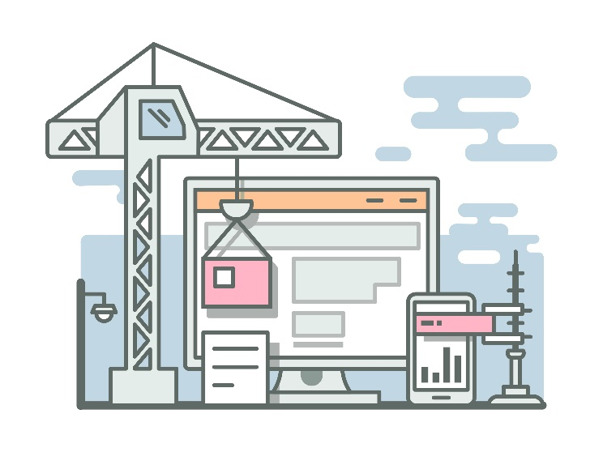10. Designing for Mobile Devices

Exercise 5: Sign Me Up