**The Fun Guy (get it?)**

**Pictures of awesome mushrooms I have encountered.**

**January 1, 2015**

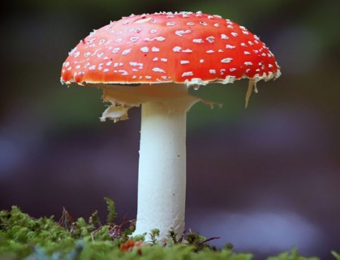

**I am visiting my sister in Vermont. This beauty was growing right beside her house. I say “was” -- I told my nephew it looked like a candy cane, and the kid picked it up and ate it! I hope it wasn’t poisonous.**

**January 4, 2015**

**My nephew Roger survived the mushroom!**

**March 14, 2014**

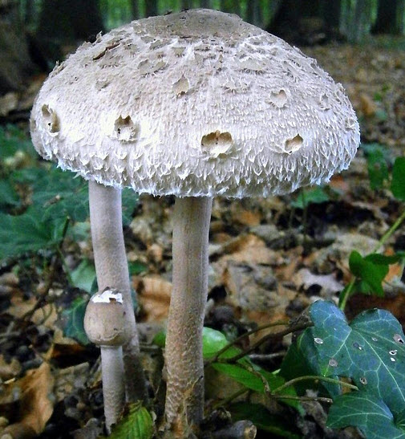

**It finally stopped raining after almost a week! I took a hike in the woods behind the house and ran into this beauty. The detail around the edges made me think of a jellyfish.**