**Rubber Bands**

**Highlighters**

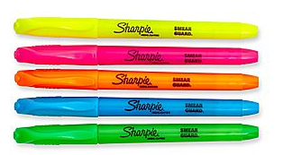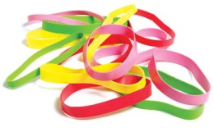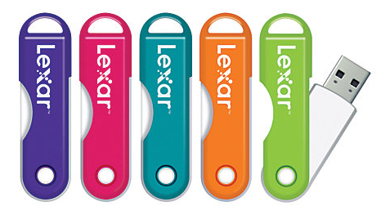

**Jump Drives**

*Specialty items change each week. Mention this flyer for 10% off any one item.*

Sharpie brand highlighters in a variety of colors and Sizes. Perfect for marking memorable spots in Mr. Thompson’s note handouts.

16G Lexar jump drives in a variety of colors. Supplies are limited – get them before they are gone.



**Weekly Item**

**Specials**

A variety of sizes and colors. These bands are perfect for pony tails and 5th period study hall rubber band fights.