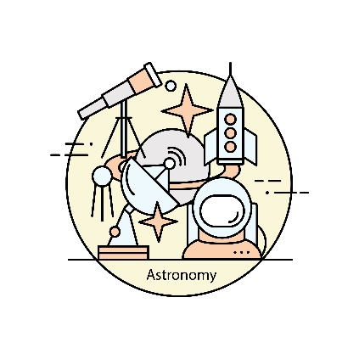Exercise 1: Kid Space

You are building the landing page for a cool new, kid-friendly web site called “Kid Space”.

Your page should have a header [1] and footer [2] and two sections of educational material [3]. You can use fake text in place of the actual material.

Your page should have a navigation section on the left with several links [4] (maybe one for each planet). Your footer should have a link [5] to the NASA web site and anything else you want to add. None of these links needs be functional – they are just placeholders.

Your header should have “Kid Space” centered in a creative font of your choice [6].

Use an external CSS stylesheet to style the page [7]. You should validate your final HTML with the online validator.

Be creative! Add elements you think the web site needs. My minimal solution is shown below.

