Some Assembly Required

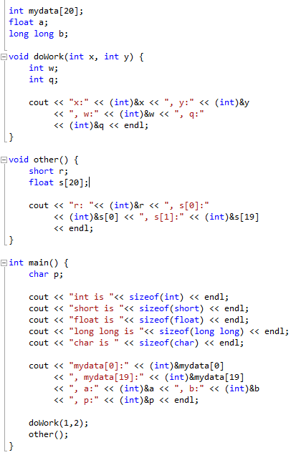

1608: w / int

1596: q / int

1624: x / int

1628: y / int

1612: r / short

1524: s[0] / float

1528

...

1600

5248: mydata[0] / int

5252

5324

5336: a / float

5328: b / long long

...

