# Opening a New Project in Visual C++ 2010

An empty project works fine for all of the exercises in this class.

File/New/Project…/Empty Project/ (Name: Day1) (Location: C:/cpp_7_2012)

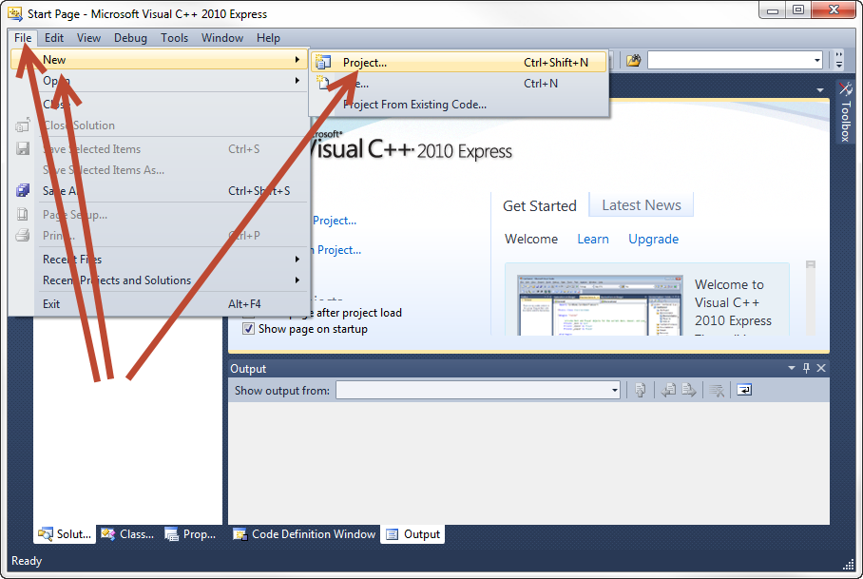

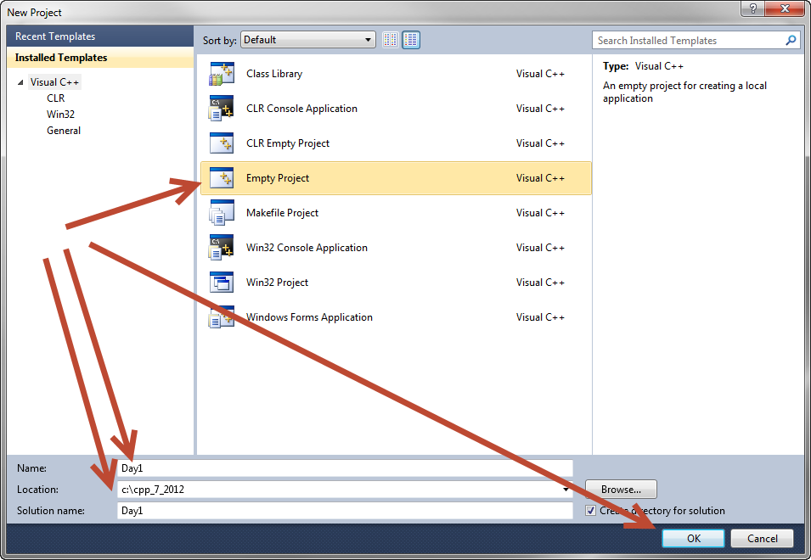

Add a “main” source file to the project. Right click on “Source Files”.

Source Files/Add/New Item…/C++ File/ (Name: one.cpp)

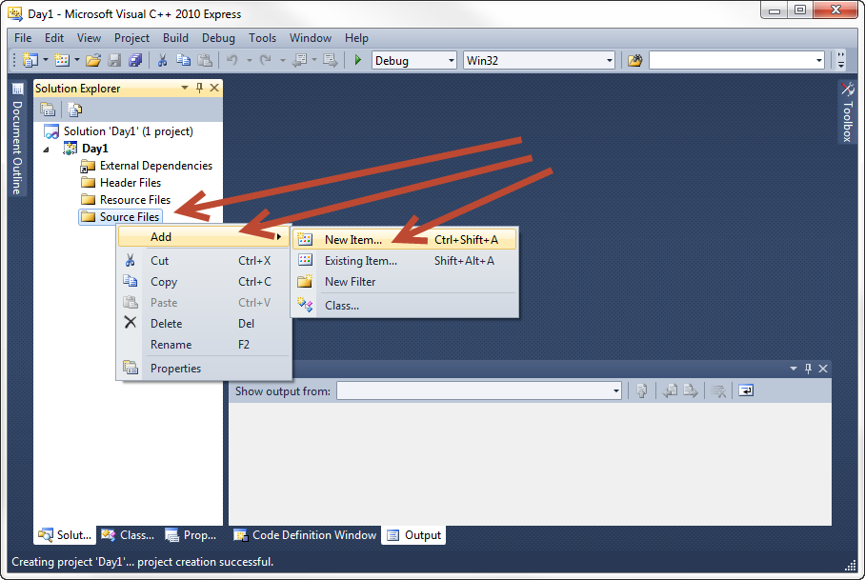

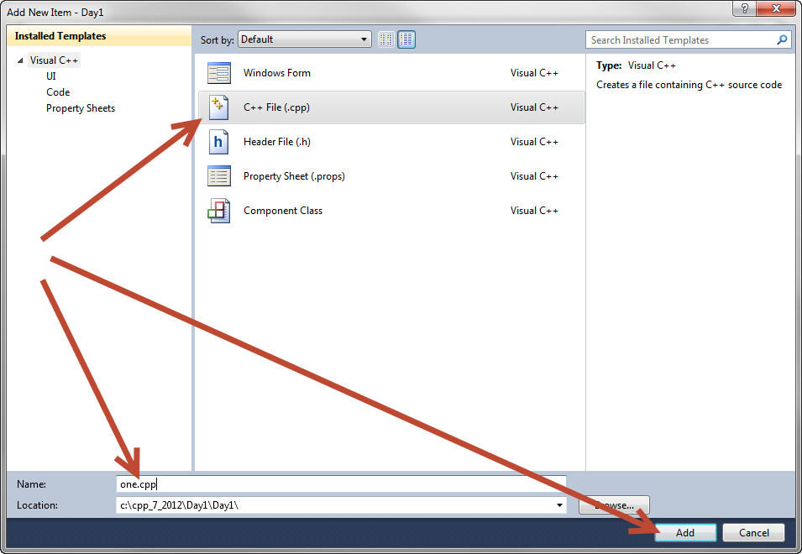

Turn on line numbering and advanced options.

Tools/Settings/Expert Settings

Tools/Options/Text Editor/C_C++/Line numbers

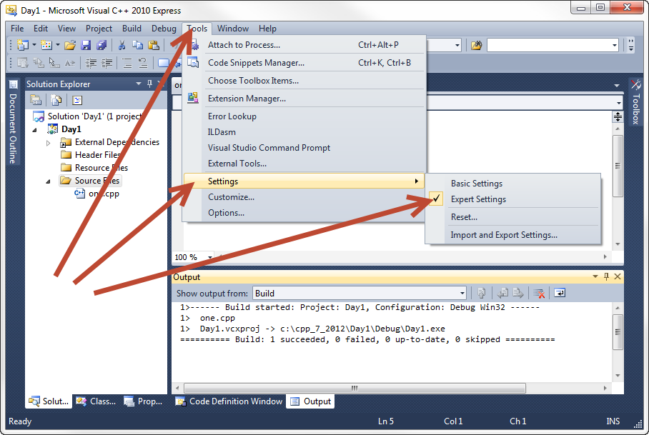

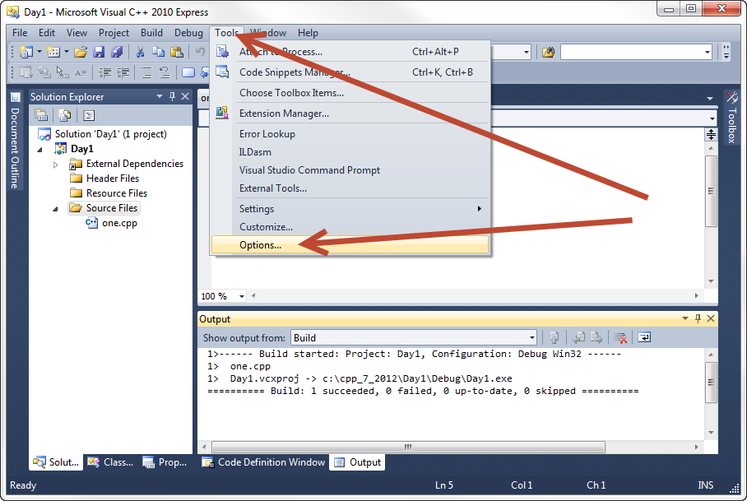

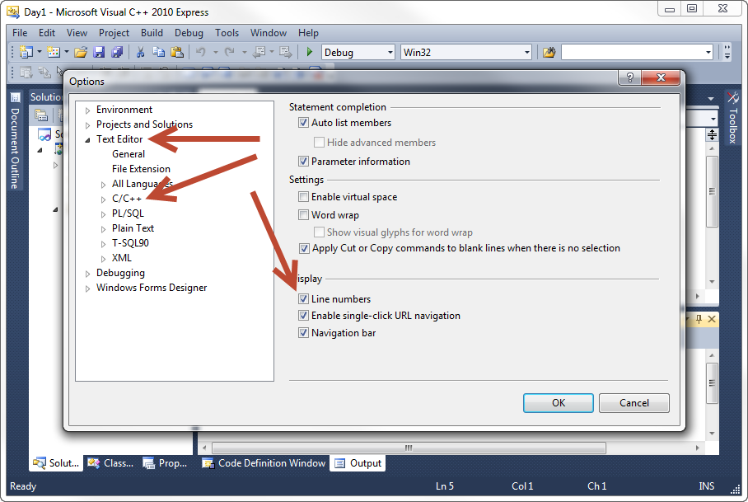

Hello World

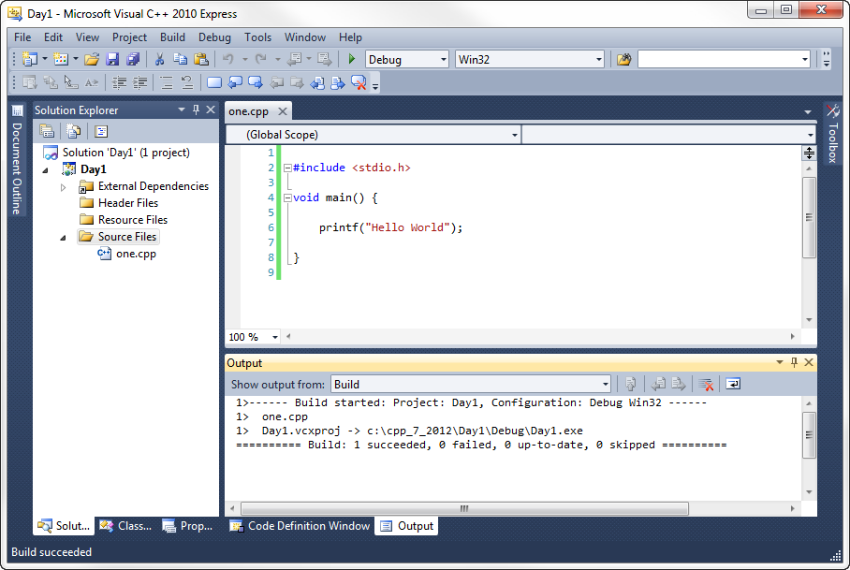

# Visual C++ Keyboard Shortcuts

F7 Build

Shift-F5 Run without debugging

F5 Debug/continue

Shift-F5 Stop debugging

F10 Step over

F11 Step into

Right-click on line to add/remove breakpoint