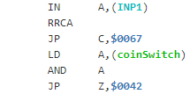

**MoveMotor**

**MoveLeg**

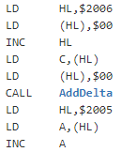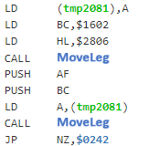

**Walk**

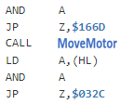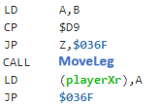

**Jump**

**MoveArm**

int

 byte

 byte

 byte

 byte

**int**

 int

 int

x

y

 point

 point

start

end

 line

 color

line

color

int

int

red

green

blue

**color**

**point**

**line**

**colorLine**

4 bytes

12 bytes

8 bytes

16 bytes

28 bytes