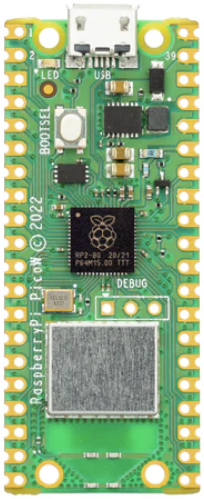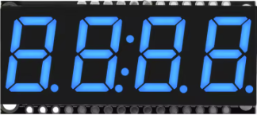

**25 Total**

**Neo Pixel Strip**

**Raspberry Pi Pico Wi-Fi**

**+5**

**GP28**

**GP17**

**GND**

**+3.3**

**SDA**

**SCL**

**HT16K33 Driver**

**GP15**

**GP13**