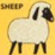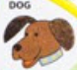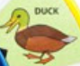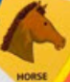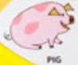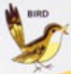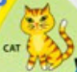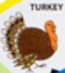

Barn



Use empty, have pail. Then pail has milk.

Coup

Use worm to get eggs.

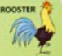

Pig Sty

Meadow

Use watergun to pass.

Tree

WORM

WATERGUN

Stream

Use watergun to fill.

Pond

Yard

Garden

Pasture

Kitchen

Porch

Use wheat to make bread. Use milk, bread, eggs to win.

Parlor

Use milk to make butter.

Use wheat to get pail.

start