# Remove Existing Gear Basket Door LEDs

Carefully pry them from the old doors.

# Adjust LEDs for New Gear Basket Doors

Remove center four pixels from each vertical. Solder the vertical strips back together. New strands are 42 pixels each.

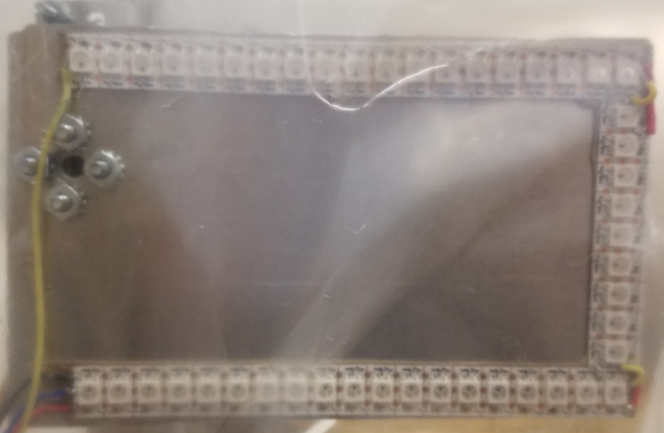

# Mount New Gear Basket Door LEDs

Use clear packing tape. Leave slack in the wires for the doors to open and close.

# Replace the Oreo Board

Unscrew the wires from the existing board. Unscrew the existing board from the robot. Screw the new Oreo board to the Robot.

# Connect Oreo Serial to Robo Rio MXP

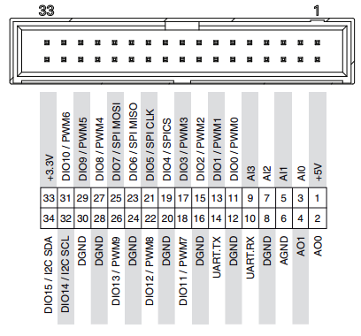

S1

GND

# Connect Oreo Power +12/GND

Add connector to old wires. Connect to new Oreo board.

# Connect D1 (Bottom of Robot)

D1

# Connect D2 (Gear Basket Doors)

Note the “forked” power and ground lines.

D2

# Connect D3 (Pixel Grid)

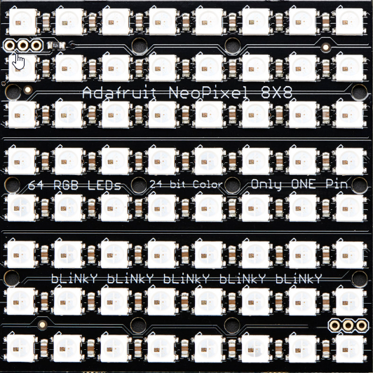

D3