The OO Carol Bot

Introduction
Programs are traditionally requirements driven; there is an immediate need, and the software is designed to fit that need. Object Oriented programming adds forethought on top of the present design. Yes, there is an immediate need that must be filled, but with just a little planning we can design modules that are easy to reuse in future endeavors. Take the Carol Bot, for instance. I have an immediate and desperate need for a robot that roams the hall playing Christmas Carols! But with a little planning, I have created a basic framework for many years of robotics experimentation.

When we hear the phrase “embedded programming” we think of optimizing every byte of ROM and RAM for a PIC or some other resource-limited CPU. Amdahl’s Law, however, insists that CPU speeds and memory double every 18 months. Yesterday’s workstations are today’s embedded processors and we will find the capabilities of today’s PCs in tomorrow’s toasters!

Take Java for instance. When Java first came out, the interpreted language was barely practical for high-end workstations. But just a few years later now, Motorola is shipping Java as a standard feature in their cell phones – not because Java has shrunk all that much but because the embedded processors have grown.

In this article I will discuss the application-like features becoming available to embedded developers. The Carol Bot is a simple robot hardware platform powered by full-featured Object Oriented Java code running interchangeably on a Palm PDA or Motorola cell phone. I will demonstrate the principals of OO design in the hardware and software. I will also discuss the pros and cons of using an OO approach and how they apply to the embedded world.

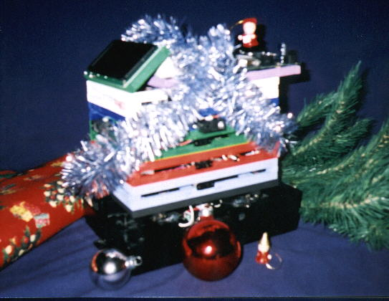
Figure 1. The Carol Bot Dressed up for Christmas

The OO Mindset
Despite what you may have heard, OO is not an alternative to procedural programming – it is a layer of abstraction above it. In procedural programming, you start with low-level functions and build up complexity in layers of functions that call the lower layers. In OO programming, the meat of your code is still procedural functions, but you organize the functions and data into abstract objects. The main power of an object is the virtual function table that allows you to specify a function’s signature and change the implementation of the function at runtime.

The extra organization of OO makes a large code base easier to maintain, but it requires additional training and forethought at design-time. If your code base remains small and rarely evolves, the OO learning curve might be wasted. The virtual function table makes it easy to add features to a product in the future, but the extra indirection imposes a performance penalty and an additional memory overhead. If your product is performance-sensitive you may not have the extra overhead to apply OO effectively.

OO modules are usually designed for reuse, and they often contain features (or support for features) that are not immediately useful. If I need a linked-list of packets in my router code, I might start by creating a general-purpose linked-list for reuse in other parts of the code and later products. I would spend a little extra time adding generic list functions that I won’t be using now; these extra functions are easier to create while I have the innards of the linked-list in mind.

Designing for reuse is a gamble on the future! If I never reuse the linked-list then I have wasted valuable development effort on it, and the linked-list may not be as fast as it would have been if I had custom fit it to my immediate needs.

OO is a mindset, not a language. You can write lean-and-mean purely-procedural code in Java. And you can write flexible, reuse-minded object-filled code in C. But OO languages offer automatic support for the additional abstraction layer.

Discussions of OO design usually become aloof philosophical arguments filled with strange terminology! Fortunately we can demonstrate sound OO concepts in a very concrete and physical design.

OO Hardware
The Carol Bot has various TTL hardware pieces that require a regulated 5V power supply. My first thought was to mount a 9V RC car battery and a 7805 voltage regulator directly to the robot base I scavenged from a Wal-Mart toy. There is a cranny in the base that seems made for the battery, and the frame would nicely dissipate any heat generated by the regulator.

The initial design is very sleek and efficient. If I were delivering a product to the market at the lowest possible cost, the design would be optimal. But as an experimenter, I am more interested in creating a generic power supply that can be re-used in future robots.

The OO design of the power supply is built in a stand-alone rectangular frame (see Figure 2 below). I have added a power switch to the frame along with a jack for an external 9V wall transformer. This jack seems wasted on the mobile robot, but it is a good general-purpose power supply feature that will be useful in future stationary products.

The rectangular frame contains three screw terminals for the other modules to tap into. I am providing access to the 5V and ground that I immediately need, and I am providing an extra screw terminal for the unregulated 9V. Again, I don’t currently need for 9V. But I might in the future, and it is easy to add one extra screw terminal now while I am building the supply.

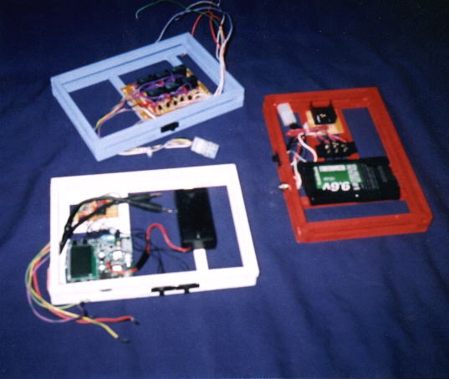
Figure 2. Three Carol Bot Modules (Power Mode in Red)

All of these “added features” of the generic supply seem wasteful in my current application. The extra power jack and screw terminal consume space and add weight. And I have to stick in a bulky heat sink for the regulator instead of using the robot base. If I never reuse the power supply in a future project, then the extra time and space is just wasted. On the other hand, if I ever add a module to the robot that needs 9V then my power supply needs no additional work.

The Carol Bot is a physical incarnation of Object Oriented design principals. The robot is a collection of rectangular modules all built to the same size for easy stacking. The robot is very symmetrical and almost too tall with much wasted space in the core; some modules contain few components but are placed in a uniformly sized container. Without the balsa frame, the robot could be much lighter. OO systems (hardware and software) are thus fatter and fluffier than they need to be with all the generic features the designer HOPES will prove useful in the future.

I am an experimenter, and the flexibility is the most important feature of the robot. Since I am not tied to any particular robot base, I can easily swap bases to the new tank treads I pulled from a Tonka Toy. I can swap out the sensor module for better technology tomorrow. I can replace the MP3-player module with a spit-wad-shooter module to give the robot a new personality. I can remove the rolling base completely and use the servo-module to make a web-controlled fish-feeder for my aquarium.

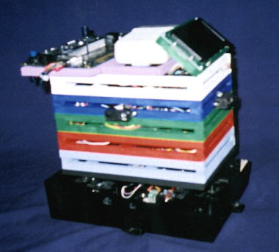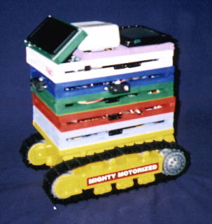
Figure 3. TINI Brain (left) and Palm Pilot Brain with Tonka Base(right)

Carol Bot CPU
Embedded programs run on embedded CPUs. Given the choice, I would shrink my 1.6GHz PC – hard drive and all – down to a tiny chip and use it for my embedded projects. Physical limitations, however, force me to choose a processing environment less capable. But remember Amdahl’s Law: the same processor tomorrow will be half the size that it is today. We are already seeing many general-purpose computers making their way into the embedded space.

The TINI board from Dallas Semiconductors is a full-featured Java computer on a tiny 72-pin SIMM card. The board features a built-in ethernet chip, two serial ports, a file system, and a UNIX-like operating system. You transfer your compiled Java code to the board across the network with FTP and then login remotely with TELNET to run it from the command prompt. You can even create a web site with a Java web server and surf to the TINI board with your web browser. You get all this for about fifty dollars!

But you probably already have a general-purpose emebedded brain for your projects right there on your belt; look no further than your PDA! PDAs like the Palm Pilot continue to grow in capabilities and shrink in price. While a general-purpose PDA may not be practical to redistribute within a commercial product, it is perfect for a robot enthusiast. You already use the portable computer to track your appointments and phone numbers; why not use it to run your robot too?

Cell phones are merging with PDAs; how about using your new cell phone as a general-purpose computer to control embedded experiments like robots? With wireless ethernet on your phone, you could put your mobile robot on the web. All you have to do is hook your phone up to your robot hardware. And how do you do that?

General-purpose computers usually have wonderful high-level features like operating systems and IP stacks, but they have very little general-purpose hardware control capabilities. On the other hand, PICs and other traditional embedded solutions have lots of I/O lines but generally lack the high-level computing features. You can merge the best of both worlds by using both solutions at the same time.

The Carol Bot uses a general-purpose I/O processor module that connects to the main computer with a serial cable; most general-purpose computers have an available serial port. I used a BasicStamp as my coprocessor simply because I had one on hand. Most PICs cost much less and offer the same kind of I/O support. Still, the BasicStamp has many built-in features like support for direct servo control. I’m not taking advantage of these features in the Carol Bot, but who knows what the future will bring?

When the software running on my Palm wants to turn on the robot’s wheels, sends a sequence of text characters through the serial port to the coprocessor. When the main program wants to read the sensors, it sends a command to the Basic Stamp and then reads the serial result back. You can even use a terminal program like Hyper-terminal to control the hardware manually (great for debugging).

You can develop your robot code on the PC using the PC’s serial port to run the robot. Then you can compile your code for your Palm Pilot and use the hot-sync cradle’s serial cable to run the robot. If you are writing Java code, you can run the (nearly) same piece of code on any general-purpose computing platform! That’s the ultimate in code reuse.

Speaking of programming languages, there are several factors to consider when choosing a language for your embedded project. If performance is crucial, you might need raw assembler. If future enhancement is crucial (as to an robot enthusiast), you might consider the built-in reuse features of an OO language like C++ or Java. Java is particularly easy to learn and tinker with. You don’t have to worry with complex compiler options or makefiles. That leaves you more time to spend on the business logic at hand. But the best language to use is the one you are most comfortable with. You can write flexible/reusable code in any language, but you’ll have more fun and be more successful in home projects if you are speaking your native tongue.

I chose Java for the Carol Bot primarily because I love it! The TINI board I used has a JVM built into the operating system, and I used the free WABA Java package that runs on many embedded platforms including my Palm V. I wanted to use Sun’s Java Micro Edition for my Palm Pilot, but it currently lacks support for the serial port.

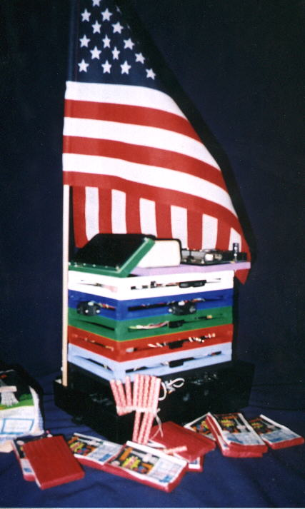
Figure 4. The Carol Bot dressed up for the 4th of July

Carol Bot Software
When I first sat down to write the CarolBot control software I created several “global” methods to perform various hardware functions. The setMotors() function accepts two integers that represent the left and right wheels with values for each: OFF, BACKWARDS, and FORWARDS. The pressButton() function accepts a single integer representing a button to press on the MP3 player: ON/PLAY, OFF/STOP, and FORWARD. The getSensor() function accepts a sensor number and returns the 8 bit distance value read from the specified Sharp IRRD sensor. Each of these functions sends the appropriate serial data to the coprocessor and reads any return values.

Next, I organized the methods into separate objects. All of the robot-base methods went in the Robot object. All of the sensor methods went in the Sensor object, and the MP3 methods went in an object named MP3. Why the extra organization? It seems wasted for such a simple design.

I did it for future flexibility. If I swap out physical MP3 modules in the future, I’ll need to change the code in the MP3 functions. If I keep the MP3 functions together and alone in a single class file, I can simply create a new MP3 class and use it in my future code. I don’t have to worry about recompiling the other code like the sensor class. And I can create a new SuperMP3 class that extends the older MP3 class. If the new MP3 class provides the same methods as the old class, then I can just swap out the MP3 class without changing any of the other code that uses the methods. That’s a powerful practice in OO programming.

Next I needed higher level algorithms to track the walls of my office building. Our walls are nice and straight making the algorithm fairly easy:
- Turn the motors on
- Loop reading the sensors
- If the wall is too close, pause the opposite wheel to correct outward
- If the wall is too far away, pause the adjacent wheel to correct inward
- If the wall suddenly vanishes, we have found a door:
- Drift forward a bit, stop, and play a song
- Start the motors and roll forward until the wall appears again

I also need other control algorithms … methods to track around an open corner (where the wall vanishes) or a closed corner (where the robot bumps into the wall). These algorithms are what ultimately what robot programming is about. Here is where I need the most flexibility. I want to be able to add additional routines in the future with minimal changes to the rest of the code.

I chose to use an OO design pattern called the “Command Pattern” to abstract the algorithms from the controller code that uses them. I created separate classes for each of the algorithms giving each class a single method named “execute()”. The execute method of each class performs all of the steps for the desired robot function (like tracking the wall to a door).

To create a sequence of commands for my robot, I just create a list of command objects in the order I want them executed. A typical sequence for my office building might contain a list of six objects something like this: TrackWall, TrackWall, TrackWall, OpenLeft, TrackWall, OneEighty. This sequence would traverse 3 doorways, make a left turn around a corner, traverse another door, and turn around 180 degrees.

The central controller simply reads a list of command objects, takes each object in turn, and calls the execute() method. When that method returns (when the robot function is complete) the next object is executed. New and exotic control objects can be added without changing the central controller’s loop.

In fact, I can create a small GUI to select command objects from a pull-down list. I choose from my “favorite” sequences that match my hall or build new sequences for other halls. Suddenly that GUI screen on the PDA is very useful! At first I had thought it to be wasted space, but more often than not in OO designs: if you build it they will come.

My favorite command object for the Carol Bot is the RemoteControl object that displays a GUI touch screen on my Palm. Using a long serial cable, I can walk around behind the robot and drive it with the GUI remote control. Then there is the NetworkControl object for my cell phone brain that connects through a TCP socket to the web server running on my PC. I can sit at my desk and use my web browser to drive the robot around the halls.

Conclusion
My immediate project was a mobile MP3 player that tracks walls. I could have packed all of the hardware onto the toy robot base. I could have used a super-tiny PIC as the embedded processor, and I could have gotten by with a few control functions written efficiently in assembler. And my pride and joy Carol Bot would now be a dusty trophy sitting on the bookcase in my office. But by applying just a little forethought and Object Oriented design in the hardware and software I have created a flexible, reusable platform for years of experiments to come.

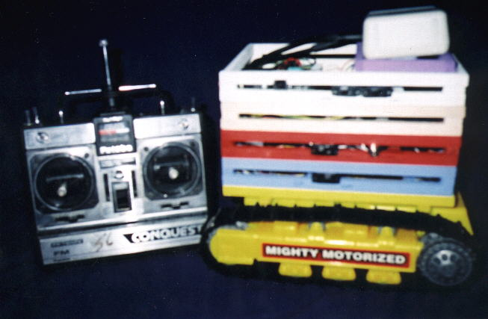
Figure 5. The Carol Bot using the RC-Receiver Brain Module

When my nephew was bored with his Mighty Tonka bulldozer, I “borrowed” it from him, removed the base, and added a molex connector to connect to the Carol Bot. I can swap out bases in just a few seconds with no software changes. The original base is fast but only runs on short carpet like I have around the office. On the other hand, the Tonka base is a slow moving tank-tread that easily crawls through my thick carpet at home.

But the Carol Bot is just the beginning for this hardware and software! Before I went on vacation, I created a new module … the Servo Control module … that controls a couple of external hobby servos (remember the Basic Stamp interfaces directly to hobby servos). I hooked up the power module (with external wall power), the servo module, the coprocessor module, and the TINI board brain. Then I plugged the TINI brain into my hub and presto: I can feed my fish from across the Internet. The high-level Java language features for the TINI board makes it a breeze to write a web server application.

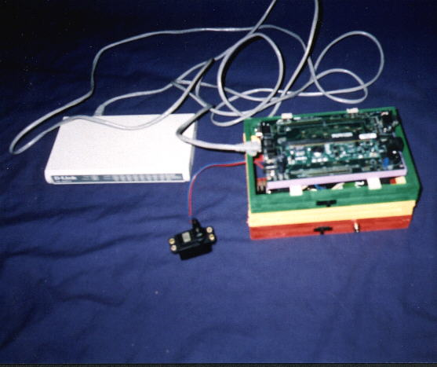
Figure 6. The Internet Fish-Feeder connected to my hub

END

The following side-blocks could be sprinkled throughout the article
<Code snippets for the printed article … ALL code available for download>
<Part of the Basic program from the I/O coprocessor>
<The guts of the Robot driver that writes serial to the I/O coprocessor>
<The Palm GUI Remote Control code>
<Part of the TrackWallCommand command object>
<The central controller loop>

<Side block outlining the various Carol Bot hardware modules (and the peer software drive objects)>

<Side block showing the schematic of the MP3 controller circuit (4066 based)>

<Side block showing the relay control board for the robot base>

<Side block with references>
<TINI site>
<WABA site>
<J2ME site (SUN)>

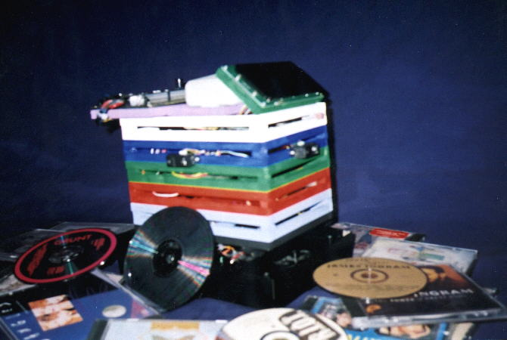
Figure 7. The Generic Carol Bot with some CDs

