English II: Sophomore Writing

Catalfano

Writing Mode: **Persuasive Research**

Due: Please upload your essay to turnitin.com by the assigned due date. Late papers will incur the typical 10% per day late grade deduction.

Length: Between 700 and 850 words for College Prep students; between 850 and 1000 words for Honors students.

Format: Typed, double-spaced, 10-point Times New Roman font.

Grading: 60 points, graded according to the standard rubric.

(Note: this paper will also require two or three “checkpoints,” each of which is worth 10 points.)

**Topic** **Selection: What do you care about?**

This is a **persuasive research paper**, which means you are taking a position on a contemporary issue *that you care about* and setting out to prove that your position is correct with strong, convincing sources. How many sources?

* *at least* four sources for College Prep students
* *at least* six sources for Honors students

Of course, you need to set out to support an idea that is capable and worthy of being supported—not something completely obvious. Because one of the major course objectives is to write about what you believe in (as you find your writing voice), you will be allowed to choose your own topic for this persuasive research paper, so long as it is **not** a topic you have written about already for another class (remember: your intellectual and personal integrity should be important to you, so research something new to you, which is most of the “fun” of research). I must also approve your topic before you begin writing your paper. In order for me to approve your topic, you must have at least four reliable, strong sources in your hand that you have read, highlighted, and taken notes on.

**Conducting Good Research**

Many high school students do not know how to conduct strong, valid research—perhaps because we now live in the world of Google, which has, unfortunately, made many of us lazy…and extremely credulous. Many people (not just students) think that simply typing a key word into a search engine and pressing enter is going to lead them to a wealth of valid information; however, as you most likely know, the Internet is filled with as much garbage as actual valid, useful, reliable information from *reputable* sources. Just think: which of these would you believe more, and would add credibility and maturity to your essay: referencing information from a personal blog from some unknown person or www.randomwebsitewithnocredentials.com over something printed in a reputable publication like *The New York Times* or *CNN*?

In elementary and perhaps middle school, you were allowed to use an encyclopedia to conduct research; however, in high school, this is no longer acceptable. Thus, Wikipedia is not a valid resource for this, or any high school or college, paper. Why? The answer is simple: there is no specific author to the information on Wikipedia—it is “the people’s encyclopedia,” and therefore an eight-year-old could be posting information about gene splicing, for example, if he should want to. Moreover, you will often see cautionary remarks at the top of a Wikipedia entry that question an article’s credibility or sources. In short, you need to know where your information is coming from; usually this means that there is an author and/or an established, respected, published source listed in your resource. Now, if there are sources listed at the bottom of a Wikipedia page, these sources may be useful to you (if you’re lucky, some may be clickable—but you must make sure that you’re being taken to a credible website or resource).

You are fortunate, however, to have access to numerous databases through our school, which is a valid path to take to acquire credible, reliable information for this paper. Many of you have used this academic search engine before, but for those who have not:

1. On the DS High School website, under the *Our School* tab, click on *Library*, and then *Databases*.
2. Under High School Library Databases, you have a lot of options, and depending on your topic, a few of these databases may be good options for you to use. A good general one for you to start with would be *InfoTrac Gale*.
3. You will now see a long list of different databases. Read the descriptions of each different database and select those that you believe are relevant to your topic, or simply select the “search all databases” option to get the most comprehensive results for your search.

You may, however, need to get creative with your search terms. For example, if you want to research the cheating epidemic that is plaguing high schools throughout the country, you may need to conduct a variety of searches—not just one—on high school, cheating, ethics, lying, stealing, teenagers—or any variety of these terms together. Don’t just stop at one search, *school cheating*, and call it quits. There are also many major newspapers and magazines that now have entire articles posted online; you should research these as well. Although you have a minimum number of articles to read and use in your paper, you may have to read over a few articles before you find a good one with information you can use. Also, if you find an article mostly duplicates the information from another one of your resources, then find another article. In short, don’t print any sources you find on your topic until you have read them for relevant, useful information. The purpose of research is to find the best information possible; this takes time, effort, and patience, because your information is not going to be given to you.

You must have at least four valid, credible, current (within the past three years) sources to support your position within your paper. You should *weave* ideas and information from these various sources together; some sources you will use only once, while others you will use two or more times. You should not, however, overuse one or two sources, because this would reveal that most of the ideas in your paper are not yours, or that most of your information or support came from only one or two sources.

**Putting Together the Works Cited Page**

Before you begin writing you paper, you will be required to create a proper Works Cited page; this will make your in-text citations much easier, because your in-text citation will always be the first item in the Works Cited entry followed by a page number. One great online resource that will help you generate this page can be found at www.easybib.com. This site, with all its drop-down boxes and text fields, should be fairly self-explanatory and easy to navigate. Remember: every source you list on your Works Cited page must be (here comes the obvious) cited! Do not list anything on this page that you do not specifically refer to within the text of your research paper. This is NOT a bibliography page, which is a general list of the resources you consulted. For your reference, here is an overview of proper Works Cited page format:

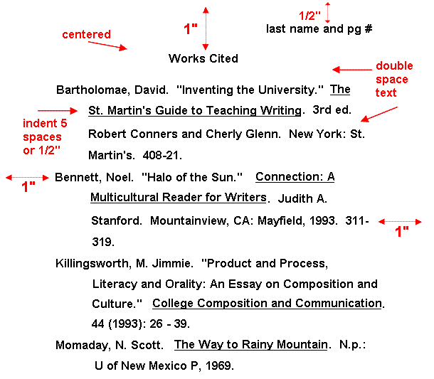

The above image was taken from:

"MLA Style Page Format." *Sacramento State*. Web. 05 Apr. 2012. <http://www.csus.edu/owl/index/mla/mla_format.htm>.

**Proper Citations and the Risk of Plagiarism**

If you do not properly document and give credit to your sources as you write your paper, then you put yourself at risk of plagiarism. You must keep track of where your information comes from. You should document your sources in MLA format, which is usually the author’s last name and page number in parenthesis at the end of a sentence. Generating a proper Works Cited page first will make these citations easier, because you will always use whatever word(s) appear first in the entry whenever you cite it. For example, if your Works Cited entry is:

"Under pressure." *Girls' Life* Apr.-May 2007: 15. *General OneFile*. Web. 5 Apr. 2012.

whenever you use information from this source—even if you are not directly quoting the same words but using the information, you will use (“Under Pressure”) at the citation in your sentence, like so:

A study of stress in high school revealed that 50% of teenage girls feel overwhelming pressure

to succeed in school, while only 38% of teenage boys felt such pressure (“Under Pressure”).

If your Works Cited entry is this:

Park, Jane Shin. "Breaking Point." *Teen Vogue* Sept. 2008: 246. *General OneFile*. Web. 5 Apr. 2012.

then you should use the author’s last name in your citation, like so:

According to other research, "girls often get stressed by relationships within their own support group more than guys do” (Park).

Traditionally, you would also include a page number with your in-text citation, but because so much research is now conducted online, this requirement is now debatable. If you do have the actual, hard-copy source (imagine you have the actual issue of *Teen Vogue* in your hands), you should include the page number, as this is proper MLA format.

**When to Quote, When to Paraphrase**

Students often have a tendency to use too many quotations in a research paper because they forget about paraphrasing; thus, their research papers seem mostly someone else’s words. This is not good. If you read some information in one of your articles and feel that you could just as easily summarize it in your own words, then you should do so. However, even when you paraphrase, you must always credit your source (use in-text citations), for the idea is not yours, and changing a word or two does not make the idea yours. If you believe that the exact words as you read them in your resource are the best words possible, or said by someone of prominence or importance (such as a lead researcher on gene splicing), then you may want to quote the information. Also, for longer quotes, you should observe proper block quoting format:

* single-spaced,
* an extra inch of indentation on both sides of the page,
* a proper in-text citation with a period BEFORE the parentheses, like so. (Andrews)

**The Style of a Research Paper** (yes—there is one!)

Many students suffer from the widely-held belief that research papers are bland regurgitations of someone else’s ideas that you somehow only need to assemble—however, I would say to these students: then you’ve never read or written a good research paper before. A good research paper WILL have a strong, original voice in it; just because you are using information that you have gleaned from various sources, you are pulling the information together in your own original, insightful way. I like to think of a good research paper as a tapestry; yes, someone else most likely made the different colored threads, but you are the weaver, and the final product can and should be one that is original and uniquely your own design. Keep this metaphor in mind as you research and write. Merely copying and pasting (or paraphrasing) large blocks of text from your sources is NOT good research paper writing. Strive to be engaging; try to enjoy writing! After all, you have been given the opportunity to write on a topic you care about. If your paper feels bland and unexciting to you, then it will most likely be the same experience for your reader (namely me). Excite me with your ideas and voice!

**Other Valuable Resources**

On evaluating web pages for reliability: <http://www.library.cornell.edu/olinuris/ref/research/webcrit.html>

On proper MLA format for Works Cited: <http://hs.doversherborn.org/hs/socialstudies/andrew/documentation.htm>

On proper in-text citation format: <http://leo.stcloudstate.edu/research/mlaparen.html>