|  |  |  |  |  |
| --- | --- | --- | --- | --- |
| **SOP Number** | **0001** | | | |
| **SOP Title** | **Jetson-TK1 setup** | | | |
|  | NAME | TITLE | SIGNATURE | DATE |
| Author | Christopher Enriquez | Software Engineer |  | 2017-09-20 |
| Reviewer |  |  |  |  |
| Authoriser |  |  |  |  |

|  |  |  |
| --- | --- | --- |
|  | Effective Date: |  |

|  |  |  |  |
| --- | --- | --- | --- |
| READ BY | | | |
| NAME | TITLE | SIGNATURE | DATE |
|  |  |  |  |
|  |  |  |  |
|  |  |  |  |
|  |  |  |  |
|  |  |  |  |
|  |  |  |  |

1. **PURPOSE**

The message of this Standard Operating Procedure (SOP) is to provide detailed instructions on how to setup and build the MegaBank program so that any person who will use the said application can setup and build the MegaBank correctly

2. **INTRODUCTION**

This is the process on how to build the MegaBank, follow all the instructions and the project will be built successfully.

3. **SCOPE**

This SOP include only how to setup the MegaBank in the environment the users have. The computer must be Windows 10 and Windows 7 only. It is the supported OS right now.

This application works with the computers that have a Visual Studio 2015 installed, otherwise, program will not push through

**4.** **RESPONSIBILITIES**

**4.1** **SOP Author**

**•** Draft SOP in consultation with the intended users.

**•** Make SOP available with the intended users

**•** Amend SOP if required

**4.2** **Users**

* Ensure that the computer will be use have a Microsoft Visual Studio 2015 installed.
* Ensure that all the guidelines and procedures listed here are properly followed to fully use the program.

**5.** **SPECIFIC PROCEDURE**

**5.1 Setup the necessary files for MegaBank**

* To start this tutorial, these are all necessary files you needed.

1. **MegaBank.rar –** files that are important to build the **source code / solution / project.**
2. **MegaBank_WPF folder –** this folder is the **source code / solution / project.**

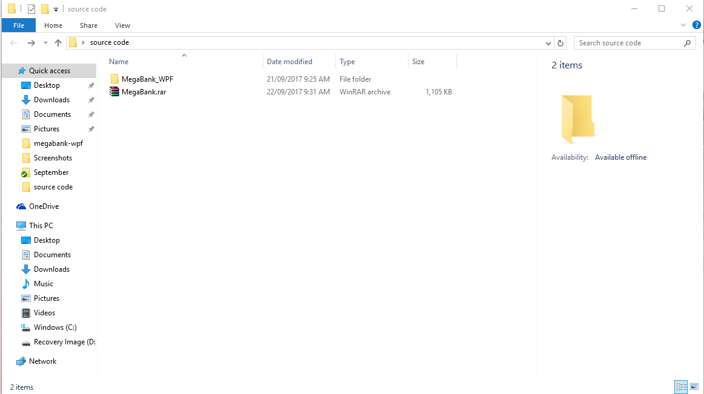

* Copy the **MegaBank.rar** in Desktop or wherever you want except flash drives.
* Extract the **MegaBank.rar** using WinRAR, right click to the file and click **Extract to Megabank**

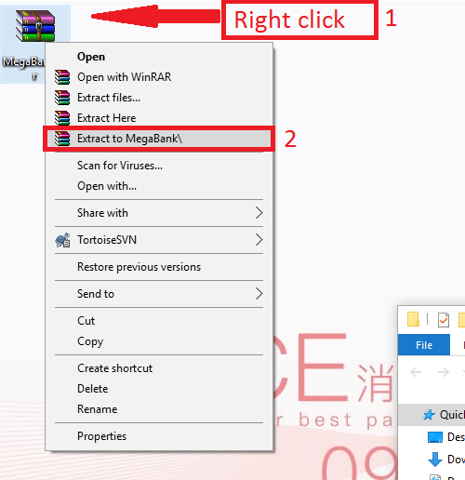

* It will generate a folder named MegaBank

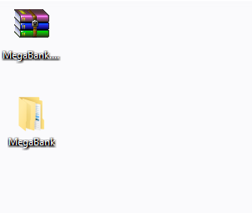

* Open the MegaBank folder and search for the file named **“run first.bat”**. Right click on that file and click open.

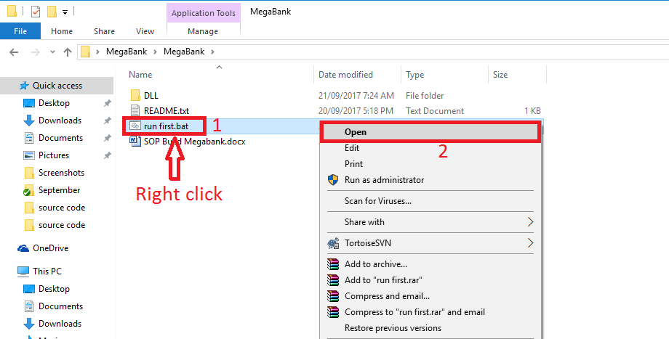

* If the OS of the computer is Windows 10, opening the **run first.bat** will prompt a User Account Control. Click **Yes** to continue. 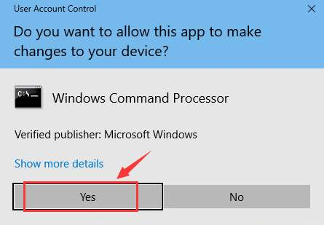
* If the OS of the computer is Windows 7 and it does not prompts a **User Account Control**, meaning the account used in the computer have an administrator rights. If it prompts, just click **Yes** to continue.
* After running bat file, all necessary files are in the right place and the MegaBank source code is ready to build.

**5.2 The source code**

* Copy the **MegaBank_WPF (this folder is the source code you’ve downloaded from our gitlab)** folder into Desktop or wherever you want except flash drives.
* The **MegaBank_WPF** folder must be look like the photo below.

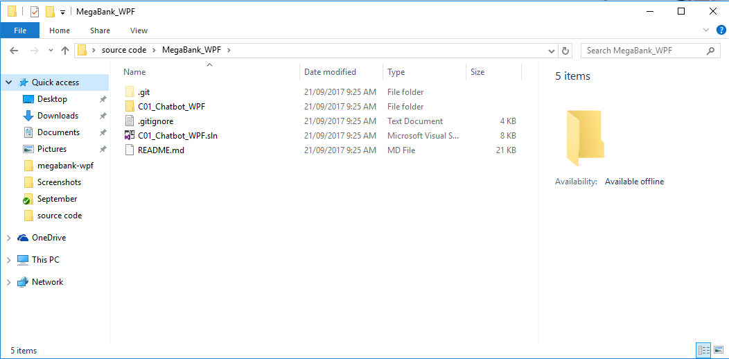

**5.2 Building the project in Visual Studio**

* Open Visual Studio 2015 in Windows 7 by clicking the **Start Menu,** expand **All Programs,** and then expand **Visual Studio 2015.**
* Open Visual Studio 2015 in Windows 10 by clicking the **Start menu,** find Visual Studio 2015 and open it.

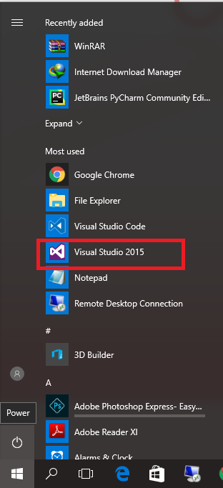

* Go to File > Open > Project/Solution. Click Project/Solution

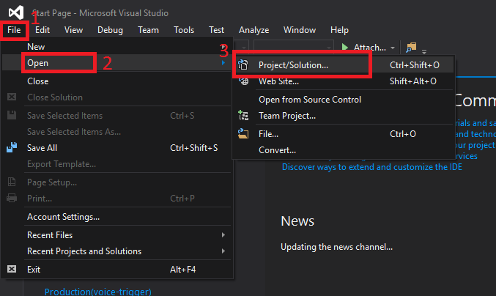

* Go to the directory where the **MegaBank_WPF** folder is saved and select the C01_Chatbot_WPF.sln.

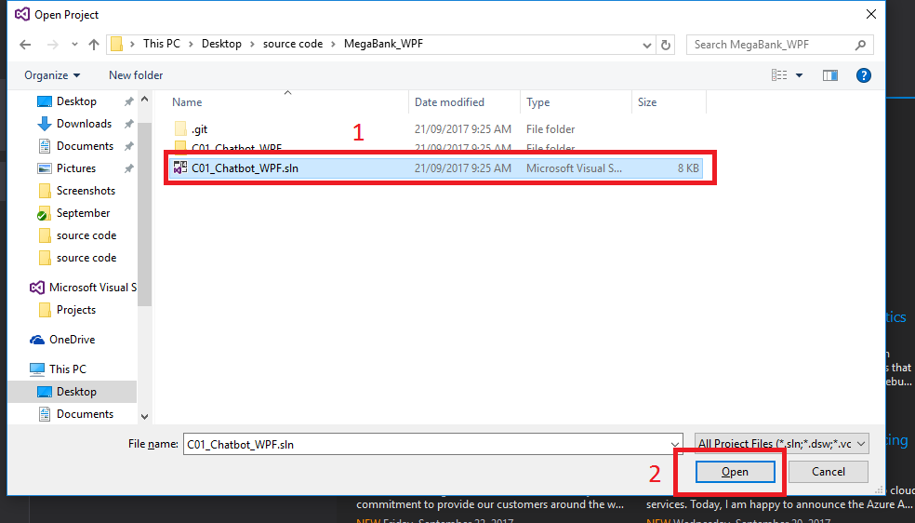

* Alternative way in opening the solution is by double clicking the **C01_Chatbot_WPF.sln**
* Go to **Project** and click C01_Chatbot_WPF Properties like the photo below.

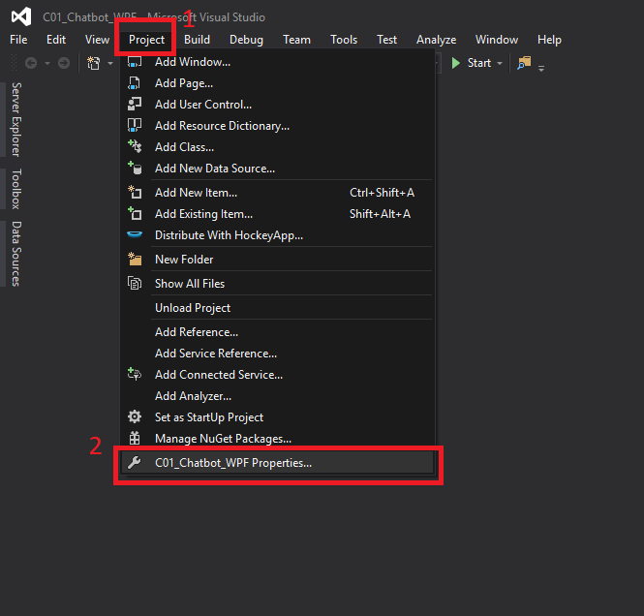

* Go to **Build,** a screen like this will appear. Make sure that the Prefer 32-bit is unchecked and the Platform target must be **Any CPU.**

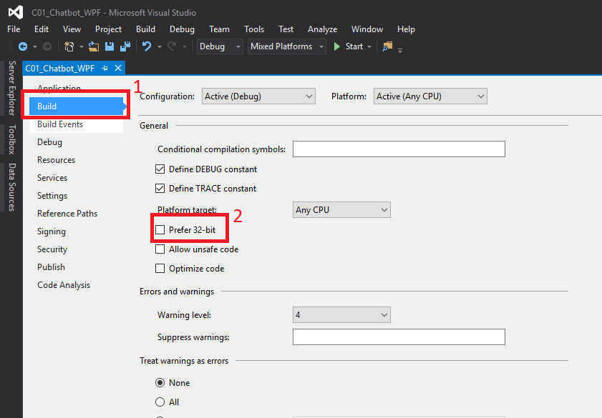

* Go to **Debug** and click **Start Debugging** or simply press **F5**

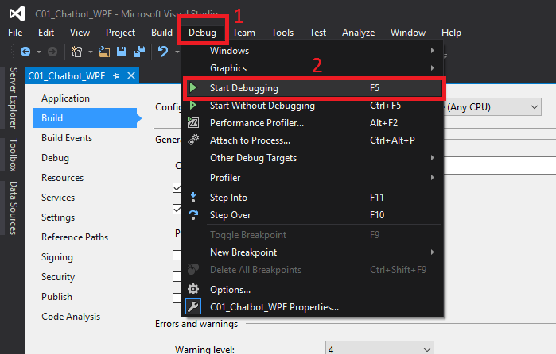

* Wait after nugget packages are loaded. Make sure that the computer has an internet access to successfully load the nugget packages.
* The source code will build and run after following all the process included this SOP. The image below is the software output.

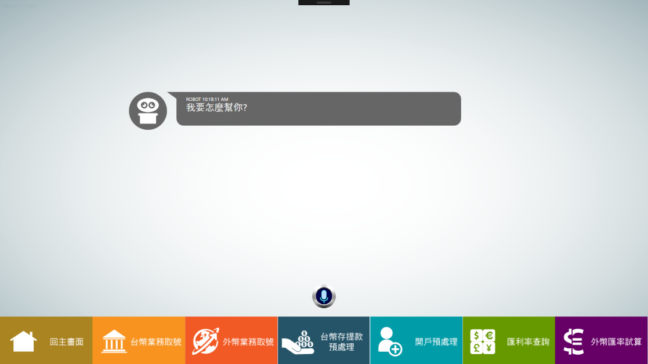

# 6. Change History

| SOP no. | Effective Date | Significant Changes | Previous SOP no. |
| --- | --- | --- | --- |
|  |  |  |  |
|  |  |  |  |
|  |  |  |  |