**React – a view core library**

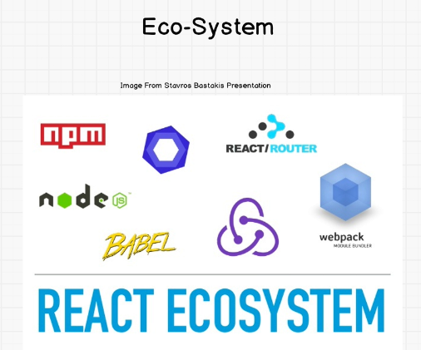

**To start project using REACT**

* Run the command in console/terminal “npm install –g create-react-app”

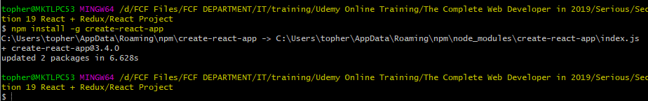

* Now create a project name – “create-react-app robofriends”

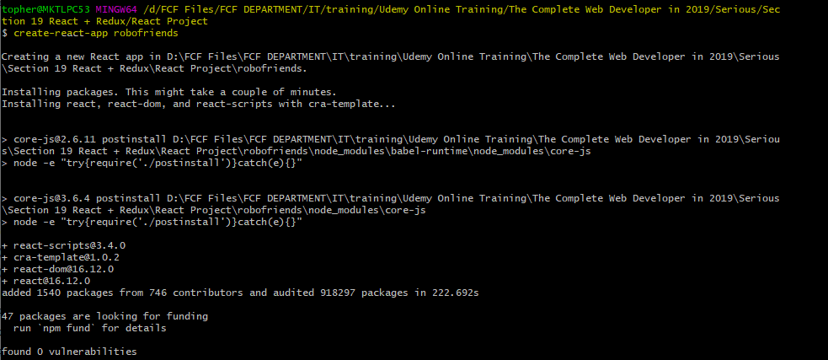

* 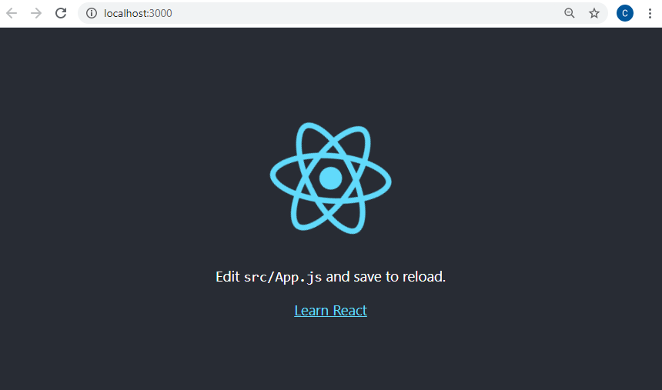Then try to start the NPM to view the react page – “npm start”
* Also the predefined packages were added inside of that folder

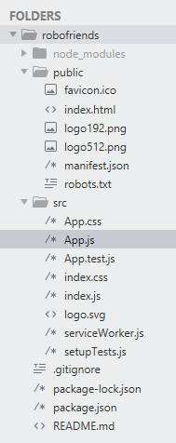

* Also note to always update the react version installed in the project – just use command “npm install” on the termninal
* 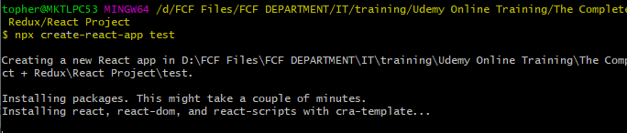Another way to install using new version is – “**npx create-react-app** newproject” take note that the project name strictly use lowercase.

Now go the test project and expand the app.js

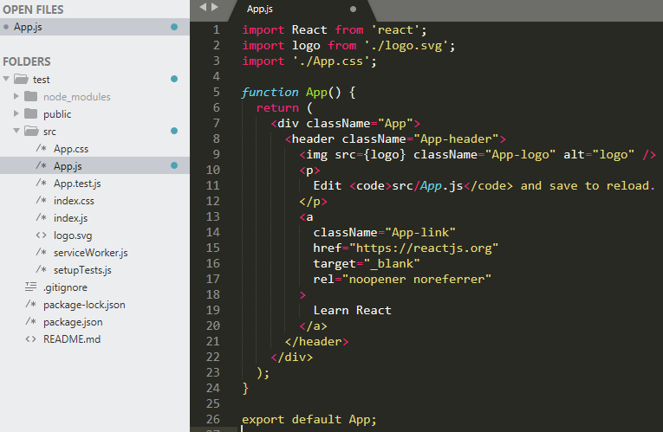

And have it change to

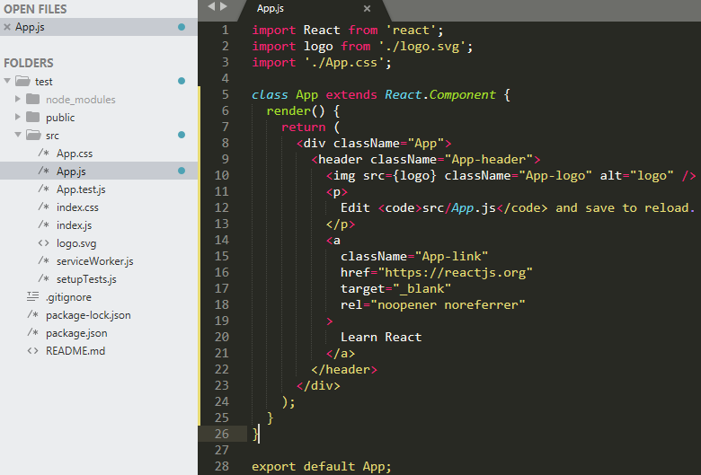

**Build first a component**

* As we run the robofriends project there is an error.

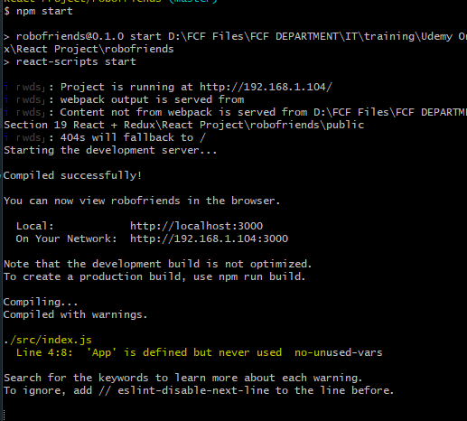

Error seems App.js is defined but never used or no unused vars.

**Installation of tachyons -** It's a collection of small modules that can be mixed and matched or used independently. Create fast loading, highly readable, and 100% responsive interfaces with as little css as possible.



**Verified added in package.json**

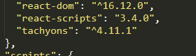

**How to use tachyons** [**http://tachyons.io/docs/typography/text-align/**](http://tachyons.io/docs/typography/text-align/)

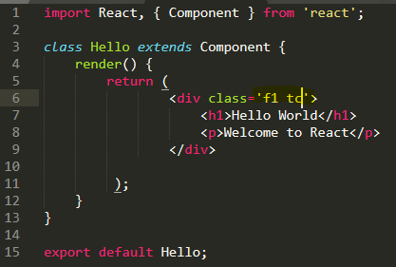

It allows to add command inside of the HTML once the package was imported inside of the component

**Additional Power of React**

* 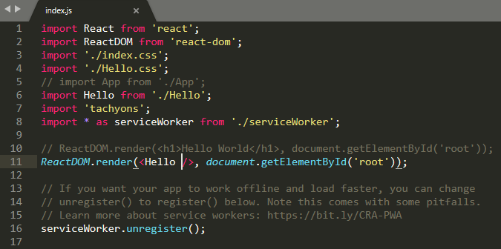We can now able to add properties “props” inside of Hello component

**Create a properties inside of the Hello component**

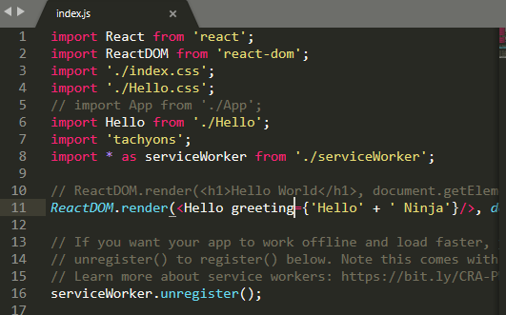

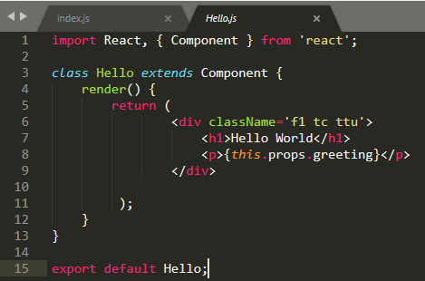

**Output**

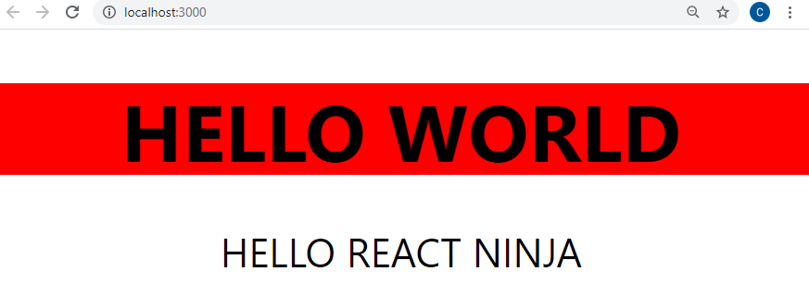

Another is to convert the component into function like this

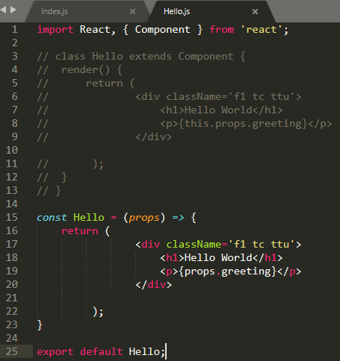

***Important note:***

If we not use “import React from ‘react’;” into the scope, the JSX command will not be work, JSX is like a HTML syntax shown on the image

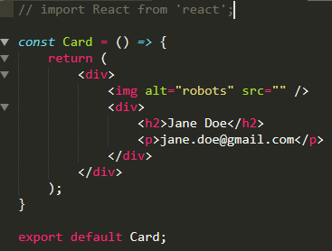

And we will notice this error

