Christopher Villarreal
Module 9 Assignment 2

Test Connection Result
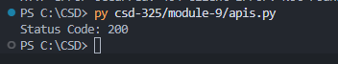

ISS API – Tutorial
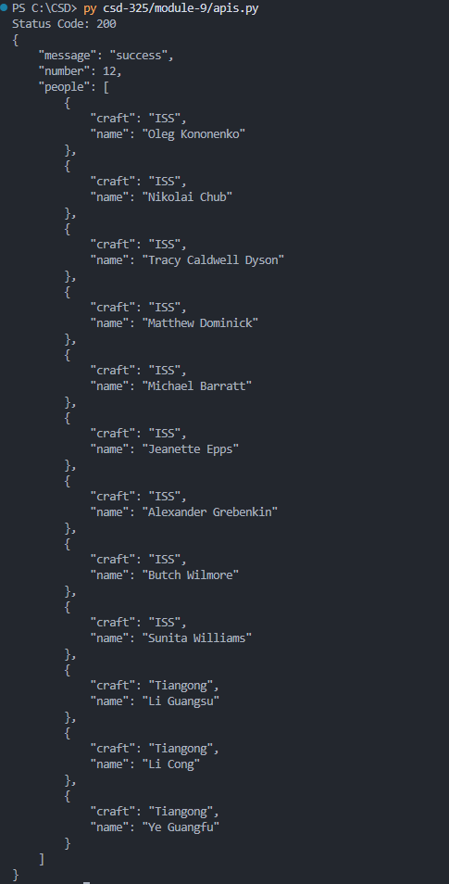
PokeAPI – Raw Output
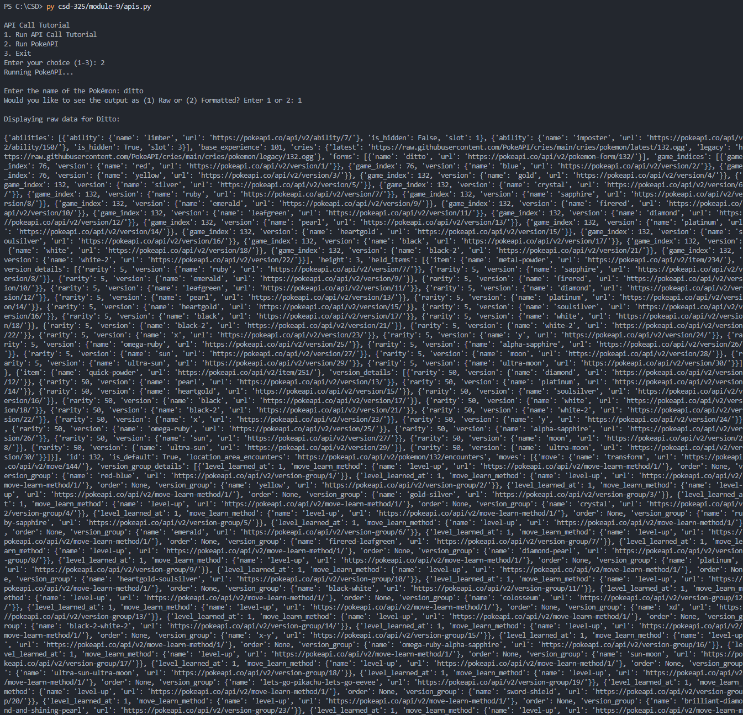

PokeAPI – Formatted Output
