Initial Run
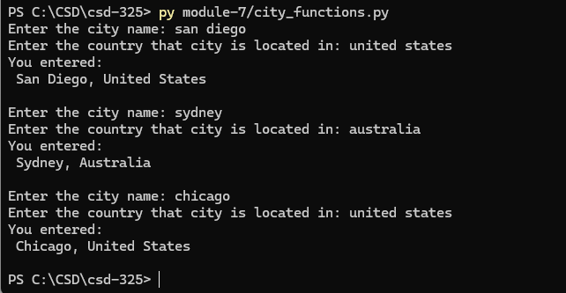
First Unit Test
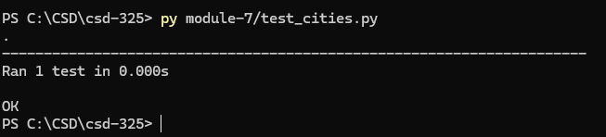
Second Unit Test – Error – Add Population
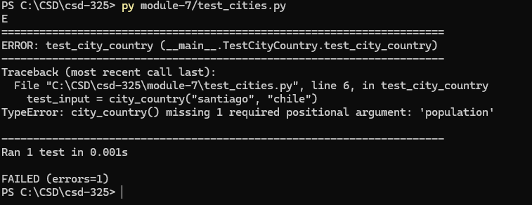
Second Unit Test – Added Population
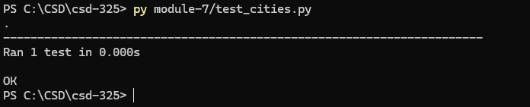
Third Unit Test – Error – Added Language parameter
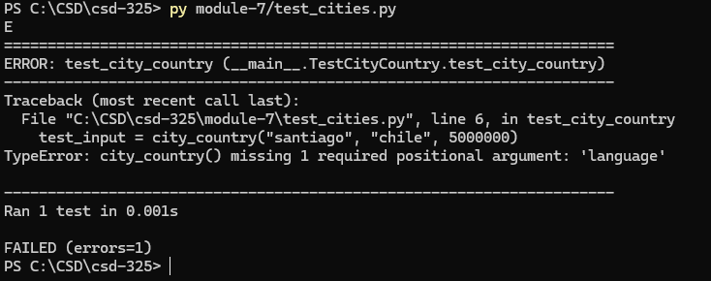
Fourth Unit Test – Updated function
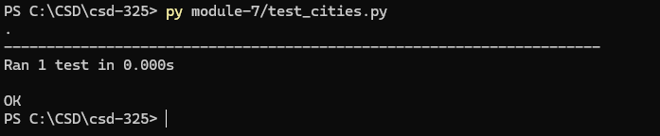

Final Run – 3 Outputs
