Confirmation ‘student.json’ was updated by program
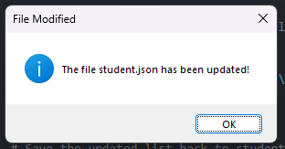
Console output from ‘students.py’
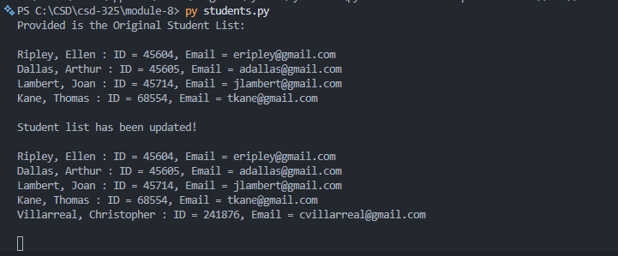
Updated content from ‘student.json’
[
{
"F_Name": "Ellen",
"L_Name": "Ripley",
"Student_ID": 45604,
"Email": "eripley@gmail.com"
},
{
"F_Name": "Arthur",
"L_Name": "Dallas",
"Student_ID": 45605,
"Email": "adallas@gmail.com"
},
{
"F_Name": "Joan",
"L_Name": "Lambert",
"Student_ID": 45714,
"Email": "jlambert@gmail.com"
},
{
"F_Name": "Thomas",
"L_Name": "Kane",
"Student_ID": 68554,
"Email": "tkane@gmail.com"
},
{
"F_Name": "Christopher",
"L_Name": "Villarreal",
"Student_ID": 241876,
"Email": "cvillarreal@gmail.com"
}
]
