Christopher Villarreal
Module 10 Assignment 2
December 5, 2025

Few Tasks Added
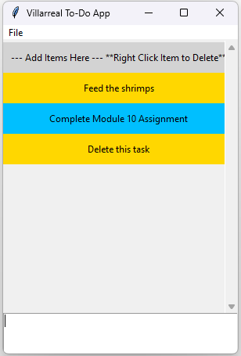
Task Deleted
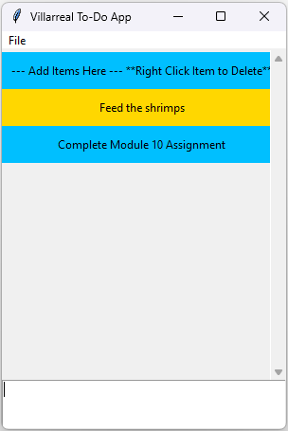
Final look of To-Do App
