Christopher Villarreal
Module 11 Assignment 2

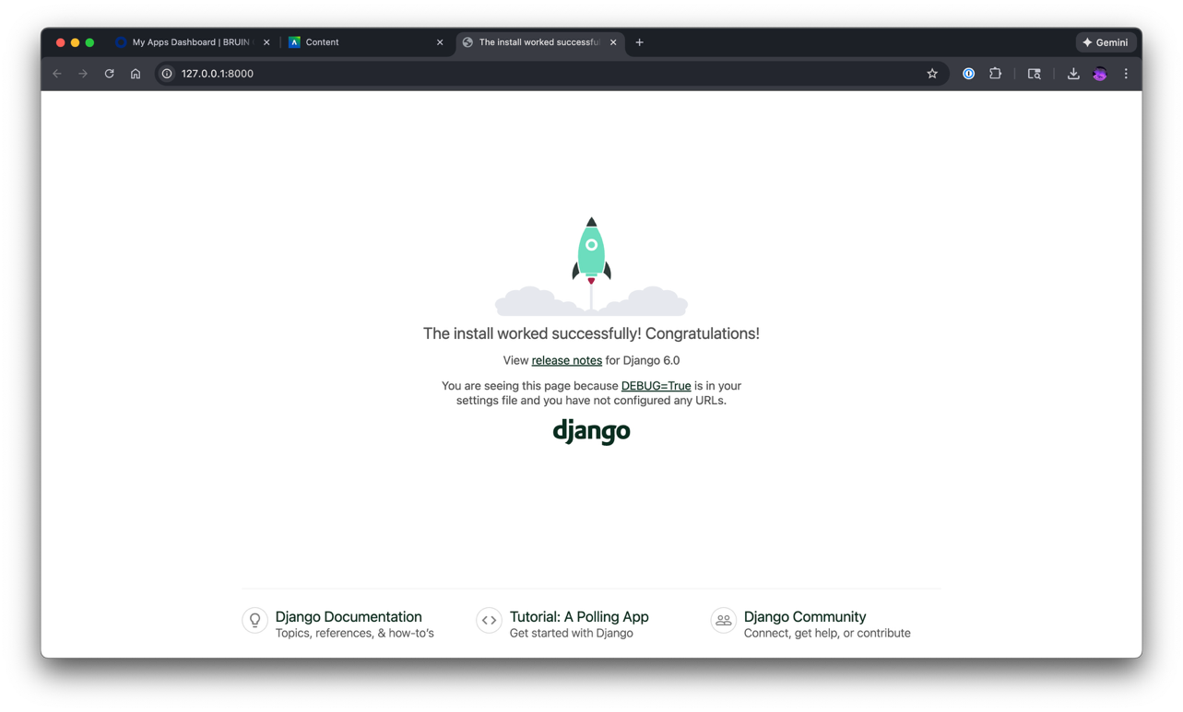
Results from: ‘python manage.py runserver’
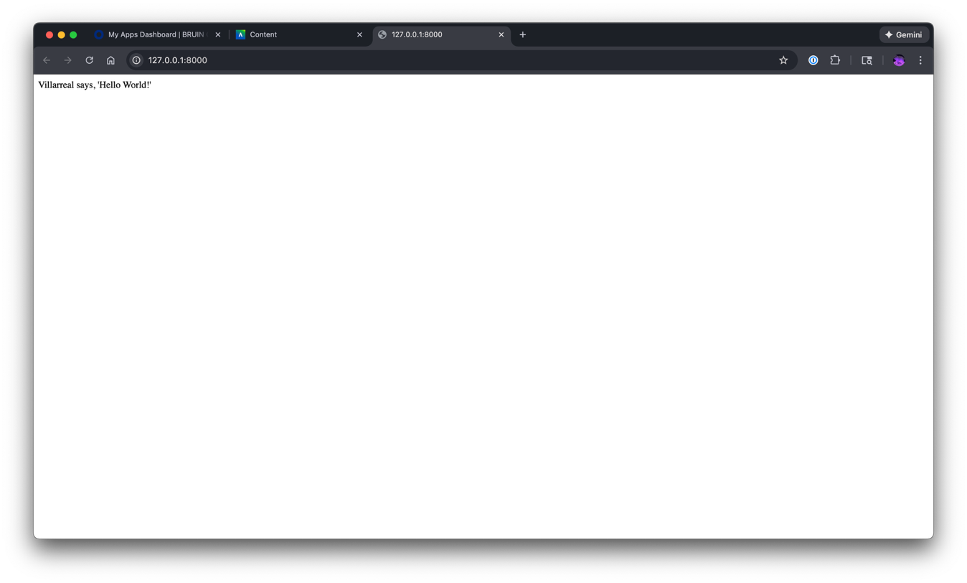
Returning Hello Function

