To complete the test case plan, fill out the information for Project, Course, Description and Date in the header below.

Project: denzlinger_module-4_csd380
Course: CSD-380
Description: Assignment 4.2
Date: 2026/06/28

TABLE OF CONTENTS
<Test 1> 2
<Test 2> 2
<Test 3> 3
<Test 4> 3
<Test 5> 4

For each test, the developer should: provide a test description, a test objective, the developer name and date tested. For each step, fill out the actions to be taken and describe the expected results, and indicate yes or no for each step depending upon the result. The peer tester should provide their name, date tested, indicate yes or no for each step depending upon the result, and a screenshot (thumbnail) of the result.

Test 1 | Task Creation
 | Test Objective: Ensure new tasks can be created. | Developer: Denzlinger  Date tested: 2026/06/28 | Peer tester: Christopher Villarreal  Date tested: 2026/06/28
Step | Action | Expected results: | Developer pass/fail | Tester pass/fail  + Screenshot
1 | Enter text into the "Task Form" input. | Form accepts text | Yes | Yes  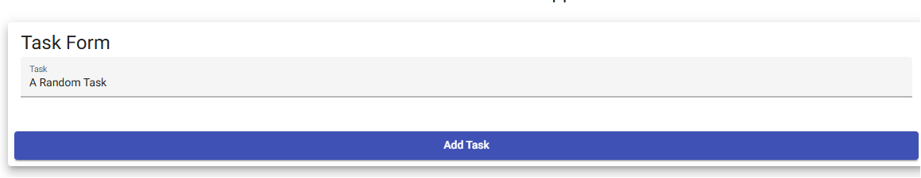
2 | Click the "Add Task" button. | Button responds | Yes | Yes
3 | Attempt to click "Add Task" with an empty input field. | Task appears in the list after valid input; submission is blocked for empty input. | Yes | Yes  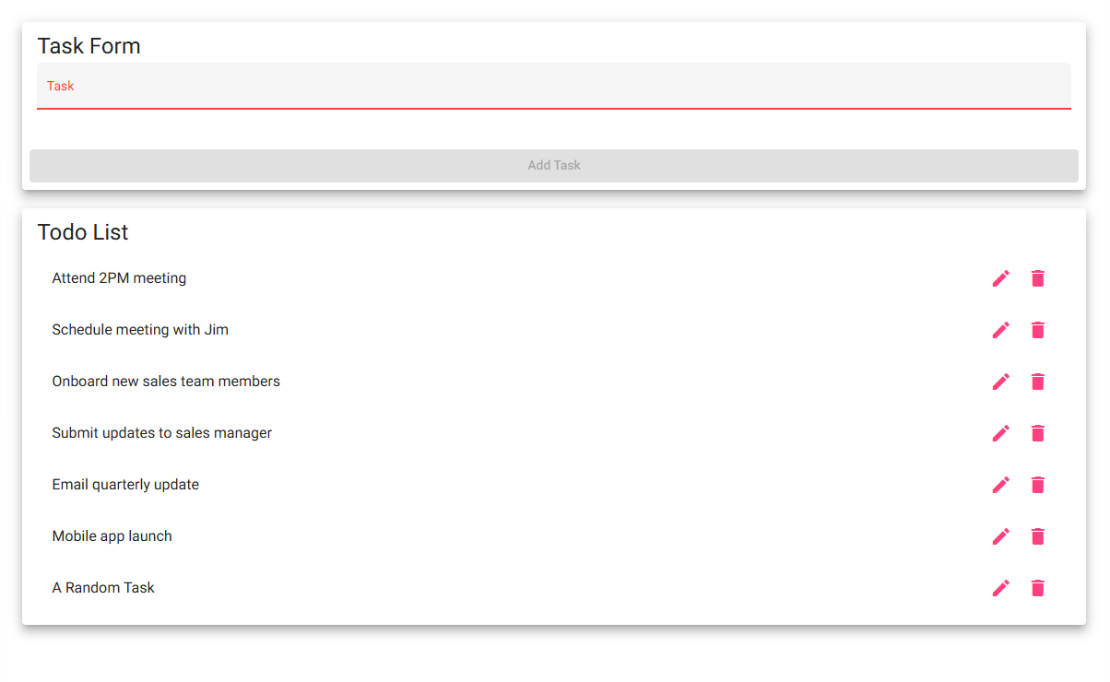
4 | <Enter an action> | <Enter the expected results> | <yes/no> | <yes/no>
5 | <Enter an action> | <Enter the expected results> | <yes/no> | <yes/no>
Comments | Developer: The web page loaded as expected. As text was typed into the form, it was displayed on the screen as expected. “Add Task” button could not be pressed until the 4th character was typed. Add Task button was pressed, and new task populated at the bottom of the screen.  Peer Tester:

Test 2 | Task Deletion
 | Test Objective: Ensure tasks can be removed. | Developer: Denzlinger  Date tested: 2026/06/28 | Peer tester: Christopher Villarreal  Date tested: 2026/06/28
Step | Action | Expected results: | Developer pass/fail | Tester pass/fail
1 | Identify an existing task. | n/a | Yes | Yes  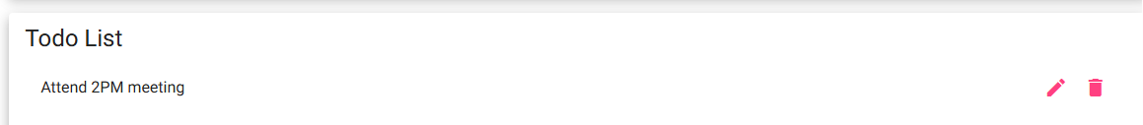
2 | Execute the delete function. | The task is removed from the list view. | Yes | Yes  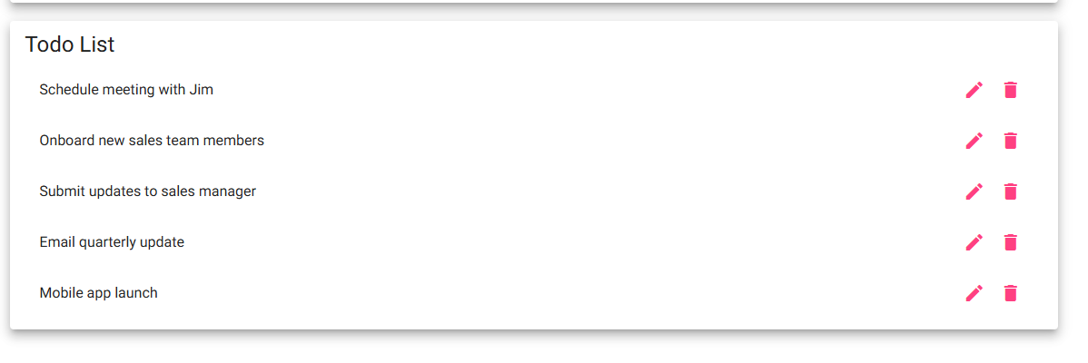
3 | <Enter an action> | <Enter the expected results> | <yes/no> | <yes/no>
4 | <Enter an action> | <Enter the expected results> | <yes/no> | <yes/no>
5 | <Enter an action> | <Enter the expected results> | <yes/no> | <yes/no>
Comments | Developer: The web page loaded as expected. All tasks were visible. Identified a task and clicked the delete icon. Task was removed from list as expected.

Test 3 | Task Editing
 | Test Objective: Ensure existing tasks can be modified. | Developer: Denzlinger  Date tested: 2026/06/28 | Peer tester: Christopher Villarreal  Date tested: 2026/06/28
Step | Action | Expected results: | Developer pass/fail | Tester pass/fail
1 | Access the "Edit Form" for a task. | Edit form displays | Yes | Yes  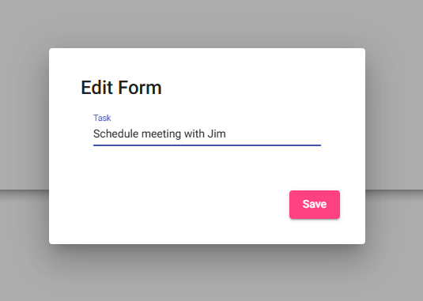
2 | Modify the text and click "Save". | Task is updated with new text | Yes | Yes  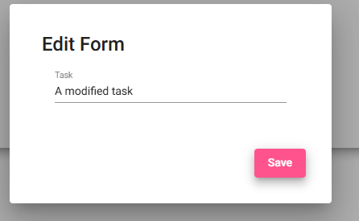
3 | Attempt to save the form with an empty field. | Saving is blocked if input is empty. | No | No  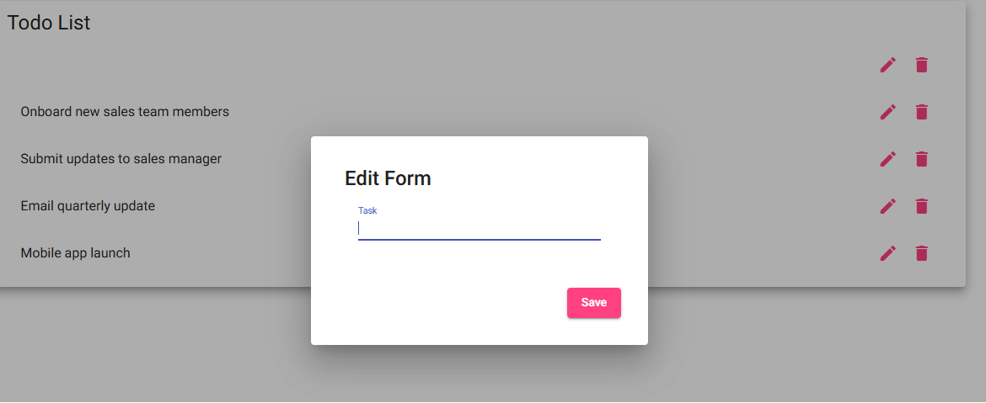
4 | <Enter an action> | <Enter the expected results> | <yes/no> | <yes/no>
5 | <Enter an action> | <Enter the expected results> | <yes/no> | <yes/no>
Comments | Developer: The web page loaded as expected. Clicked on the edit icon and the edit form displayed as expected. Modified the task name and clicked save, and the task saved as expected. Attempted to save the empty form and the save was not blocked. Tests 1 & 2 passed. Test 3 failed.

Test 4 | Environmental & Error Handling
 | Test Objective: Verify application accessibility and error handling. | Developer: Denzlinger  Date tested: 2026/06/28 | Peer tester: Christopher Villarreal  Date tested: 2026/06/28
Step | Action | Expected results: | Developer pass/fail | Tester pass/fail
1 | Navigate to https://buwebdev.github.io/todo/. | Website loads | Yes | Yes  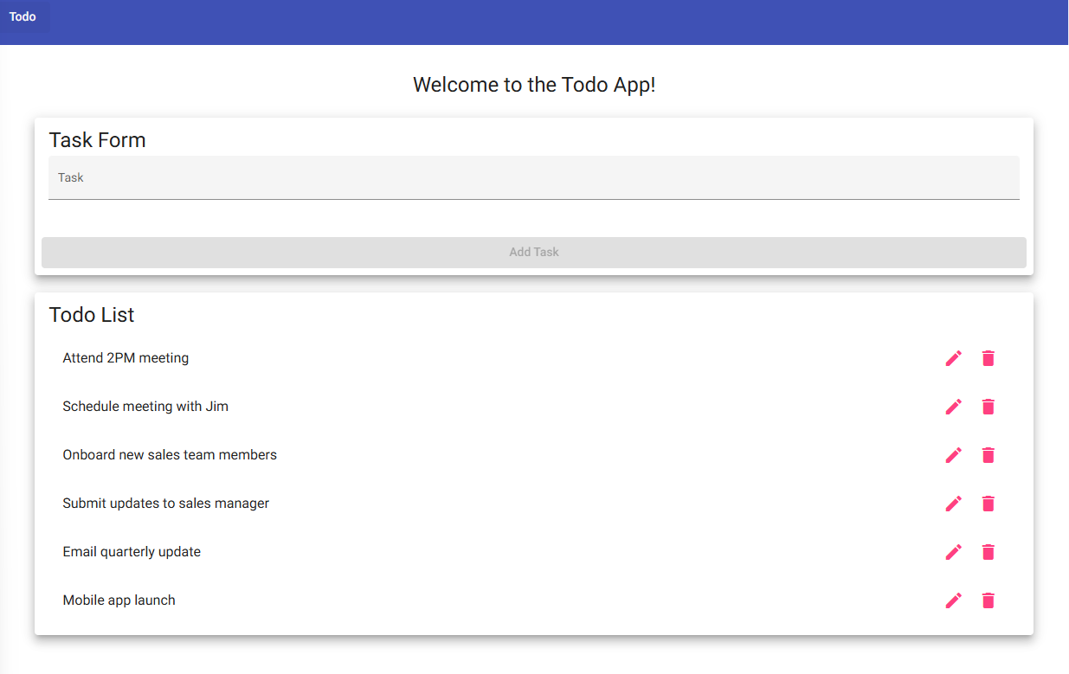
2 | Resize window to simulate mobile and tablet viewports. | Layout adjusts for different devices | Yes | Yes  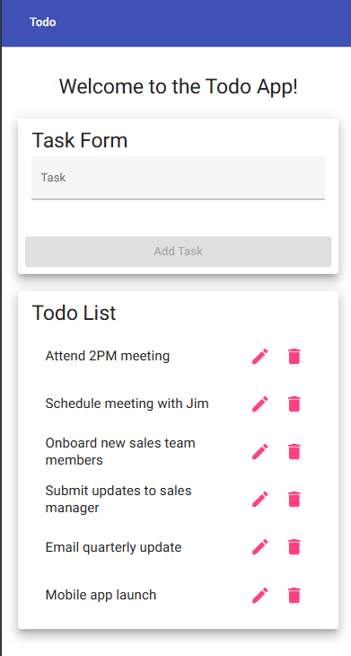
3 | Navigate to an invalid URL path. | Custom 404 page is displayed. | No | Yes  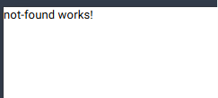
4 | <Enter an action> | <Enter the expected results> | <yes/no> | <yes/no>
5 | <Enter an action> | <Enter the expected results> | <yes/no> | <yes/no>
Comments | Developer: The web page loaded as expected. Checked Tablet 768px, Mobile L 425px, and Mobile M 375px. All resized appropriately. Navigated to https://buwebdev.github.io/todo/1, and did not specifically get a 404 message as outlined in the test plan. Steps 1 & 2 passed, step 3 failed.

Test 5 | List Visibility
 | Test Objective: Verify the user can see their todo items. | Developer: Denzlinger  Date tested: 2026/06/28 | Peer tester: Christopher Villarreal  Date tested: 2026/06/28
Step | Action | Expected results: | Developer pass/fail | Tester pass/fail
1 | Load the landing page. | Page loads. | Yes | Yes  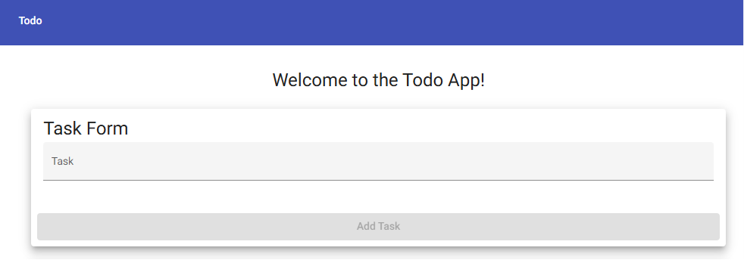
2 | Verify the presence of the "Todo List" section. | All created tasks are accurately rendered on the screen. | Yes | Yes  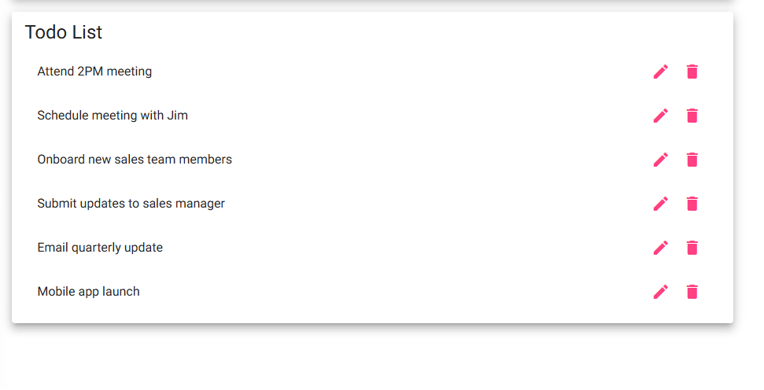
3 | <Enter an action> | <Enter the expected results> | <yes/no> | <yes/no>
4 | <Enter an action> | <Enter the expected results> | <yes/no> | <yes/no>
5 | <Enter an action> | <Enter the expected results> | <yes/no> | <yes/no>
Comments | Developer: The web page loaded as expected. All tasks displayed as expected. Steps 1 & 2 passed.

