Value Stream Mapping (VSM)
Villarreal, Christopher
Bellevue University, CSD380 DevOps
Module 5 Assignment 2
July 5, 2026

Value Stream Mapping (VSM)

Value Stream Mapping PNG (Canva)
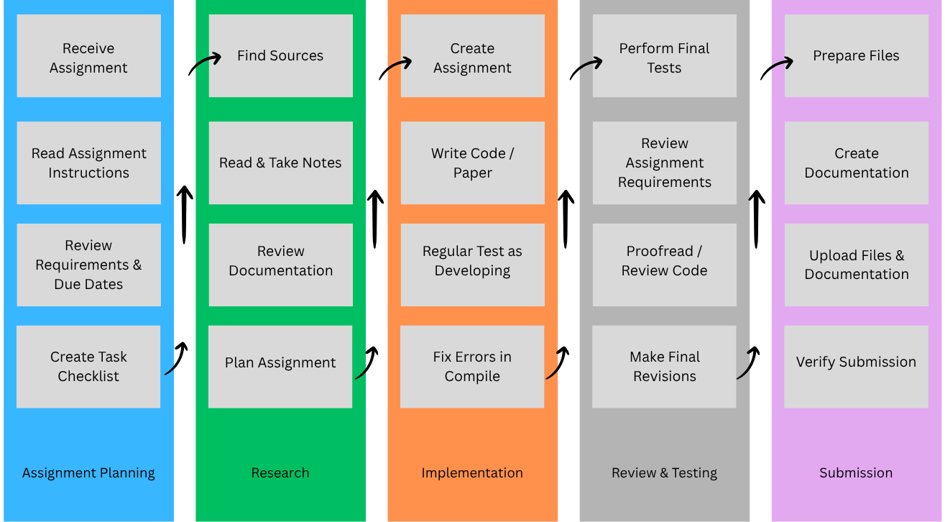

Analyzing Lean Metrics

Estimated Average Flow Time
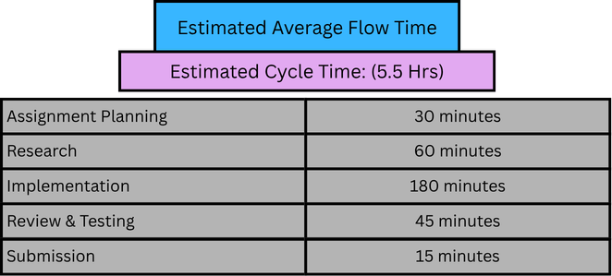

Optimizing the Process

Eliminating Waste
One way I can improve my assignment process is by reducing unnecessary work before I begin. Carefully reading the assignment instructions and grading rubric first helps prevent spending time on research or features that are not required from the assignment itself. I can also keep reusable templates for documentation and project setup, which allows me to spend more time on completing the assignment instead of recreating the same files each week. Testing my work throughout development instead of waiting until the end also reduces the amount of time spent debugging multiple issues at once.

Workflow Orchestration
Breaking the assignment into smaller stages helps keep the workflow organized and prevents rushing close to the deadline. For example, I can dedicate one session to planning and research, another to implementation, and a final session to testing and submission. Following this sequence makes it easier to stay focused on one task at a time while ensuring each stage is completed before moving to the next.

Governance Models
To maintain consistency, I can use a checklist that includes reviewing the assignment requirements, verifying documentation, testing the completed work, and confirming that all required files have been uploaded before submitting. Using Git is already advised for submitting class assignments, but it also helps to save progress throughout development also provides version control, making it easier to recover previous versions if a mistake is introduced. These practices help improve organization and reduce the chance of submitting incomplete or incorrect work.

