GitHub Repository Setup
Villarreal, Christopher
Bellevue University, CSD402 Java for Programmers
Module 1 Assignment 1.2
January 17, 2025

GitHub Repository Setup

Link to GitHub Repository
https://github.com/tophervill/csd-402
Screenshot of GitHub Repo Landing Page:
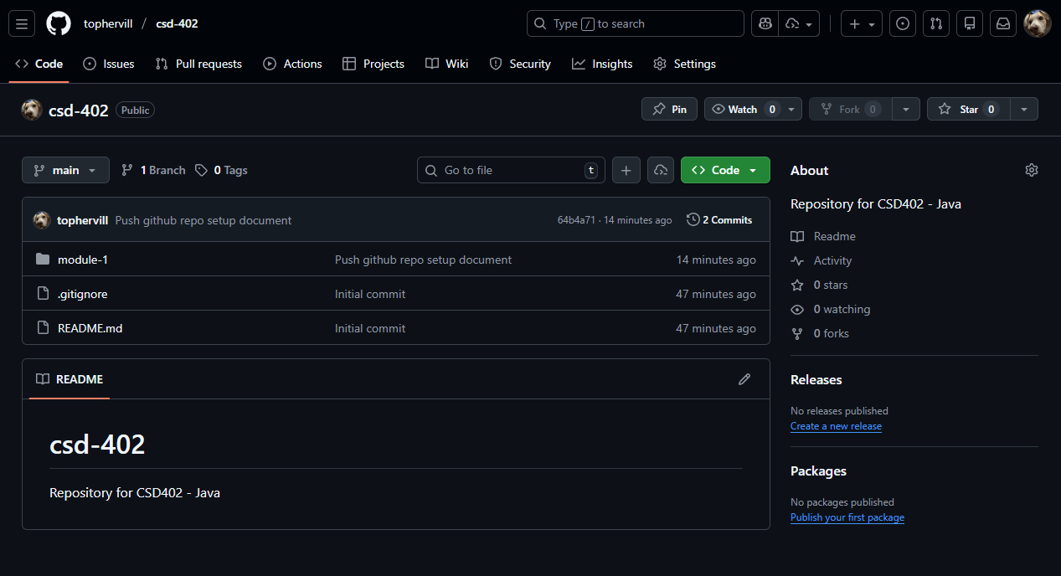
Screenshot of ‘dir’ result:
