Random Cards Display
Villarreal, Christopher
Bellevue University, CSD420 Advanced Java Programming
Module 1 Assignment 3
March 29, 2026

Random Cards Display

Java Installed Validation
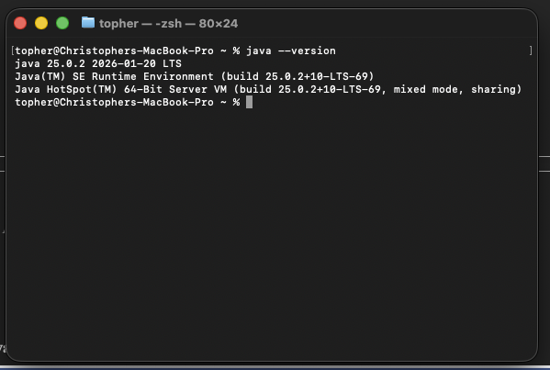

JavaFX Validation
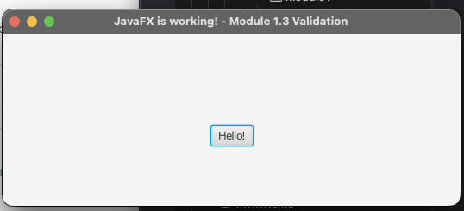

Program Startup
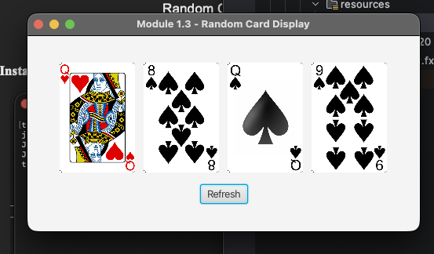

Program after ‘Refresh’ button is clicked
