Read & Write Java Program
Villarreal, Christopher
Bellevue University, CSD420 Advanced Java Programming
Module 2 Assignment 2
April 5, 2026

Read & Write Java Program

Comments
None.

Execution of ReadData.java without File Existing

Execution of WriteData.java – Two Times
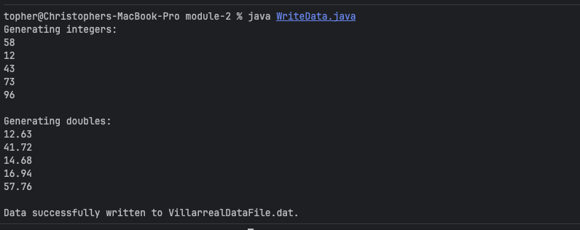
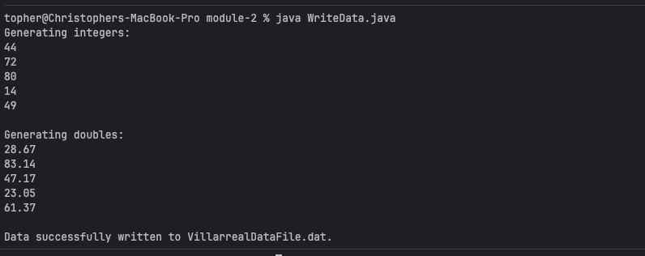

Execution of ReadData.java
