**Project Workflow**

*Repo for LAANC: --- git clone* [*https://github.com/edgar-munoz-aeronyde/LAANC.git*](https://github.com/edgar-munoz-aeronyde/LAANC.git) *---*

**Step One:** Review the following links to get a background of what the project entails and the purpose of the app.

[Low-Altitude Authorization & Notification Capability (LAANC)](https://www.faa.gov/uas/programs_partnerships/uas_data_exchange/) - It enables drone pilots access to controlled airspace near airports through near real-time processing of airspace authorizations below approved altitudes in controlled airspace.

[FAA UAS Facilities Maps](https://www.faa.gov/uas/request_waiver/uas_facility_maps/)- UAS Facility Maps show the maximum altitudes around airports where the FAA **may** authorize part 107 UAS operations without additional safety analysis. [The maps](https://www.faa.gov/exit/?pageName=The%20maps&pgLnk=https%3A%2F%2Ffaa%2Emaps%2Earcgis%2Ecom%2Fapps%2Fwebappviewer%2Findex%2Ehtml%3Fid%3D9c2e4406710048e19806ebf6a06754ad) should be used to inform requests for part 107 airspace authorizations and waivers in controlled airspace.

[Global UTM Association (GUTMA) - is a non-profit consortium of worldwide Unmanned Aircraft Systems Traffic Management (UTM) stakeholders. Its purpose is to foster the safe, secure and efficient integration of drones in national airspace systems. Its mission is to support and accelerate the transparent implementation of globally interoperable UTM systems. GUTMA members collaborate remotely.](https://gutma.org/)

[Aeronyde](https://www.aeronyde.com/) - We build systems for autonomous vehicles to fly safely and securely in urban areas. Our work provides flexible infrastructure for aerial logistics, transportation, and data collection. Our system makes autonomous flight safe, secure, and scalable by giving our unmanned aerial vehicles (UAVs) the intelligence to make the right choice in the right moment.

* Real-time data analysis to contextually apply sequencing, tasking, local environment, and weather.
* Machine learning to build situational awareness.
* Live flight and testing in our research and development centers.

**Step Two:** Establish roles & responsibilities

Project Manager:

* Planning Project Resources
* Time Management
* Monitoring Progress
* Quality and Satisfaction

Front-End Teams:

* Design
* HTML
* CSS
* User-interface (UI)

Back-end Teams:

* Development of all server-side logic
* Optimization of the application by using Airmap’s API
* Ensure high performance and responsiveness to requests from the front-end
* User-experience (UX)

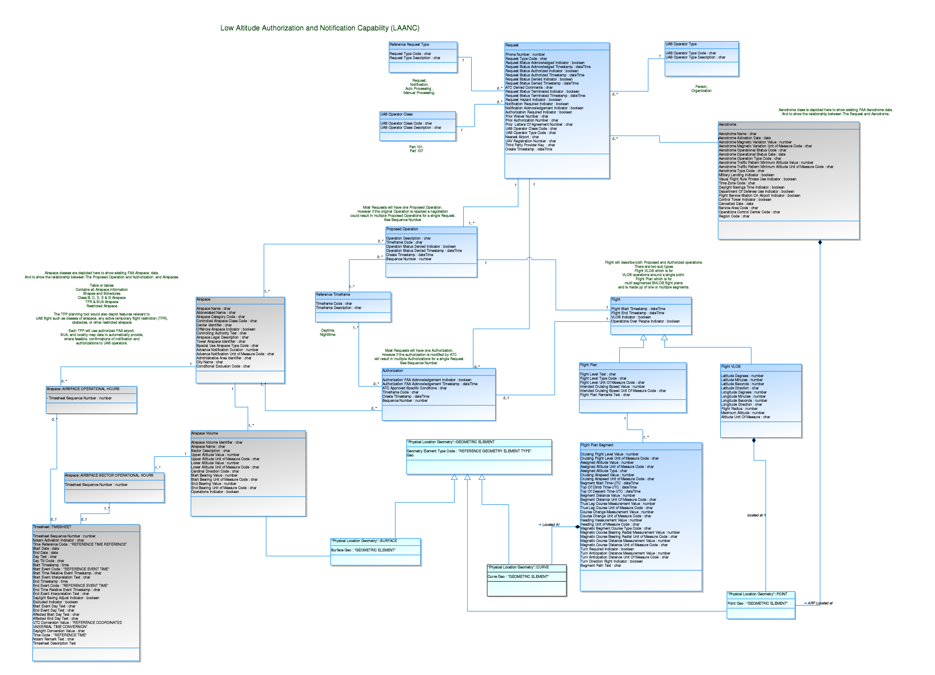**Step Three:** Review through schema

**Step Four:** Create goals and objectives

*\*\*\*This can be decided at our first meeting together.\*\*\**

**Step Five:** Scheduling & Timeline

For quick software projects many organizations (including Aeronyde), use the [Agile Sprint Process Planning](https://www.scrum.org/resources/what-is-sprint-planning).

Sprint planning is a timeboxed working session that lasts roughly 1 hour for every week of a sprint. In sprint planning, the entire team agrees to complete a set of product backlog items. This agreement defines the sprint backlog and is based on the team’s velocity or capacity and the length of the sprint.

Before each sprint process, we must define acceptance criteria. Acceptance criteria are the conditions that a software product must satisfy to be accepted by a user, customer, or in the case of system level functionality, the consuming system.

Acceptance Criteria are a set of statements, each with a clear pass/fail result, that specify both functional and non-functional requirements, and are applicable at the Epic, Feature, and Story Level. Acceptance criteria constitute our “Definition of Done”, and by done I mean well done.

We’re not talking about horseshoes here, and there is no partial acceptance: either the acceptance criteria are met or not.

*\*\*\*Actual schedules and timeline will be defined at our first meeting together.\*\*\**