**PRODUCT DESCRIPTION IN ENGLISH**

1. **Login page interface**

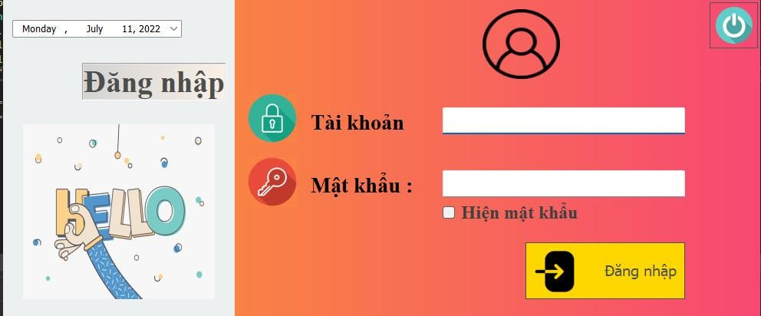

This is considered as the most important step to log in to the system, in this login system only the shop owner and employee will be logged in, using the account that the store owner has created for the employee, each shift employee will log into the system to proceed with Ordering, Menu interface, homepage, payment...

At this interface we will have the login function with password and account, when we enter the wrong account and password, the system will notify us "Incorrect account and password, please re-enter", if successful login the software will notify the user "You have successfully logged into the system".

**Functions of the Login page:**

* Input box to login with Account
* • Input box to login with Password
* • Function to show password
* • The “Login” button confirms the account is logged in with the account and password

1. **Software interface after successful login**

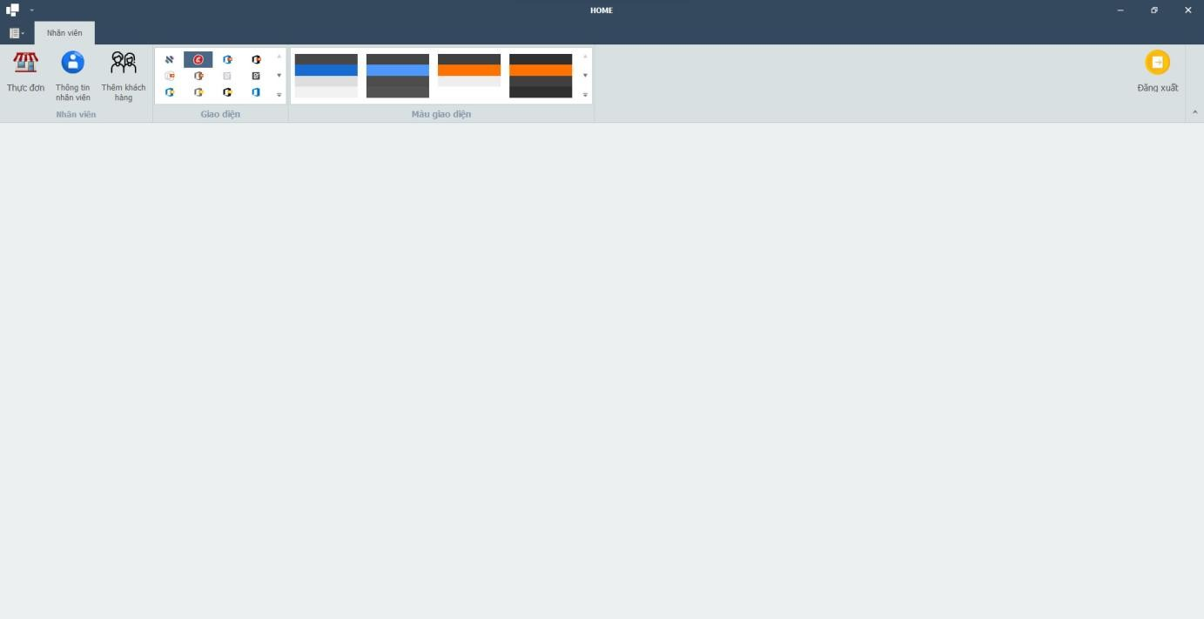

After successful login, the system will move to the Home page, making it easy for users to manipulate, where employees or shop owners will be shown the entire Teamo milk tea shop management software system such as:

* Menu menu
* • Employee Information
* • System interface
* • Interface menu
* • Logout function

On this page, employees and store owners can operate on all different words such as Manipulating the Menu Menu when there is a customer Order, confirming the invoice and printing the bill, managing all employee information, shifts, working hours of that employee at the store, managing the restaurant's sales statistics, number of cups sold, revenue statistics.

**Functions of the system interface page:**

* • Menu menu items on the interface
* • Display employee information
* • More loyal customers
* The “Log Out” button helps users log out of the system easily

1. **Menu page menu and payment system at Teamo Milk Tea Shop**

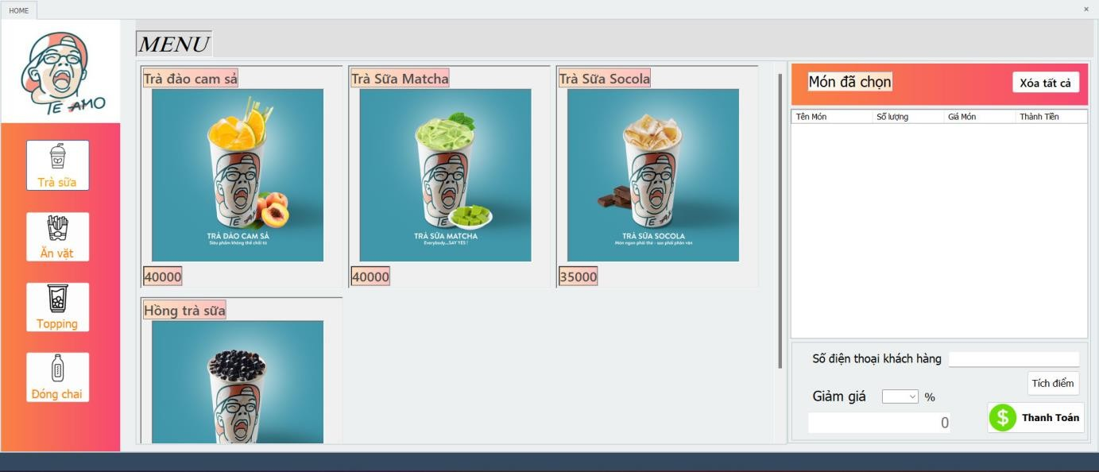

When the employee successfully logs in with the employee code, the system will switch the employee into a successful login state and allow the employees who successfully log in to have full control over the system.

When a customer orders milk tea, the staff at the store will click on the Menu item, select Milk Tea, the system will receive the employee's actions and will process and display the Milk Tea menu for the staff to help the staff operate quickly and receive the customer's requests in the fastest way.

Similarly, when a customer has a request to order snacks, extra toppings or bottled milk tea, the staff will select the corresponding items, the system will receive and display all the actions of the staff.

At the menu menu when customers order drinks, snacks, toppings, bottled drinks, the right side of the screen will display what the customer has ordered to help staff easily re-read the invoice for the customer, avoid errors, here the staff can delete the item if the customer needs to change the item, when receiving the customer's order, the system will charge the customer's items the easiest way to make the order and make the payment.

For loyal customers, they will be given discount codes, here the system will directly give discounts to customers when they come to buy milk tea and the staff will directly enter the discount code into the system, the system will process and proceed to output the total amount when entering the discount code.

**Interface function:**

* • Display the menu of the dishes available on the system when the user requests it
* Displaying images of items on the system to help users avoid mistakes as much as possible
* The system pays and charges directly when the user has received the customer's request.

1. **Employee information page interface when logging in**

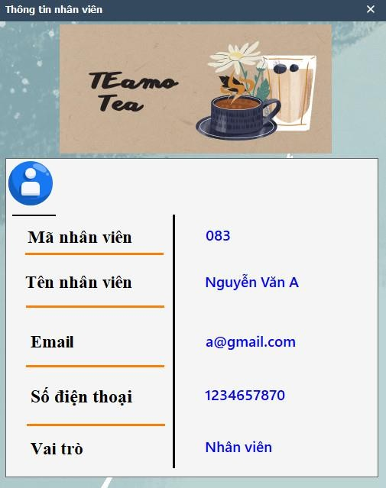

This is the employee interface, here will display all employee information including: Employee ID, Employee Name, Email, Phone Number, Role at the store. At the interface on the shop owner will be able to easily control the employee at the shift, easily calculate the salary, calculate the number of hours worked by that employee in 1 shift. When an employee prints an invoice for a customer, the employee's name will appear in the shift when that employee works at the cashier counter and logs into the system.

**Interface functionality:**

* • Display all employee information at shift
* •Each employee will be added by the store owner when the employee is allowed to work at the store

1. **Interface of Manage Add, Delete, Edit dishes on Menu**

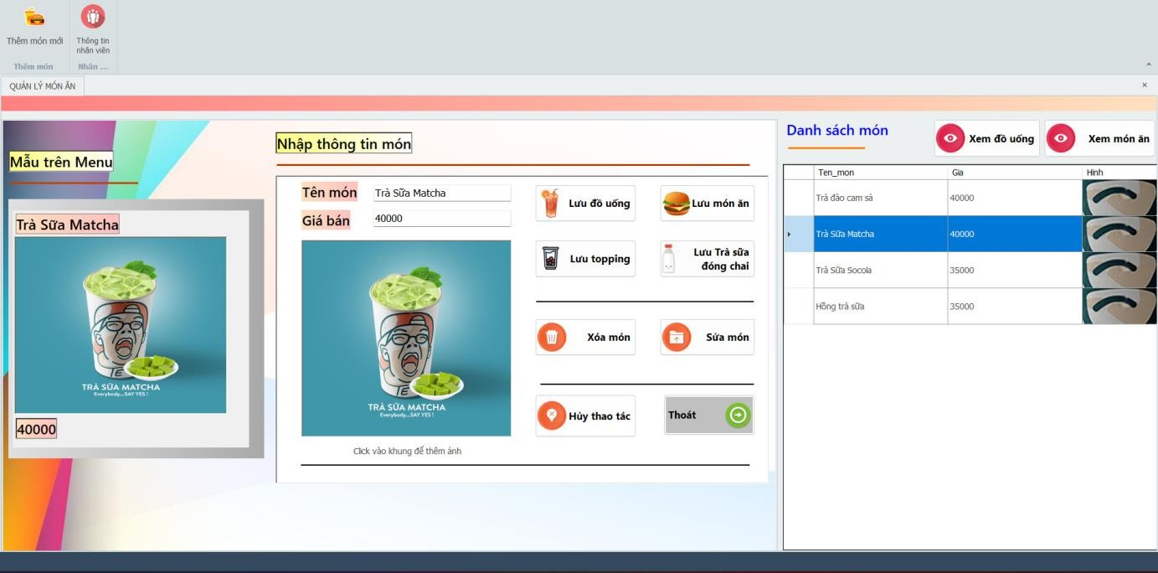

At the interface on the shop owner and staff will be able to add, delete and edit menu items. Only employees who receive a request from the store owner can use the above operations. After working with the add, delete, edit function, the staff and the store owner will proceed to save the item depending on that item such as saving drinks, saving dishes, saving toppings, saving bottled milk tea, after performing the operation to save saved items will appear on the Menu interface.

Items deleted by staff and shop owners will be removed from the System Menu. Particularly for items that are priced, edited, or edited, the image will be updated on the system with a new name, new price, and new image depending on the request.

When we do not use the operation, the staff or shop owner will be able to cancel the operation and exit the above system.

**Interface function:**

* • The “Add” button helps users to add new items to the system
* • The “Delete” button allows the user to delete the item from the system
* • The “Edit” button allows users to edit all items, prices, and images in the system.
* • Click "Save" button when the user performs the "Add, delete, edit" and press the save button, the system will process and follow the user's request.
* • The "Cancel operation" button will help users cancel all operations being performed on the system in the fastest way.
* After performing the operation successfully, the user can review the drinks and food he has performed to avoid errors.

1. **Employee information management page**

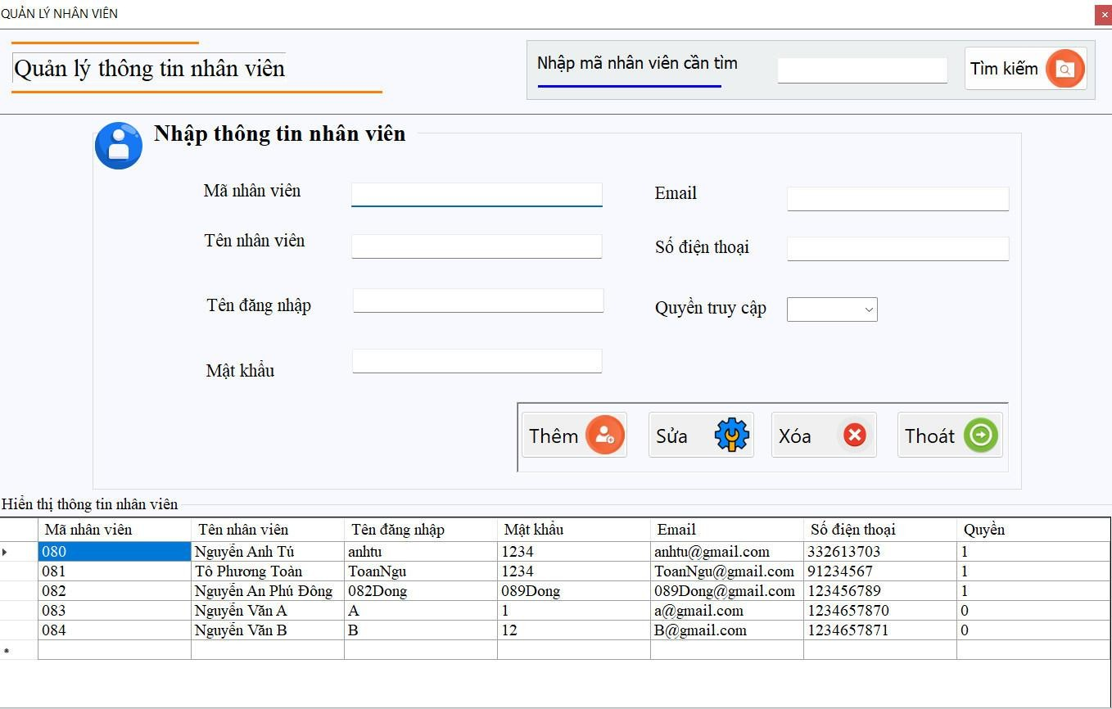

At the interface on the store owner will be manipulated with the functions of Add, Delete, Edit, Search, Exit.

The store owner wants to add a new employee, he will enter the employee code, employee name, login name, password, email, phone number, access rights and manipulate with the Add button, here the system will receive and process then notify the employee has been added successfully. Similar to the add operation, the delete and edit operation will be similar.

When the store owner wants to search for 1 employee information at the store, he will proceed to enter the employee code at the store, then the system will output the employee with the employee code that the store owner needs to find.

**Interface functionality:**

* • Users can add, delete, edit, search, exit on the employee information management page.
* Input employee code, employee name, login name, password, Email, phone number, access right will be done successfully when the user fully enters and uses the add, delete, and edit buttons, and then outputs the datagridview of the operations he has just performed.
* Employee search input will help users to quickly find employees when entering employee code, the system will process and output the employee code that the user needs to find.

1. **Customer loyalty page interface**

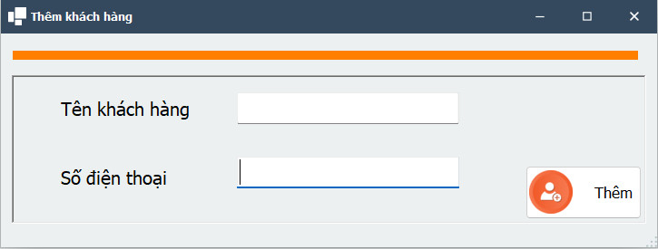

Customers who come to Teamo Milk Tea will be favored with a loyalty program when buying milk tea and accumulating enough points, staff will perform the operation of entering customer names, phone numbers and adding customers to the loyalty system to receive many incentives.

**Interface function:**

* Input customer name
* Input phone number
* The “Add” button only works successfully when the user enters the full customer name and phone number.

1. **Admin page interface**

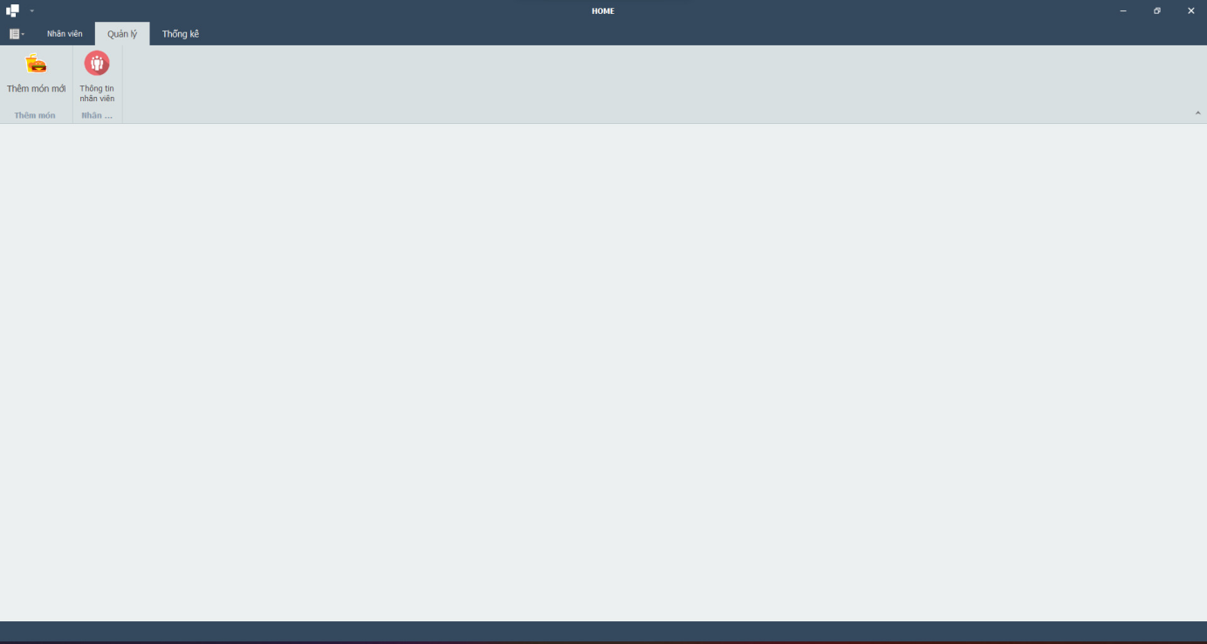

At the Admin management interface page, only users such as shop owners or managers will be given an Admin code to use for full control on the system.

**Interface function:**

* • The button “Add new dish” will go to the “Add dish” interface page when Admin works.
* The button "Employee Information" will move to the "Employee Information" interface page when the Admin works.

1. **Statistical management page interface of Admin**

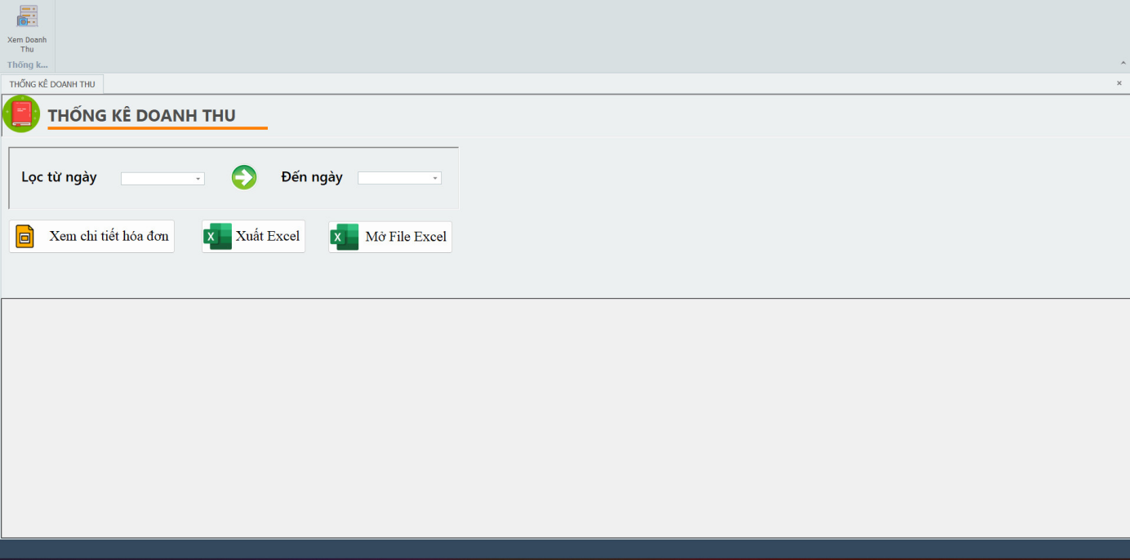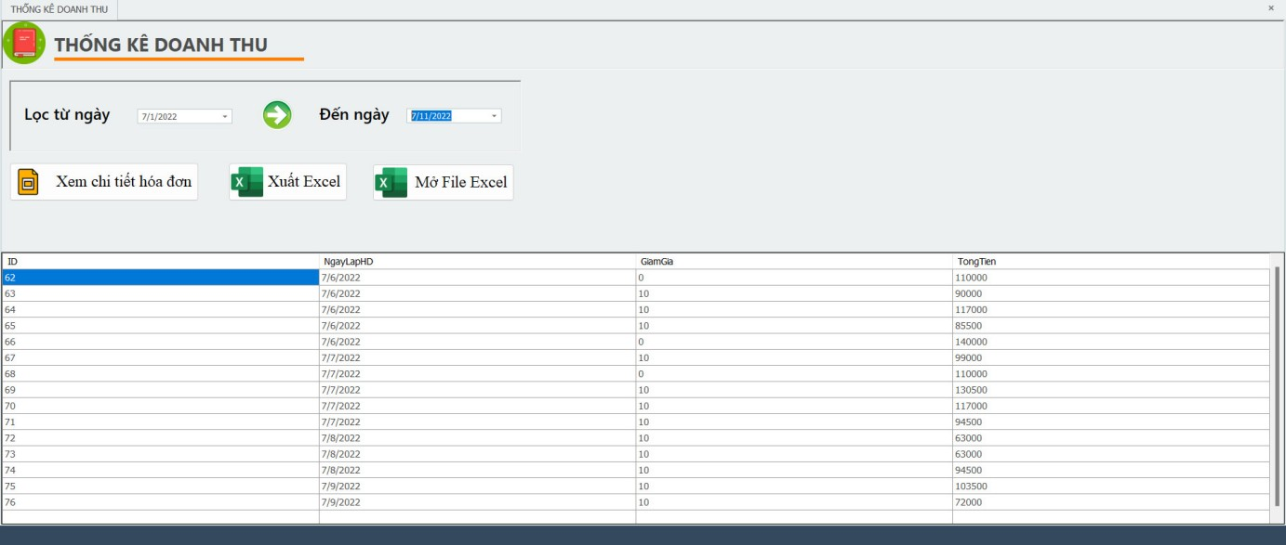

Coming to the interface "Manage Admin's statistics" Admin will have full rights to view the restaurant's revenue statistics for all days.

Employees after each shift will close the shift according to the revenue statistics and export the Excel file of that shift.

Employees and Admins will be able to see the details of all sold invoices by entering the Id, NganlapHd,GiamGia,Tongtien codes when necessary.

**Interface functionality:**

* Input filter from date to input to date when the user enters the date to find the system will process and output on the screen
* The button "View invoice details" will output the screen of the sold invoices according to the user's filtering requirements.
* Click "Export Excel" button, after each shift, the employee will close the shift and export the Excel file to the store owner.
* The button "Open Excel file" helps employees and store owners to open Excel files in the fastest way without taking too much time.

1. **Detailed invoice page interface**

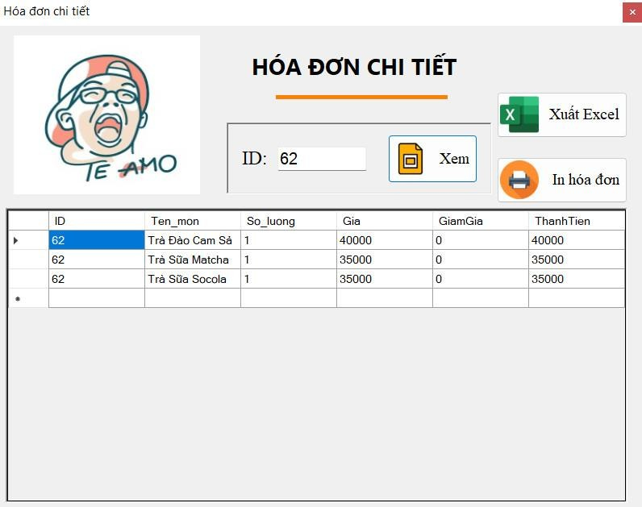

After the user wants to review the detailed invoice, he will enter the ID code of each invoice, then the system will output the screen of the invoice ID to find, the invoice will be exported to Excel file and printed if the customer requests it.

**Interface function:**

* ID search input helps the system to process and search that invoice by ID in a neat way.
* Click the “View” button after searching, the invoice is coded with the user ID, allowing you to review the items you have sold.
* The button "Export Excel file" will export the Excel file if the customer requests it or the user wants to see it.
* Click "Print Invoice" button after exporting Excel file, user can "Print invoice" from Excel file.

1. **The interface of the restaurant's Report page**

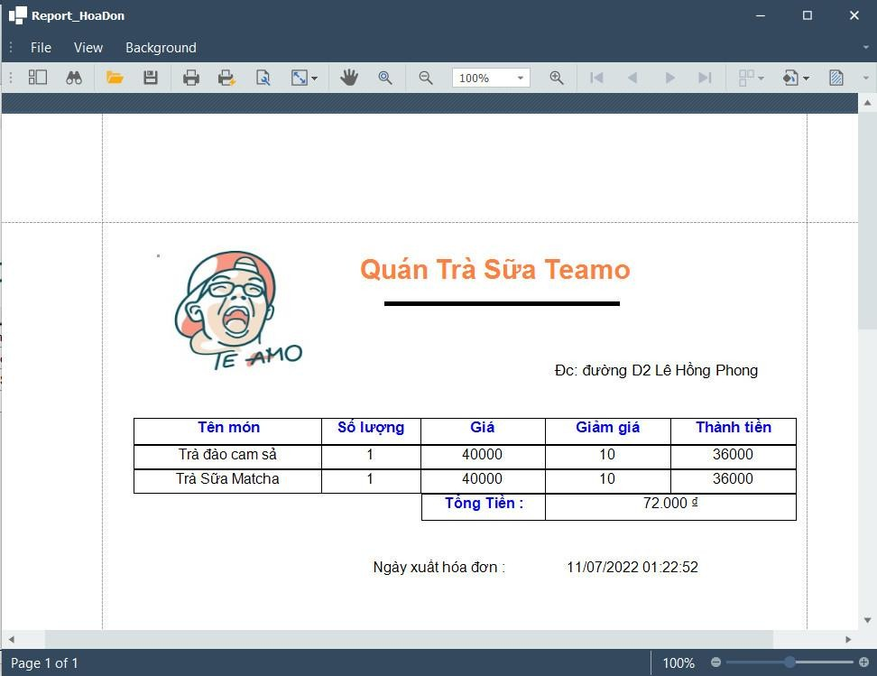

Report page after receiving the customer's request, the staff will proceed to read the invoice and print the invoice for the customer. On the invoice, there will be a logo with the image of the shop, the name of the restaurant, the address, the name of the dish, the quantity of the item, the price, the discount, the amount, the date and the invoice to help customers know what they have requested.

**Interface function:**

* Print invoices for customers.