Check_data_integrity

Tobias Opialla

9/27/2019

***Nothing conclusive that would explain the huge shifts in CA-intensity by treatment or handling bias from experimental design or sample clean up.***

## -- Attaching packages -------------------------------------------------------------------------------- tidyverse 1.2.1 --

## v ggplot2 3.2.1 v purrr 0.3.2  
## v tibble 2.1.3 v dplyr 0.8.3  
## v tidyr 0.8.3 v stringr 1.4.0  
## v readr 1.3.1 v forcats 0.4.0

## -- Conflicts ----------------------------------------------------------------------------------- tidyverse_conflicts() --  
## x dplyr::filter() masks stats::filter()  
## x dplyr::lag() masks stats::lag()

# cinnamic acid

df_cinnamic=read.csv('./outputfiles_20190914/cinnamic_acid_09-14-2019_19-54-24/matrices/quantMassAreas_cinAcidNormMatrix.csv',stringsAsFactors = F)  
df_sample_metadata=read.xlsx("../Sample_overview.xlsx",sheet = "Sample_overview",rows=1:37) #row 38:43=Testsamples  
  
df_cinnamic=gather(df_cinnamic,key = "file",value = "AUC",-Metabolite,-QuantMasses)  
df_cinnamic=df_cinnamic %>% mutate(  
 injection_no=str_replace_all(file,".*_to_(\\d{3})_.*","\\1") %>%   
 as.numeric(),  
 sample_no=str_replace_all(file,".*_to_\\d{3}_(\\d{2})_.*","\\1") %>%   
 as.numeric(),  
 MG_treatment=ifelse(str_detect(file,"_MG_"),"MG","noMG"),  
 Carbon=str_replace_all(file,".*_(C1[23])_.*","\\1"),  
 labelling_time=str_replace_all(file,".*_(\\d+min)_.*","\\1"),  
 labelling_time_num=str_remove_all(labelling_time,"min") %>%  
 as.numeric(),  
 Replicate=str_replace_all(file,".*_(R\\d)..*","\\1"),  
 Replicate_num=str_remove_all(Replicate,"R") %>% as.numeric()  
)  
  
df_cinnamic=left_join(df_cinnamic,df_sample_metadata %>%  
 select(corrected.SampleNo.Fabiola,  
 cellnumber.according.to.conditions,  
 derivatization.same.MeOX.as.Ident.and.Quant),  
 by=c("sample_no"="corrected.SampleNo.Fabiola"))  
  
p=ggplot(df_cinnamic,aes(x=injection_no,y=AUC))+  
 scale_fill_viridis_d()+  
 scale_x_continuous(breaks = seq(0,65,5))+  
 geom_hline(yintercept = mean(df_cinnamic$AUC,na.rm = T)+  
 sd(df_cinnamic$AUC,na.rm = T),  
 color="black",linetype="dashed") +  
 geom_hline(yintercept = mean(df_cinnamic$AUC),color="black")+  
 geom_hline(yintercept = mean(df_cinnamic$AUC,na.rm = T) -  
 sd(df_cinnamic$AUC,na.rm = T),  
 color="black",linetype="dashed")  
p+geom_col(aes(fill=MG_treatment))

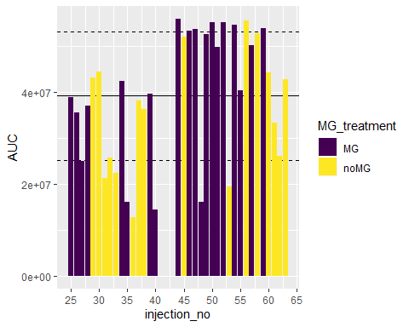

p+geom_col(aes(fill=Carbon))

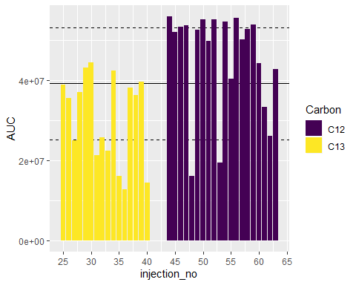

p+geom_col(aes(fill=labelling_time))

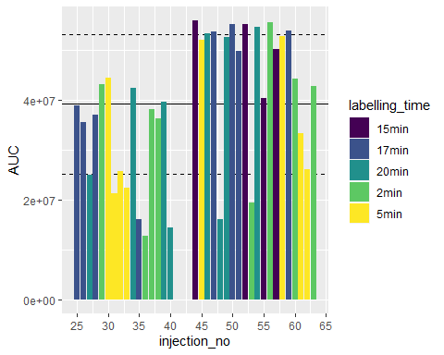

p+geom_col(aes(fill=Replicate))

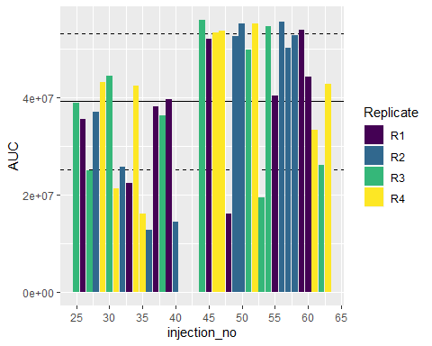

p+geom_col(aes(fill=derivatization.same.MeOX.as.Ident.and.Quant))

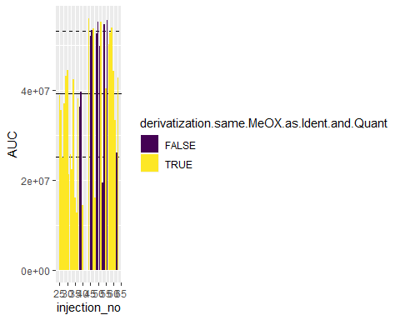

ggplot(df_cinnamic,aes(x=injection_no,y=AUC))+  
 scale_fill_viridis_c()+  
 geom_hline(yintercept = mean(df_cinnamic$AUC,na.rm = T)+  
 sd(df_cinnamic$AUC,na.rm = T),  
 color="black",linetype="dashed") +  
 geom_hline(yintercept = mean(df_cinnamic$AUC),color="black")+  
 geom_hline(yintercept = mean(df_cinnamic$AUC,na.rm = T) -  
 sd(df_cinnamic$AUC,na.rm = T),  
 color="black",linetype="dashed")+  
 geom_col(aes(fill=sample_no))

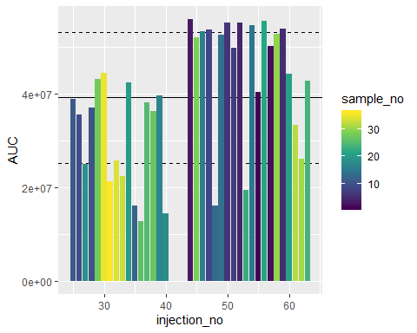

ggplot(df_cinnamic,aes(x=injection_no,y=AUC))+  
 scale_fill_viridis_c()+  
 geom_hline(yintercept = mean(df_cinnamic$AUC,na.rm = T)+  
 sd(df_cinnamic$AUC,na.rm = T),  
 color="black",linetype="dashed") +  
 geom_hline(yintercept = mean(df_cinnamic$AUC),color="black")+  
 geom_hline(yintercept = mean(df_cinnamic$AUC,na.rm = T) -  
 sd(df_cinnamic$AUC,na.rm = T),  
 color="black",linetype="dashed")+  
 geom_col(aes(fill=cellnumber.according.to.conditions))

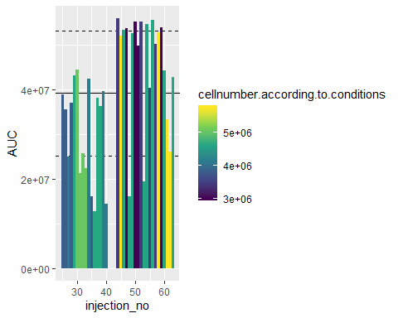

***Nothing conclusive that would explain the huge shifts in CA-intensity by treatment or handling bias from experimental design or sample clean up.***