Check\_label\_intensity\_distribution

Tobias Opialla

9/29/2019

Fructose shows difference, Pyruvate and Lactate as well. Sorbitol, Citrate, Succinate, Fumarate and Malate have to be checked manually. Everything currently is still very abstract

## -- Attaching packages -------------------------------------------------------------------------------- tidyverse 1.2.1 --

## v ggplot2 3.2.1.9000 v purrr 0.3.2   
## v tibble 2.1.3 v dplyr 0.8.3   
## v tidyr 1.0.0 v stringr 1.4.0   
## v readr 1.3.1 v forcats 0.4.0

## -- Conflicts ----------------------------------------------------------------------------------- tidyverse\_conflicts() --  
## x dplyr::filter() masks stats::filter()  
## x dplyr::lag() masks stats::lag()

# load data

df=read.csv("./outputfiles\_20190914/labelincorporation\_09-14-2019\_19-57-09/DataMatrix.csv",stringsAsFactors = F)  
df=gather(df,key="file",value = "labelfraction",-Metabolite,-QuantMasses)  
df\_sample\_metadata=read.xlsx("../Sample\_overview.xlsx",sheet = "Sample\_overview",rows=1:37) #row 38:43=Testsamples  
 df$sample\_no=str\_replace\_all(df$file,".\*\_to\_\\d{3}\_(\\d{2})\_.\*","\\1") %>%   
 as.numeric()  
  
df=left\_join(df,df\_sample\_metadata,by=c("sample\_no"="corrected.SampleNo.Fabiola"))  
df=df %>% filter(sample\_no!=24) #had a pipetting mistake  
df$labeling.time\_effective=ifelse(df$MG.treated,df$labeling.time-15,df$labeling.time)  
df$Metabolite\_short=str\_replace\_all(df$Metabolite,"(.\*\_[MB]P)\_.\*","\\1") %>%   
 str\_replace\_all(.,"MEOX","M") %>%   
 str\_replace\_all(.,"TMS","T") %>%   
 str\_remove\_all("[()]") %>%   
 str\_replace\_all(.,"\_{1,}"," ")  
df$MG.treated\_plot=ifelse(df$MG.treated,"MG","Ø")

filter\_metabolites=c("Fructose-1-phosphate 1M6T MP")#,"Dihydroxyacetone phosphate 1M3T MP")  
  
p=ggplot(df %>% filter(!Metabolite\_short%in%filter\_metabolites),aes(x=paste(Glucose,labeling.time\_effective),y=labelfraction,fill=MG.treated\_plot,group=file))+  
 geom\_col(position = position\_dodge(),color="black")+  
 scale\_fill\_viridis\_d()+  
 guides(x=guide\_axis(angle=90))+  
 facet\_wrap(~Metabolite\_short)  
  
ggsave("Labelincorporation\_barchart.pdf",plot=p,height = 12,width = 12\*16/9)

## Warning: Removed 212 rows containing missing values (geom\_col).

ggsave("Labelincorporation\_barchart.png",plot=p,height = 12,width = 12\*16/9)

## Warning: Removed 212 rows containing missing values (geom\_col).

p=ggplot(df%>% filter(!Metabolite\_short%in%filter\_metabolites),aes(x=paste(Glucose,MG.treated\_plot,labeling.time\_effective),y=labelfraction,fill=MG.treated\_plot,group=file))+  
 geom\_col(position = position\_dodge(),color="black")+  
 scale\_fill\_viridis\_d()+  
 scale\_x\_discrete(guide=guide\_axis(angle = 90))+#(n.dodge=3))+  
 facet\_wrap(~Metabolite\_short,scales = "free\_y")  
  
ggsave("Labelincorporation\_barchart\_free\_y.pdf",plot=p,height = 12,width = 12\*16/9)

## Warning: Removed 212 rows containing missing values (geom\_col).

ggsave("Labelincorporation\_barchart\_free\_y.png",plot=p,height = 12,width = 12\*16/9)

## Warning: Removed 212 rows containing missing values (geom\_col).

Label incoroporation with free y-axis is shown in 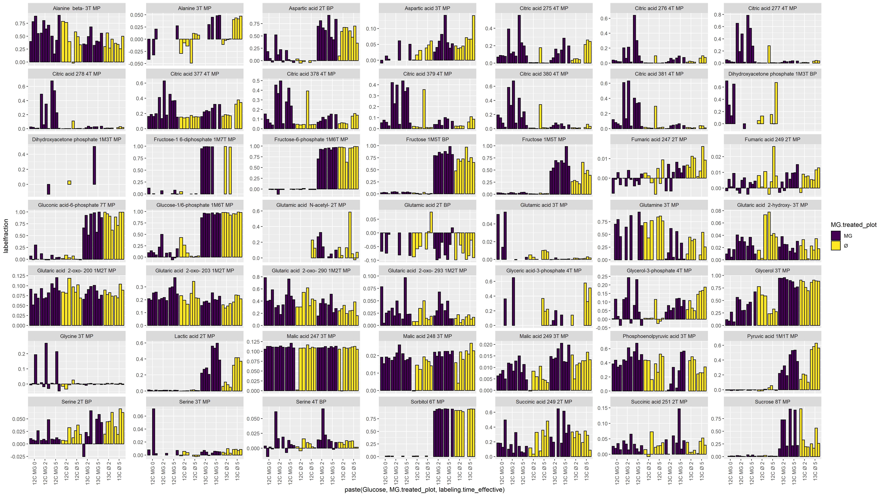

<Labelincorporation_barchart_free_y.pdf>

Fructose shows difference, Pyruvate and Lactate as well. Sorbitol, Citrate, Succinate, Fumarate and Malate have to be checked manually.