Check\_label\_intensity\_distribution\_manual, filter only interesting ones

Tobias Opialla

10/26/2019

Fructose shows difference, Lactate as well. From manual checks I know, that Sorbitol and TCA intermediates (Succinate, Fumarate and Malate) seem not to be interesting, Citrate, looks well now, after manual annotation. Citrate and pyruvate stay the same with MG treatment, the delta between 2 and 5 minutes becomes smaller.

# Load Data

## from manual peak picking

## from SILVIA annotation

# Combine dataframes and filter selected metabolites

# Generate plots

## Overview

Label incoroporation with free y-axis is shown in 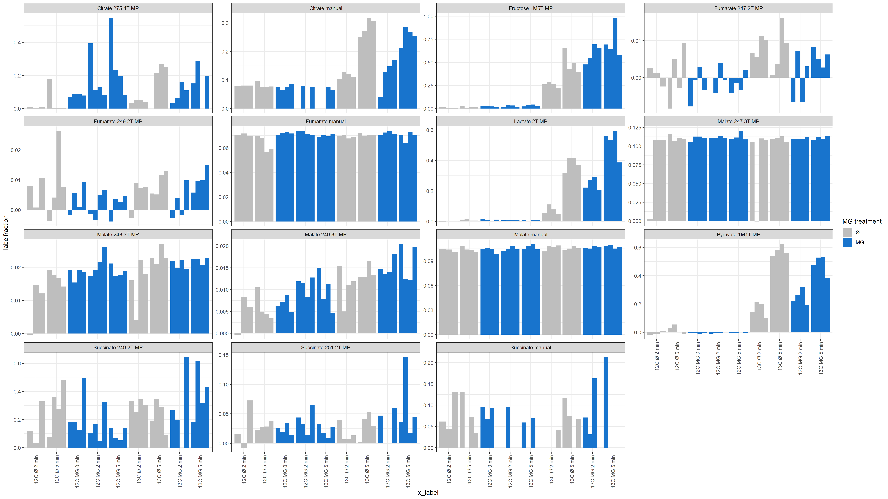

*See also pdf:* <Labelincorporation_barchart_manual_free_y.pdf>

Citrate looks much better than before. Now, where there were big outliers in 12C-samples, these values are rightfully missing (actually no citrate detected in measurement).  
Other TCA-intermediates show no real label incorporation, but are also much more consistent than before.

## Most interesting candidates

Label incoroporation with free y-axis is shown in 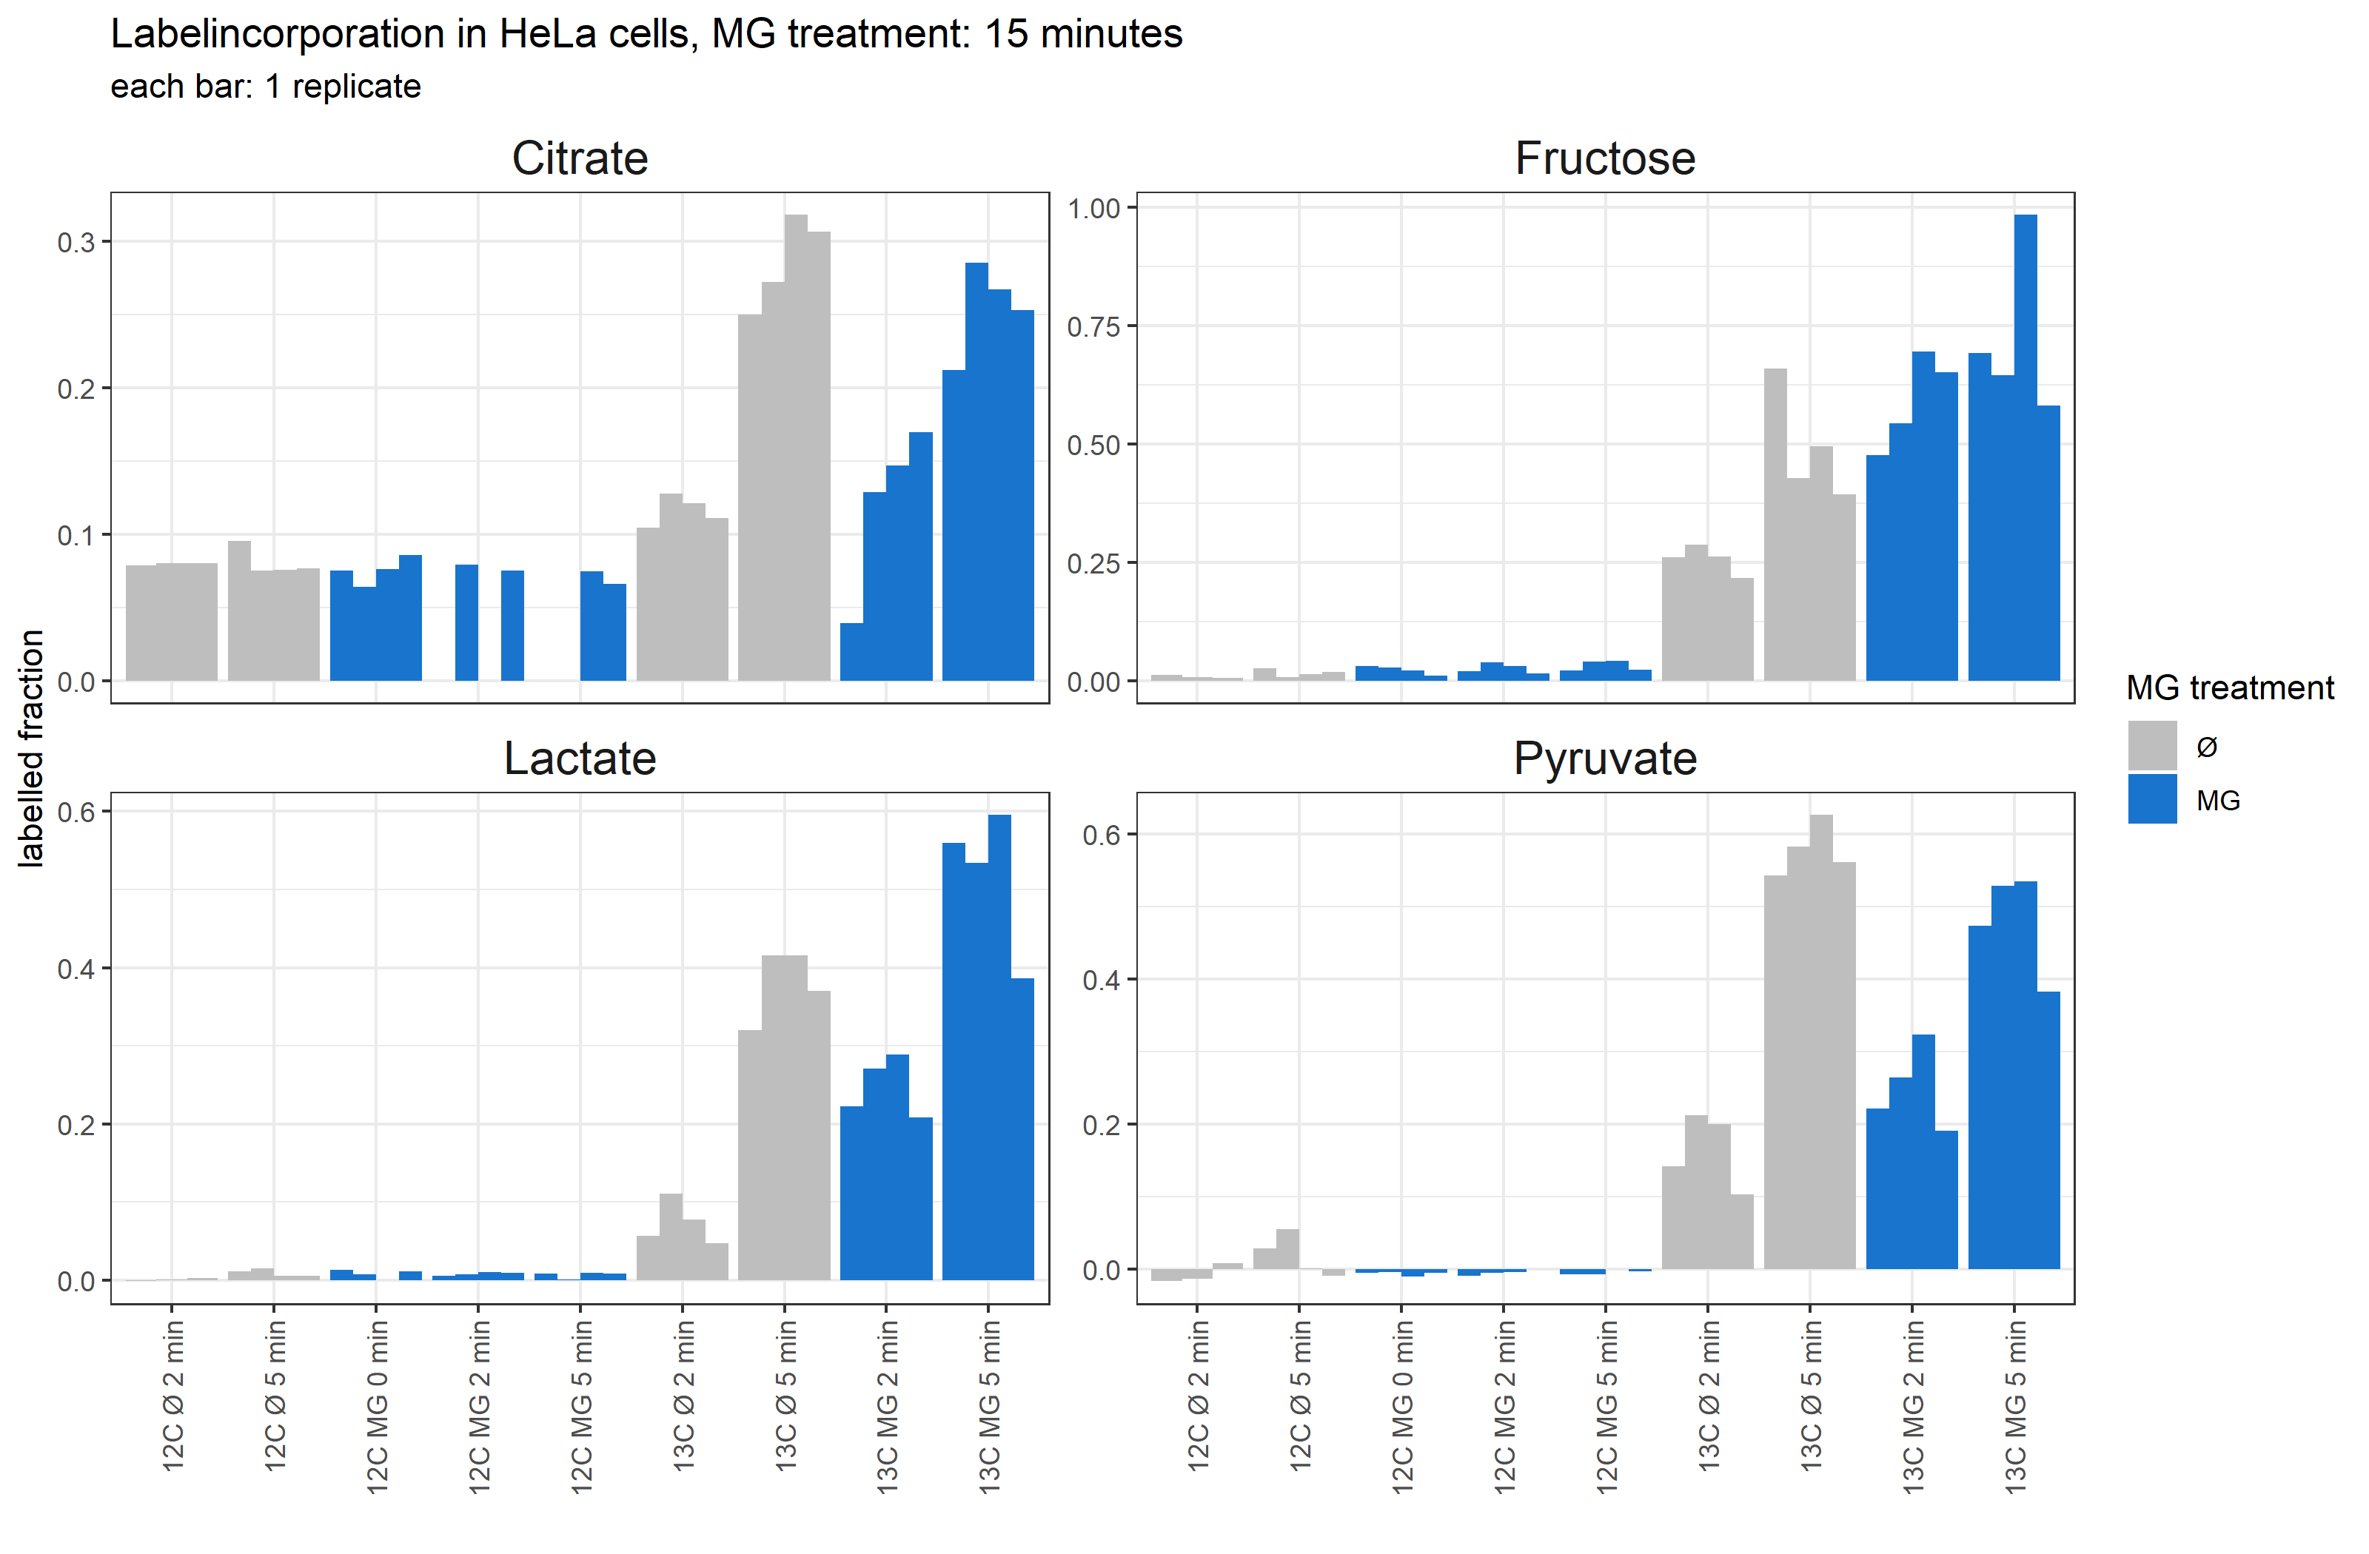

*See also pdf:* <Labelincorporation_report.pdf>

With MG treatment, label incorporation into Lactate and Fructose increases, in Pyruvate and Citrate it stays similar, (the delta between 2 and 5 minutes becomes smaller), in TCA cycle intermediates we see no label incorporation. This looks like, glycolysis is overall more active, but also polyol-pathway is more active.