Methylglyoxal influence on label incorporation from 13C Glucose in HeLas

Tobias Opialla

10/26/2019

Abstract: Pool size quantification is not reliable from this dataset, due to high variation in internal standard, which points to variations in sample collection. Label incorporation still gives reproducible results: Fructose shows a difference, Lactate as well. From manual checks I know, that Sorbitol and TCA intermediates (Succinate, Fumarate and Malate) seem not to be interesting, there is not difference in label incorporation and the samples have a relatively high background. Citrate and pyruvate stay the same with MG treatment, the delta between 2 and 5 minutes becomes smaller.

### Cinnamic Acid (internal Standard)

The general quantification of pool sizes is difficult in this sample set. Apperently deviations between samples were quite substantial during harvest, as the internal standard (Cinnamic acid) varies quite a bit. I tried to find possible biological reasons in the samples, but to no avail. I colored the bars by all possible influence factors I could think of, but there is no clear influence to be found. (see below) *Label incorporation however (especially after manual verification) still yields useful results, as this is calculated always relative within the sample.*

Cinnamic acid intensities are shown in 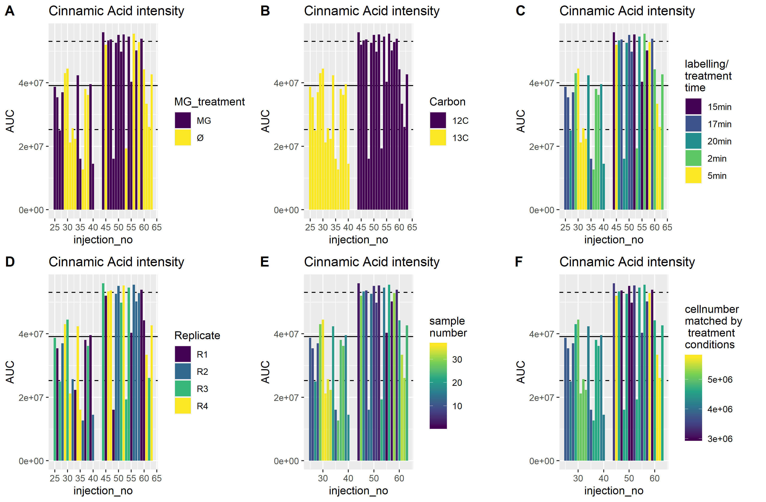

*See also pdf:* <Cinnamic_Acid_report.pdf>

### Label incorporation

Label incoroporation with free y-axis is shown in 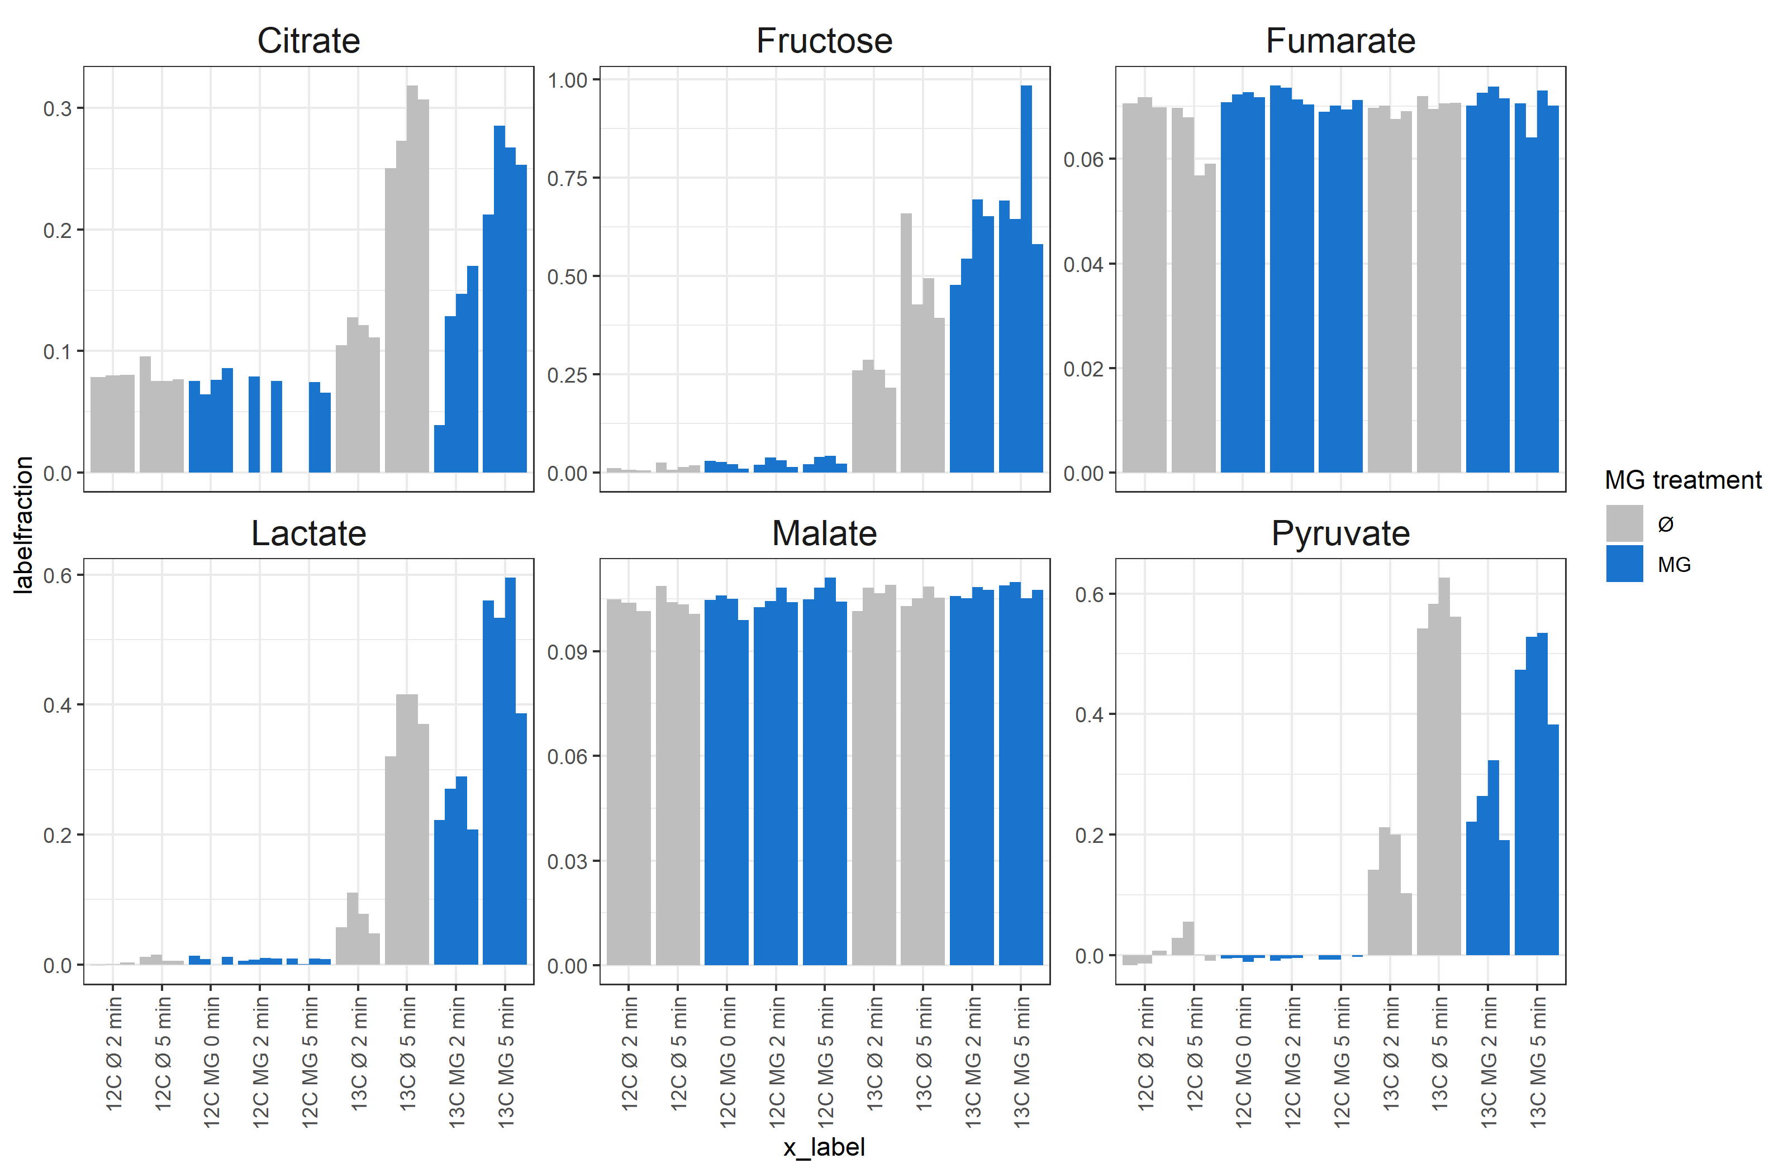

*See also pdf:* <Labelincorporation_report.pdf>

With MG treatment, label incorporation into Lactate and Fructose increases, in Pyruvate and Citrate it stays similar, (the delta between 2 and 5 minutes becomes smaller), in TCA cycle intermediates we see no label incorporation at all. This looks like, glycolysis is overall more active, but also polyol-pathway is more active.