# Medical Report

Doctor's Name: admin

Patient's Name: issame amine

Date: 2024-05-02

## Case Description:

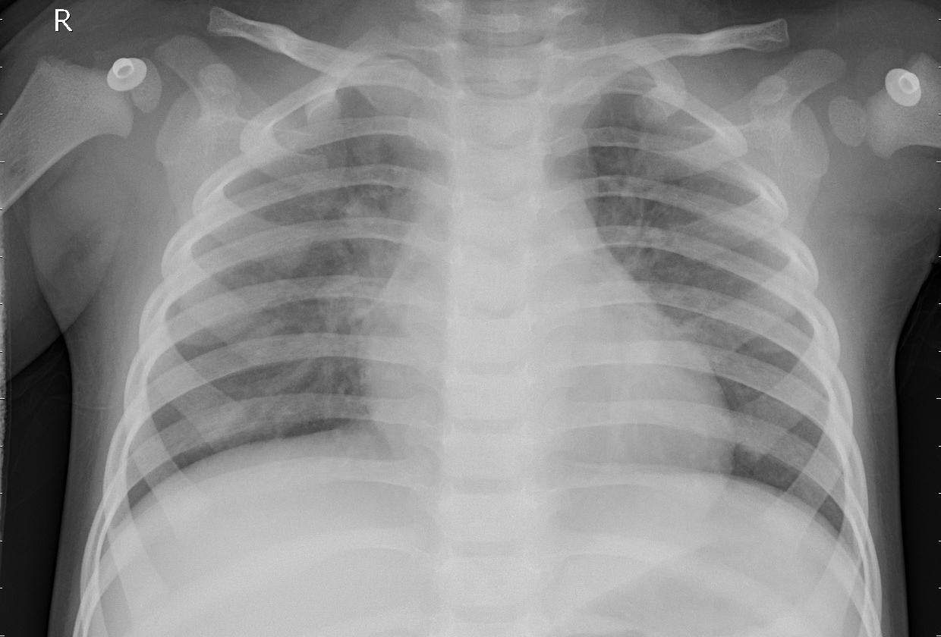

The thoracic radiographic examination reveals localized pulmonary opacities, suggesting pneumonia. Infiltrates and sometimes pleural effusions are observed, consistent with a respiratory tract infection. These radiographic findings, combined with the patient's clinical symptoms, confirm the diagnosis of pneumonia. Appropriate medical treatment is recommended to ensure the patient's recovery.