课程名称：数字逻辑实验 年级：18级 上机实践成绩：

指导老师：陈伟婷 姓名：谢建福 上机实践日期：2018/11/19

实践编号：实验二 学号：10185101252 上机实践时间：1.5学时

1. **实验目的**

(1)掌握利用基本门电路设计组合逻辑电路的方法。

(2)验证所设计是电路的逻辑功能。

1. **实验原理**

**组合逻辑电路设计方法**

1. **实验内容及步骤**
2. 试使用与非门设计一个表决电路,其中 A、B、C、D 四个各自投票时,其分数分别为 3 分、2 分、1 分、1 分,只有得票总分大于 4 分时该提案通过。绿灯亮表示提案通过,红灯亮表示提案未通过。
3. 试用门电路实现表 2.2 的逻辑功能。
4. 试设计一个两位数的比较器。输入分别是A0A1和B0B1，当 A0A1 > B0B1时,输出为 01;当 A 0 0 A 1 1 <=B 0 0 B 1 1 ,时,输出为 10。要求用与非门电路实现。
5. **理论计算，实验结果及分析**

(1)

Y = 1 表示绿灯，Y = 0表示红灯

|  |  |  |  |  |  |  |  |  |  |
| --- | --- | --- | --- | --- | --- | --- | --- | --- | --- |
| A | B | C | D | Y | A | B | C | D | Y |
| 0 | 0 | 0 | 0 | 0 | 1 | 0 | 0 | 0 | 0 |
| 0 | 0 | 0 | 1 | 0 | 1 | 0 | 0 | 1 | 0 |
| 0 | 0 | 1 | 0 | 0 | 1 | 0 | 1 | 0 | 0 |
| 0 | 0 | 1 | 1 | 0 | 1 | 0 | 1 | 1 | 1 |
| 0 | 1 | 0 | 0 | 0 | 1 | 1 | 0 | 0 | 1 |
| 0 | 1 | 0 | 1 | 0 | 1 | 1 | 0 | 1 | 1 |
| 0 | 1 | 1 | 0 | 0 | 1 | 1 | 1 | 0 | 1 |
| 0 | 1 | 1 | 1 | 0 | 1 | 1 | 1 | 1 | 1 |

|  |  |  |  |  |
| --- | --- | --- | --- | --- |
| AB CD | 00 | 01 | 11 | 10 |
| 00 | 0 | 0 | 0 | 0 |
| 01 | 0 | 0 | 0 | 0 |
| 11 | 1 | 1 | 1 | 1 |
| 10 | 0 | 0 | 1 | 0 |

Y = AB+ACD = ((AB)’(ACD)’)’

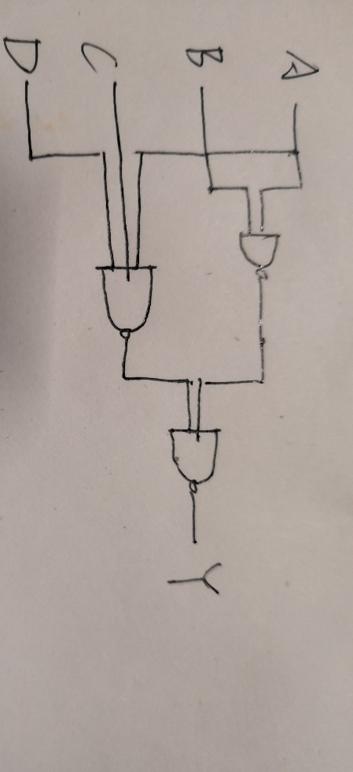

(2)

|  |  |  |  |  |
| --- | --- | --- | --- | --- |
| 输入 | | | 输出 | |
| A | B | C | S1 | S2 |
| 0 | 0 | 0 | 0 | 0 |
| 0 | 0 | 1 | 1 | 0 |
| 0 | 1 | 0 | 1 | 0 |
| 0 | 1 | 1 | 0 | 1 |
| 1 | 0 | 0 | 1 | 0 |
| 1 | 0 | 1 | 0 | 1 |
| 1 | 1 | 0 | 0 | 1 |
| 1 | 1 | 1 | 1 | 1 |

S1 = A’B’C + A’BC’+AB’C’+ABC

S2 =A’BC+AB’C+ABC’+ABC

**S1：**

|  |  |  |  |  |
| --- | --- | --- | --- | --- |
| A BC | 00 | 01 | 11 | 10 |
| 0 | 0 | 1 | 0 | 1 |
| 1 | 1 | 0 | 1 | 0 |

S1 = A’B’C + A’BC’+AB’C’+ABC

**S2：**

|  |  |  |  |  |
| --- | --- | --- | --- | --- |
| A BC | 00 | 01 | 11 | 10 |
| 0 | 0 | 0 | 1 | 0 |
| 1 | 0 | 1 | 1 | 1 |

S2 =AB+AC+BC

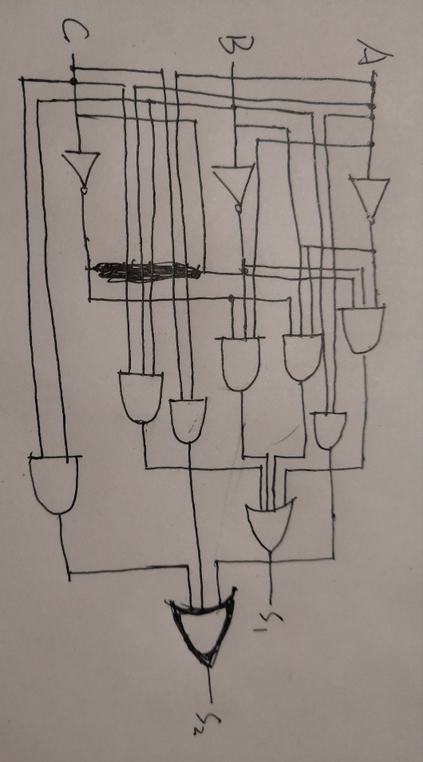

(3)

当 A0A1>B0B1时Y1Y0为10，当 A0A1<= B0B1时Y1Y0为01。

**Y1:**

|  |  |  |  |  |
| --- | --- | --- | --- | --- |
| A0A1 B0B1 | 00 | 01 | 11 | 10 |
| 00 | 1 | 1 | 1 | 1 |
| 01 | 0 | 1 | 1 | 1 |
| 11 | 0 | 0 | 1 | 0 |
| 10 | 0 | 0 | 1 | 1 |

**Y2:**

|  |  |  |  |  |
| --- | --- | --- | --- | --- |
| A0A1 B0B1 | 00 | 01 | 11 | 10 |
| 00 | 0 | 0 | 0 | 0 |
| 01 | 1 | 0 | 0 | 0 |
| 11 | 1 | 1 | 0 | 1 |
| 10 | 1 | 1 | 0 | 0 |

Y1 = A0’A1’ + B0B1 + A0’B1+A0’B0=((A0’A1’)’ (B0B1)’(A0’B1)’ (A0’B0)’)’

Y2 = A0B0’+A0A1B1’+A1B0’B1’=((A0B0’)’(A0A1B1’)’(A1B0’B1’))’

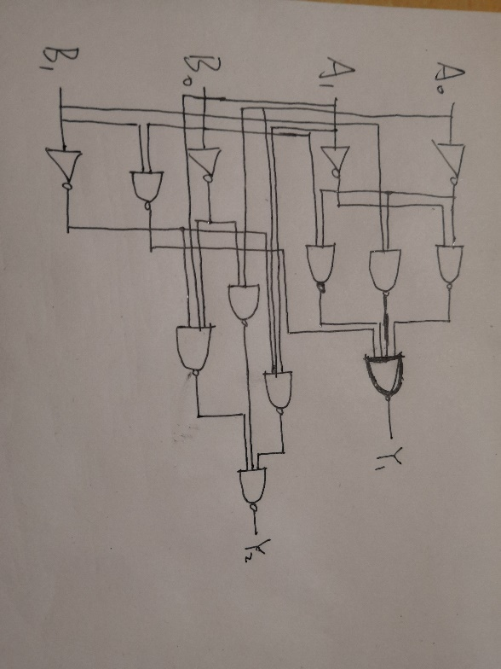

**五、心得体会**

**实验分析和对实验的心得体会自己对于实验的理解和存在的问题**

**对出现的问题进行分析，及问题是如何解决的**

1. 使用元器件前要先测试一下该元器件是否可以正常工作
2. 输出不正确不一定是接线错误，也可能是接触不良。