**Spectrum.html**

When a HTML is being launched in this application, All JavaScript codes inside **$(document).ready(function(){})** wait till all elements of html is loaded on to browser.

Here in Spectrum.html, on load of html inside the **$(document).ready(function(){}),** we retrieve all the information stored in the local storage.

The information is then placed into input blocks which we will discuss below.

Spectrum.html consists of majorly 4 blocks.

* Input block (peaks, Masses and intensities, Ion Types, Fixed PTMs, Protein sequence)
* SVG of Amino Acid
* Spectrum and MonoMass Graph
* MonoMass table and Theoretical fragment masses table

**Input Block:**

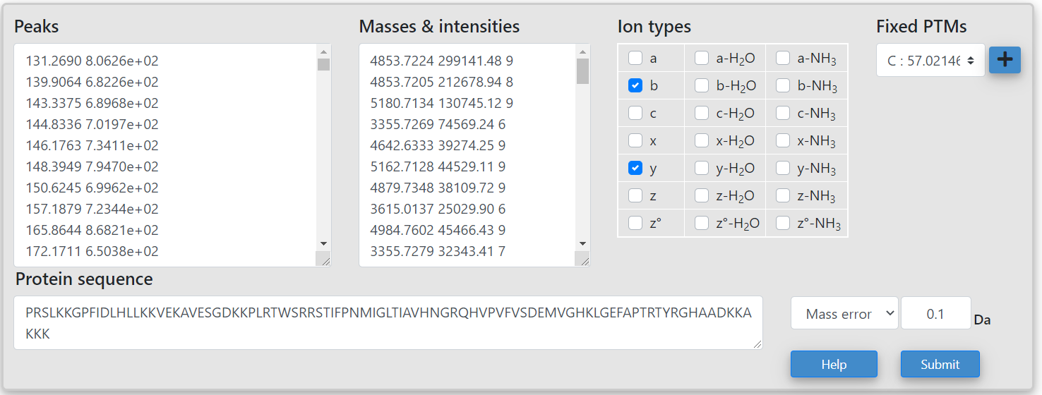

Input block contains input spaces to enter data like **Peaks**(peak mass and intensity separated by space or tab), Masses & Intensities(mass and intensity and charge separated by space or tab), Selection of Ion Types, Adding Fixed PTMs, Protein sequence(Amino Acid information).

Here, Protein sequence (Amino Acid information) can be added along with mass shift at specific position by using a **(mass value).**

**Eg: PRSLKKG(13.65)PFIDLHLLKKVEKAV -**  This is a valid format and the value inside () will be taken as a mass shift upon G.

Mass Error is a dropdown with a default threshold value of **0.1 Da** or PPM error with **15ppm**.

On click of submit button, the algorithms behind generates, SVG of amino acid, spectrum graphs and MonoMass tables.

**SVG of Amino Acid sequence:**

On click of submit, series of function are executed to get all the information entered by the user and to generate respective functionalities.

**On Load of HTML 🡪**

🡪 $(document).ready(function(){}) 🡪onLoadOfHTML() (onclickandeventhandler.js) 🡪setFixedPtmListToUI() (./mass_shift/commonFixedPtms.js)

🡪setMassErrorValue() (./mass_shift/commonFixedPtms.js)

**On click of submit 🡪**

onLoadOfHTML() (onclickandeventhandler.js) 🡪$("#submit").click(function(){} 🡪 sequenceOfExecution() (seqofexecution.js)

**Note:**

**sequenceOfExecution() is the main function and most important function in which complete functions are invoked to generate all the functionalities. The sequence of execution contains functions need to be exceuted in a specific sequence to maintain the information passed to the next functions are retrieved prior to calling the function.**

**Any modification to the sequenceOfExecution() should be tested appropriately to check all the functionalities are in align.**

sequenceOfExecution() (seqofexecution.js) 🡪 getMassListFromUI() (./UI_helpers/helper.js)

🡪 getSequenceFromUI() (./mass_shift/ massshift.js)

🡪 getFixedMassList() (./mass_shift/ massshift.js)

🡪getCombinedMassShiftList() (./mass_shift/ massshift.js)

🡪appendtoMassShiftList() (./mass_shift/ massshift.js)

Once mass shift list is retrieved, and sequence is not empty 🡪 if(seqln != 0)

🡪 buildSvg() (./sequence_svg/drawsvg.js)

🡪handleOnClick() (./sequence_svg/drawsvg.js)

🡪MassShift() (./sequence_svg/drawsvg.js)

🡪 getNumValues() (./sequence_svg/drawsvg.js)

🡪 annotations() (./sequence_svg/drawsvg.js)

**On Click on each amino acid (this code is in the function handleOnClick()), it provides a input box and dropdown of colors to select. On click of ok on the pop-up window will re-execute all the functionality block but by executing a different function.**

handleOnClick() (./sequence_svg/drawsvg.js) 🡪 addColorsToDropdown()

🡪 onClickSequenceOfExecution()(./UI_helpers/seqofexecution.js)

🡪 getMassListFromUI() (helper.js)

🡪 getMassListToColorBG() (rectbackgroundcolor.js)

🡪 appendtoMassShiftList() (./mass_shift/ massshift.js)

🡪setBackGroundColorOnMassShift() (./mass_shift/ massshift.js)

🡪buildSvg() (./sequence_svg/drawsvg.js)

🡪getNumValues() (./sequence_svg/drawsvg.js)

🡪annotations() (./sequence_svg/drawsvg.js)

**Spectrum and MonoMass Graph:**

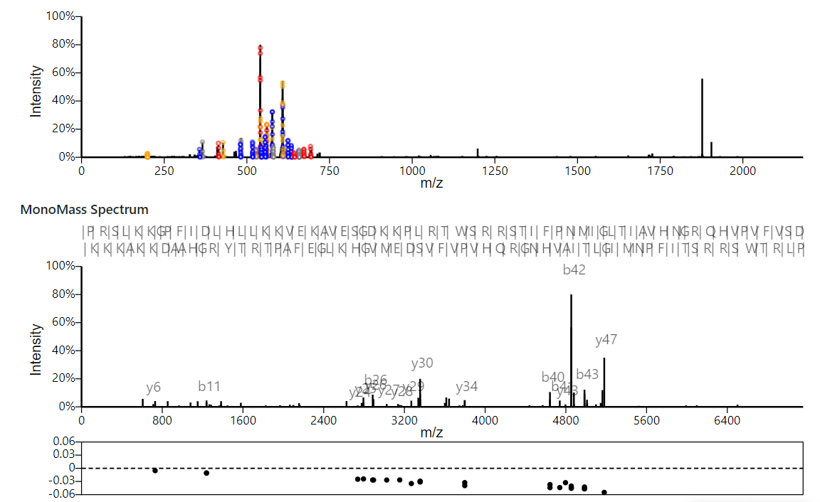

**Spectrum Graph:**

On click of submit button, series of functionalities are executed to generate envelopes by calculating distribution.

**On click of submit 🡪**

onLoadOfHTML() (onclickandeventhandler.js) 🡪$("#submit").click(function(){} 🡪 sequenceOfExecution() (seqofexecution.js)

-------

sequenceOfExecution() (seqofexecution.js) 🡪 getMassListFromUI() (helper.js)

🡪 getSequenceFromUI() (massshift.js)

🡪 getFixedMassList() (massshift.js)

🡪 removeFixedMassList() (massshift.js)

🡪 getCombinedMassShiftList() (massshift.js)

🡪getPeakListFromUI()(helper.js)

🡪getNterminusCheckedList()(iontabledata.js)

🡪getPrefixMassList() (calculateprefixandsuffixmass.js)

🡪getMatchedPeakList() (matchedpeaks.js)

🡪getCterminusCheckedList() (iontabledata.js)

🡪 getSuffixMassList() (calculateprefixandsuffixmass.js)

🡪 getMatchedPeakList() (matchedpeaks.js)

🡪getDistribution() (matchedpeaks.js)

🡪 generateCorrespondingGraph() (addIonsToGraph.js)

🡪 addSpectrum() (invokespectrum.js)

The same series of execution takes place after adding a mass shift on an amino acid and clicking **ok** but it is executed by invoking from **onClickSequenceOfExecution()**.

**MonoMass Graph:**

Mono Mass Graph execute all the above sequence along with another function (generateMonoMassGraph()) which generates the mono mass graph.

sequenceOfExecution() (seqofexecution.js) 🡪 getMassListFromUI() (helper.js)

🡪 getSequenceFromUI() (massshift.js)

🡪 getFixedMassList() (massshift.js)

🡪 removeFixedMassList() (massshift.js)

🡪 getCombinedMassShiftList() (massshift.js)

🡪getPeakListFromUI()(helper.js)

🡪getNterminusCheckedList()(iontabledata.js)

🡪getPrefixMassList() (calculateprefixandsuffixmass.js)

🡪getMatchedPeakList() (matchedpeaks.js)

🡪getCterminusCheckedList() (iontabledata.js)

🡪 getSuffixMassList() (calculateprefixandsuffixmass.js)

🡪 getMatchedPeakList() (matchedpeaks.js)

🡪getDistribution() (matchedpeaks.js)

🡪 generateMonoMassGraph() (addIonsToGraph.js)

🡪 addSpectrum() (invokespectrum.js)

The same series of execution takes place after adding a mass shift on an amino acid and clicking **ok** but it is executed by invoking from **onClickSequenceOfExecution()**.

**MonoMass Table and Theoretical mass Table:**

**Mono-Mass Table:**

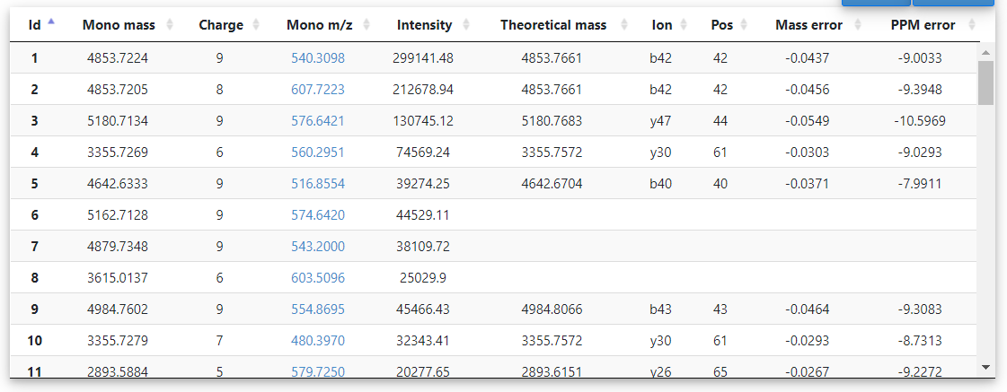

Mono Mass table contain information of theorical mass, matched positions along with Mass error and theoretical error. All the data is been calculated after calculating prefix and suffix masses and comparing the difference with threshold mass.

To get the complete list of matched and unmatched data, the functions inside sequenceOfExecution() has to be executed.

$(document).ready(function(){})

🡪onLoadOfHTML() (onclickandeventhandler.js)🡪 sequenceOfExecution() (seqofexecution.js)

🡪 getPrefixMassList() (calculateprefixandsuffixmass.js)

🡪 getMatchedPeakList() (matchedpeaks.js)

🡪 getMatchedAndUnMatchedList() (matchedpeaks.js)

🡪 createMonoMassTable() (helper.js)

🡪 addMassDataToTable() (helper.js)

In the Mono Mass table on click of the **Mono m/z**, the above graphs are zoomed to the mass point of **Mono m/z.**

The Mono m/z is a hyperlink with class name **peakRows.** On click of the link executes the below flow.

addMassDataToTable() (helper.js) 🡪 $(".peakRows").click(function() {} (helper.js)

🡪 redraw() (./js/spectrumgraph/spectrumgraph.js)

🡪 generateMonoMassGraph() (./UI_helpers/addIonsToGraph.js)

**Theoretical fragment masses:**