------------------------------------------------
TARA KLAMP
…for non-invasive male circumcision

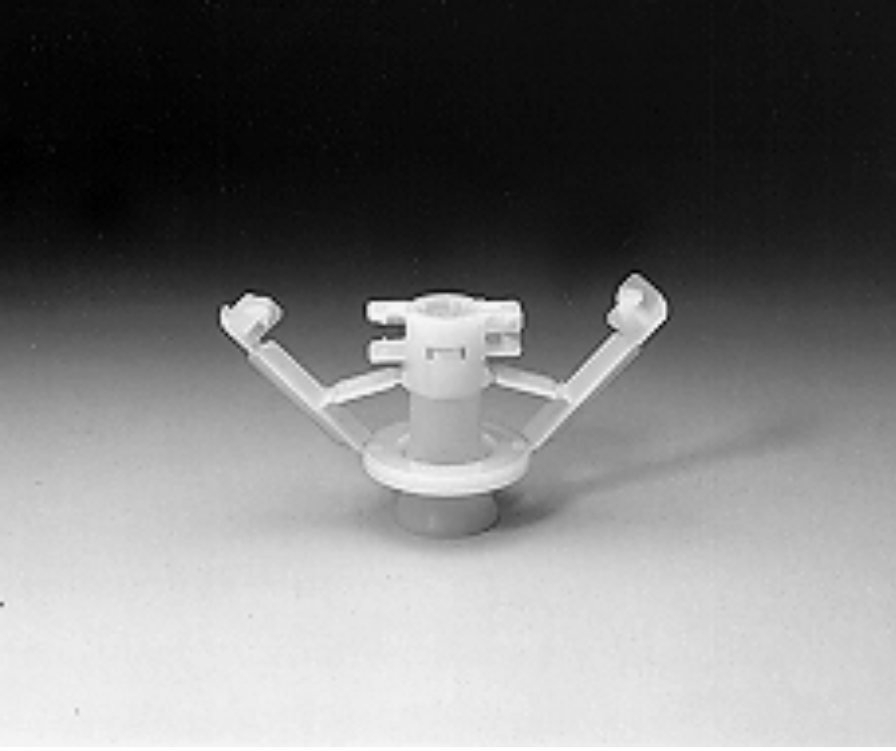

Disposable Circumcision Device

LAST FRONTIER
IN
CIRCUMCISION SURGERY

THE WORLD’S FIRST EVER DEVICE
FOR
NON-INVASIVE MALE CIRCUMCISIONS

TARA KLAMP.....A DISPOSABLE CIRCUMCISION DEVICE

CONTENTS

DESCRIPTION OF INVENTION.............................................................................................1
--Introduction
--The Invention

ADVANTAGES OF THE DISPOSABLE CIRCUMCISION DEVICE...................2

DIRECT COST AND BENEFIT..................................................................................3
--To the Health Service
--To the Patient
--Summary
--Conclusion

CIRCUMCISION PROCEDURE................................................................................4
--Surgical Procedure
--Photograph on :- (Under Construction)
--Adult circumcision.....................................................................................................6
--Small children circumcision.......................................................................................9
--Other Method.......................................................................................................…..11

HIGHLIGHTS AND AWARDS RECEIVED FOR INVENTION.......................…12

SCIENTIFIC ABSTRACTS....................................................................................….13

Page 1

DESCRIPTION OF INVENTION

A DISPOSABLE CIRCUMCISION DEVICE

INTRODUCTION

Circumcision is one of the commonest surgeries performed all over the world. It is generally performed either in a surgical theater, at home or as in some countries even at the roadsides or in the bush etc.
Circumcision methods vary in different regions and problems e.g. infections, accidental amputations of the glans penis, bleeding etc. continue to occur. This happens even in circumcisions performed in an operating theater. This research identified that most of these problems continue to occur because in all the circumcisions methods or devices invented so far, the surgery is of invasive type.
This invention enables circumcisions to be performed not only safely and easily but also ----- for the first time in surgical history ----- enables circumcisions to be performed just as aseptically, at home, on the roadsides or out there in the bush, as in an operating theater. These problems are prevented because the surgery performed by this device is of non-invasive type.

THE INVENTION

This is a pre-sterilized disposable device and is meant for Single Use only. It is of unitary construction and does not require to be assembled before use, so that even a para-medic can use it with ease, with minimal training.
Based on a concept of non-invasive surgery ----- described for the first time ever, in surgical history (confirmed by The Royal College of Surgeons, Ireland ) ----- by the inventor himself, this device does not create an open wound. Hence it does not require any sutures, ligatures or bandages.

Page 2

ADVANTAGES OF THE DISPOSABLE CIRCUMCISION DEVICE
- SAFE | : | Protects against accidental amputation of Glans Penis and other injuries.
- EASY | : | Requires minimal training
- FAST | : | Fast circumcision procedure as compared to normal method
- USE ANYWHERE | : | Can be used anywhere e.g. at home, road-sides or in the bush without fear of infections from non-hygienic places.
- NO CAUTERIZATION | : | No cauterization or other harmful agents are necessary
- BLOODLESS | : | There is no bleeding during and after the surgery.
- NO SUTURES | : | No sutures are necessary.
- NO LIGATURES | : | No ligatures are necessary
- NO BANDAGES | : | No bandages are necessary as there is no post-surgical bleeding or oozing.
- NO AGE RESTRICTIONS | : | Can be used from infants to adults.
- NO INFECTIONS | : | Because no open wound is created, it safeguards against elements in the external environment.
- NO CROSS-INFECTIONS | : | Protects against cross-infections between circumcisor and patient during the surgery e.g. HIV, Hepatitis etc.
- PRE-STERILIZED AND USE ONCE ONLY | : | Risk of cross-infections e.g. HIV, hepatitis etc, from inadequately sterilized re-usable instruments eliminated.
- IMMEDIATE RETURN TO ROUTINE | : | Patient can move about and may return to work immediately after circumcision.
- NO BATHING RESTRICTIONS | : | Patient may have his bath or shower immediately after circumcision.
- GOOD COSMETIC RESULT | : | When healed, the circumcision results in a uniformly and evenly cut and cosmetically pleasing appearance
- NATIONAL COSTS REDUCED | : | The Overall National Economic considerations on circumcision cost etc., are also improved considerably.
- INDIVIDUAL BENEFITS | : | Expenses saved and inconvenience avoided.

Page 3

Direct Cost & Benefit to the :-
Health Service Patient
- Avoids use of operating room. -can be performed at clinics, homes, religious sites.
- Avoids use of ancillary equipment. -Entire equipment in a kit.
- Pre-sterilized & disposable -Expenses saved.
- autoclaving costs avoided.
- Avoids cost of dressing, sutures etc. -Expenses saved.
- Avoids cross infections -Safeguards personal health against hospital infection.
- Nursing time & attention reduced -follow-up visit reduced. Expenses saved
- May return to work after surgery. -Reduced work time lost through medical leave.
- Overall National Economic consideration -Overall expenses reduced. on circumcision cost etc. reduced.

Summary

- World Wide patent protection until year 2010 or later.
- Tara KLamp is designed for Single use only.
- Tara KLamp is a direct replacement to current method of circumcision.
- Tara KLamp device can be used for infant and adult -- All Sizes.
- Tara KLamp is a time saving device for circumcision as compare to other methods.
- Tara KLamp is invented by a doctor who has done many circumcisions in his medical career.
- Tara KLamp has been certified to conform to Islamic religious circumcision by the Prime Minister’s Department in Malaysia.

Conclusion

The use of Tara KLamp can be encouraged on a national scale as part of the primary health care program of a country as this method is practical and inexpensive. As it addresses problems such as bleeding, infections e.g. Hepatitis, HIV etc. and deaths associated with circumcision, it has enormous implication in circumcision surgery, both to individuals and nations throughout the world.
Page 4
Circumcision Procedure
using the Tara KLamp Disposable Non-invasive Circumcision Device

1 | 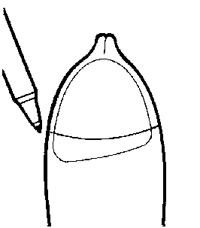 | The penis is first cleansed with sterilizing fluids. Use surgical marking pen to mark the level on the skin of the prepuce where the circumcision is to be performed. This is the level where the clamp is to be applied. This prevents too much pulling of the prepuce and thus avoids removal of too much tissue.
2 | 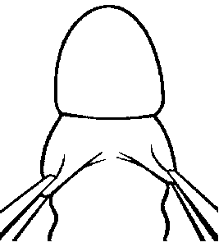 | Gently retract the prepuce. Free any adhesions, if they are present.
3 | 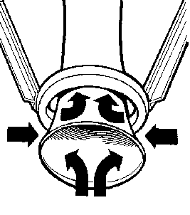 | As shown, apply Vaseline:-  - to the inner and outer surfaces of the lower end of the tubular part and  - to the inner and upper part of the ring.  This prevents the tissue from sticking to the device over the next few days.
4 | 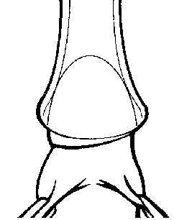 | Place the tubular part of the clamp over the glans, so that the glans is covered by the tube.
5 | 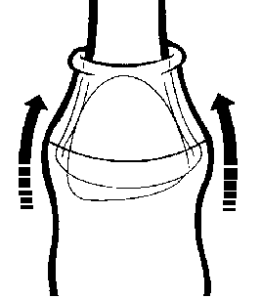 | The prepuce is now pulled over the rim of the tube. Adjust the prepuce over the tube so that the level which has been marked earlier is just above the rim of the tube.
Page 5
6 | 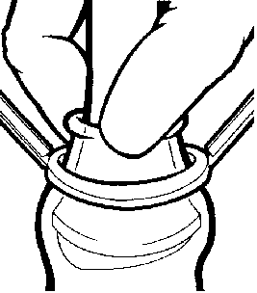 | After adjusting the level of the prepuce, hold the prepuce firmly with the fingers.
7 | 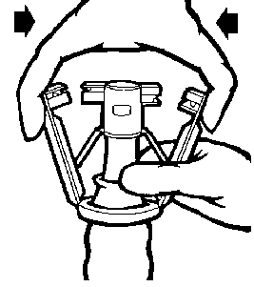 | A grip-like pressure is applied on the two arms. As this pressure is increased, the two arms are brought closer to the locking mechanisms on the tube.
8 | 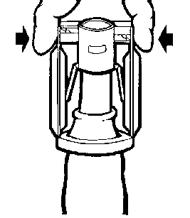 | Resistance to further movement of the arms is felt when the arms come in contact with the locking mechanisms on the device. Apply further pressure on the arms until two clicks are heard and felt. This means that the arms are already locked and the necessary occlusion has been obtained.
9 | 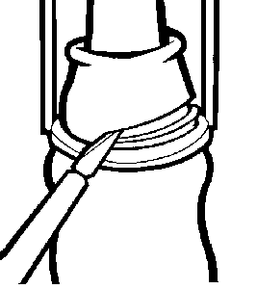 | With the tissue cutter provided, the prepuce that is distal to the clamping ring is cut away at the angle between the tube and the clamping ring.
10 | 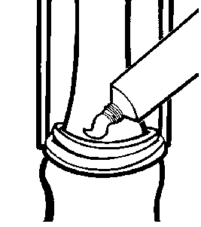 | Although there is no bleeding, the tube is cleaned with a clean gauze and ointment is applied at the cut edge. Apply the ointment a few times daily, during the next few days. The device is allowed to remain on the penis for the next few days. Urine is easily voided through the distal opening.

Page 12

OTHER HIGHLIGHTS AND AWARDS RECEIVED FOR INVENTION :

- In 1993,a grant of M$ 163,336.00 for Research & Development by the Government of Malaysia awarded for development of the Tara KLamp Circumcision Device.

- The Royal College of Surgeons in Ireland confirmed in May 1995 that “ the concept is an interesting one and this method of surgery has never been described before certainly not for the elective operation of male circumcision ”.

- This device has been approved as “ PATENTABLE ” by the PCT, The European Patent Office ( Munich, Germany ) and many member countries under the Paris Convention. This has paved the way for the grant of “ LETTERS PATENT ” in many designated countries throughout the world. Countries include OAPI, Canada, Europe, USA, Japan and various countries under The Paris Convention (e.g. Malaysia, China, Taiwan, India, Indonesia, India, Pakistan, Bangladesh, Iran, Iraq, The Middle East countries, Egypt, Sudan etc. ).

- A paper on “Circumcision Surgery : A Safe and Easy Method by Non-invasive Means” was presented at the 29th. Annual Conference of the Urological Society of India at Bangalore ( 25-28 January 1995 ). Paper was well received and procedure was described as a breakthrough..

- A paper ----- the world’s first ever description ----- on Non-invasive circumcision was first presented at the 5th. North Zone Convention Urological Society of India at Jaipur (6-8 October 1995). The paper was acclaimed as presenting a completely new surgical approach and remarks that this was could be the “ last frontier in circumcision surgery ” were made. The inventor was presented a medal and a special gift in appreciation.

- A paper on both the Non-invasive Concept as well as Bloodless Circumcision has been accepted for presentation at the 4th. International Congress of Tropical Pediatrics in July.

- MINDEX/INNOTEX 1995 : BRONZE MEDAL

- Awarded Gold Medal (1st prize) in the Medicine, Surgery, Hygiene and Orthopedics category at 24th International Exhibition Of Inventions, Geneva, 19th-28th April 1996.

- Awarded Gold Medal of Excellence from Maroc de I’invention – under the High Patronage of His Majesty the King Hassan II of Morocco.

Page 13

Subject: Circumcision Surgery : A safe and easy method by non-invasive
means

Circumcision is one of the most commonly performed surgeries all over the world. Techniques or methods in circumcision surgery vary in different regions and in different cultures and as a result, many problems e.g. infections, accidental amputations of the glans penis, bleeding etc. still continue to persist.

As a compelling need to address these problems was felt, a research effort on circumcision surgery was initiated on two fronts in Malaysia, over two decades ago. Initially, a study in depth, to look into the current state of circumcision surgery, was undertaken. This was to study :

- The surgical aspects of all known circumcision procedures

B. Whether the various problems could be prevented by another surgical technique.

Interestingly, the above study revealed that a potentially safer and aseptic circumcision could be attainable, if the surgery was performed by using the body’s ability to reject non-viable tissues by non-invasive means. This was however, hampered by lack of any established knowledge or information in general surgery, on absolute non-invasive surgical techniques, that could be used. A further effort was then directed to explore this possibility as follows:

A. To describe a safe concept for non-invasive surgery based on sound surgical reasoning,

B. To design a circumcision device based on this concept.

As a result, use is made of the ability of the body to reject non-viable tissue, as a clinical tool. The procedure for successful use of this ability, which I term as CLINICALLY INDUCED, COMPLETE AND TOTAL NON-INVASIVE ASEPTIC OCCLUSION is dependent on the concomitant use of a number of factors which do not involve the use of any invasive means or substances.

Page 14

Based on the above concept, a disposable circumcision device was invented recently. The device enables circumcisions to be performed safely and easily with the following benefits:
- Circumcision can be performed in a few minutes and does not involve the use of electro-cautery, chemical or other harmful means.
- There is no active bleeding during the surgery or in the post-circumcision period.
- There is no need for any sutures or ligatures or any dressings to be applied after the circumcision has been performed.
- There is minimal need for medication.
- It can be performed with ease and aseptically at home or at religious sites and there is no need for an operating room.
- Wound healing is faster and therefore able to return to work earlier.
- Review at hospital nil. Safeguards personal health against infections both during the surgery and in the post-surgical period.
- It is a " Use Once Only " device and therefore prevents cross-infection e.g. acquired diseases, AIDS, hepatitis etc.
- Expenses saved and inconvenience avoided.

Other aspects pertaining to this research are as follows:
A. This research was funded in part, by the Government of Malaysia.
B. The device has already been designated as an Invention.
C. Patent Protection status has already been accorded by the Patent Cooperation Treaty of World Intellectual Property Organization, Geneva, Switzerland.
D. Patent Protection has also been accorded in many countries which are members of The Paris Convention.

Summary
This has tremendous beneficial implications for circumcisions throughout the world. as in some countries, circumcisions are performed by barbers generally at road-sides. They use a barber- knife with the scantiest regard for aseptic procedures. In Africa, circumcisions are generally performed in the bush by traditional circumcisers. Besides post-circumcision deaths, various other problems e.g. infections, accidental amputations of the glans penis, bleeding etc. still continue to persist. This invention adequately addresses this situation. In brief, it enables circumcisions to be performed just as aseptically in the home or out there in the bush, as in the operating theater.

Reference :
Paper presented at : | 5th North Zone Convention Urological Society of India,  October 6-8, 1995
 | Urology Development and Research Centre,
 | S. M. S. Hospital, Jaipur, India
By : | Dr. T. Gurcharan Singh
 | Kuala Lumpur, Malaysia

Page 15

USICON 95-96
24th to 28th January 1996.
NATIONAL SCIENCE SEMINAR COMPLEX
(J.N. TATA AUDITORIUM), INDIAN INSTITUTE OF SCIENCE,
BANGALORE 560 012

SCIENTIFIC ABSTRACTS

Circumcision Surgery : A Safe and Easy Method by Non-invasive
Means.

Dr. T. Gurcharan Singh
Kuala Lumpur, Malaysia

Circumcision is one of the most commonly performed surgeries all over the world. Techniques in circumcision vary in different regions and in different cultures. In some countries, circumcisions are performed by barbers generally at road-sides. In Africa, circumcisions are generally performed in the bush by traditional circumcisers. Besides post circumcision deaths, various other problems e.g. infections, accidental amputation of the glans penis, bleeding etc. still continue to persist. Keeping in mind all these facts a need for a safe and easy method of circumcision was felt.

Herein I report the use of a disposable circumcision device and the technique of its use which has already been designated as an invention.

Clamping of the fore-skin with proper tension leads to aseptic gangrene which does not require any suture material or electrocautery for haemostasis. Besides this it has several advantages such as it can be performed at home or at religious site, less time consuming, loss of work-days because of surgery is significantly less. Wound infection and cross infection are significantly less as it is a disposable device, less post circumcision medication and pain are also the observed advantages.

TARA KLAMP

A
KINDER CUT
IN
CIRCUMCISION
SURGERY

Name of Inventor : Dr. T. Gurcharan Singh
Email : gurchs@taramed.pc.my

Marketed by : Tara KLamp Healthcare Products Company
# 1 Ground Floor Office, Equatorial Penang,
1 Jalan Bukit Jambul, 11900 Penang.
Tel/Fax : 603-6428653
Email: tara@mol.com.my

Mr. Mark Chang
Director of Sales and Marketing
Email : mark@mol.com.my

Mr. Tan Chew Lian
Sales and Marketing Manager
Email : tcl@mol.com.my

