1. **Trial Process**

* Where to sign up?

<https://www2.unotelly.com/signup>

* What info user has to enter?

First name

Email address

Password

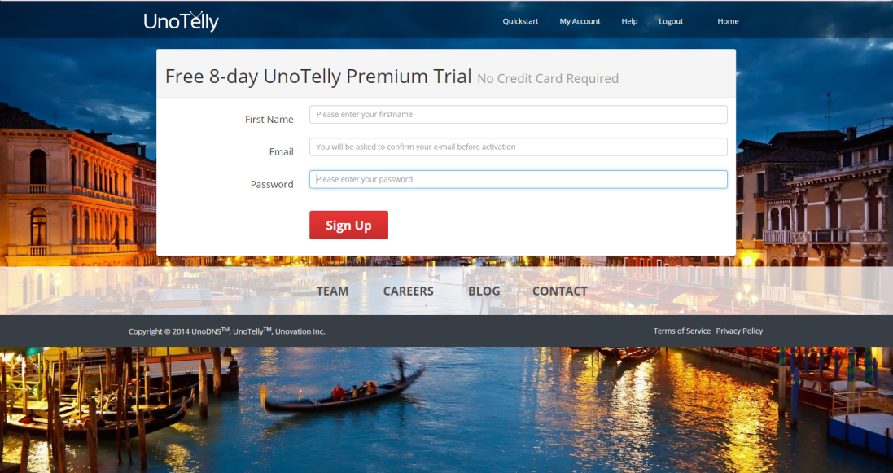

* Does user receive a confirm?

Yes.

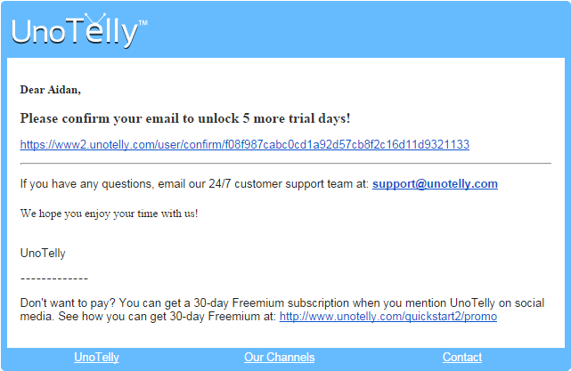

* What happens after sign up?

After sign up, users will see a form to select device to be installed the UnoTelly VPN and receive a confirm mail.

When user click the link to confirm, his or her account will be activated and get welcome message.

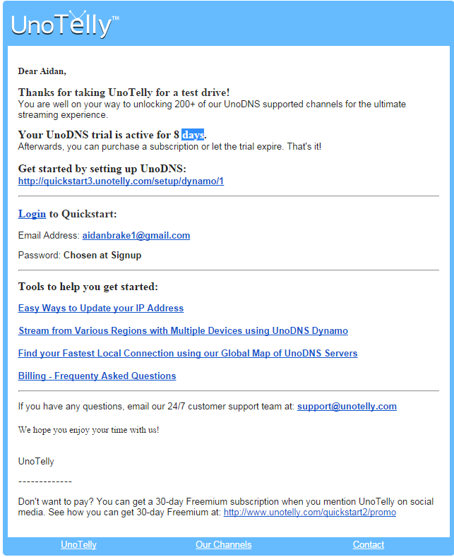

* How many days do user get?

8 days trial.

1. **DNS Setup Process**

* How to setup device?

User should visit <https://www2.unotelly.com/devices>, and select device he will use.

* Where to find setup instruction?

After user select a device he will take to visit, then he will see a link to setup instruction – “View Setup Instruction”

For instance, if I selected Windows 7, the page with the link would be <https://www2.unotelly.com/devices#device-win_7>.

* How does user check if setup is complete?

When user visits <https://www2.unotelly.com/quickstart#>, UnoTelly will tell him or her whether setup has been completed or not. User will see a red, buzzing alert.

* Can we make it easier?

I am not sure yet.

1. Purchase|Subscribe

* How do user buy?
* What packages do we offer?
* What is the checkout process?
* Any problem?
* Any improvement?
* Try the checkout process and see for yourself

1. Dynamo

* What is Dynamo?
* How do I use it?
* Why do I need it?
* Can it be easier?

1. IP Update

* Why do I need to update IP?

1. IP Update API

* Why do I need this?

1. DynDNS setting

* Why do I need this?

1. E-mail Confirmation

* Why do we confirm e-mail?
* How to confirm e-mail?