B1. What is software?
-software is a collection of computer program related data that provide the instruction for telling a computer what to do and how to do it.
B2. Types of software
-two types of software
1.system software
2.programming software
3.application software
B3. What is Software Development Methodology?

Stage 1: Planning and Requirement Analysis
Requirement analysis is the most important and fundamental stage in SDLC. It is performed by the senior members of the team with inputs from the customer, the sales department, market surveys and domain experts in the industry. This information is then used to plan the basic project approach and to conduct product feasibility study in the economical, operational and technical areas.
Planning for the quality assurance requirements and identification of the risks associated with the project is also done in the planning stage. The outcome of the technical feasibility study is to define the various technical approaches that can be followed to implement the project successfully with minimum risks.

Stage 2: Defining Requirements
Once the requirement analysis is done the next step is to clearly define and document the product requirements and get them approved from the customer or the market analysts. This is done through an SRS (Software Requirement Specification) document which consists of all the product requirements to be designed and developed during the project life cycle.

Stage 3: Designing the Product Architecture
SRS is the reference for product architects to come out with the best architecture for the product to be developed. Based on the requirements specified in SRS, usually more than one design approach for the product architecture is proposed and documented in a DDS - Design Document Specification.
This DDS is reviewed by all the important stakeholders and based on various parameters as risk assessment, product robustness, design modularity, budget and time constraints, the best design approach is selected for the product.
A design approach clearly defines all the architectural modules of the product along with its communication and data flow representation with the external and third party modules (if any). The internal design of all the modules of the proposed architecture should be clearly defined with the minutest of the details in DDS.

Stage 4: Building or Developing the Product
In this stage of SDLC the actual development starts and the product is built. The programming code is generated as per DDS during this stage. If the design is performed in a detailed and organized manner, code generation can be accomplished without much hassle.
Developers must follow the coding guidelines defined by their organization and programming tools like compilers, interpreters, debuggers, etc. are used to generate the code. Different high level programming languages such as C, C++, Pascal, Java and PHP are used for coding. The programming language is chosen with respect to the type of software being developed.

Stage 5: Testing the Product
This stage is usually a subset of all the stages as in the modern SDLC models, the testing activities are mostly involved in all the stages of SDLC. However, this stage refers to the testing only stage of the product where product defects are reported, tracked, fixed and retested, until the product reaches the quality standards defined in the SRS.

Stage 6: Deployment in the Market and Maintenance
Once the product is tested and ready to be deployed it is released formally in the appropriate market. Sometimes product deployment happens in stages as per the business strategy of that organization. The product may first be released in a limited segment and tested in the real business environment (UAT- User acceptance testing).
Then based on the feedback, the product may be released as it is or with suggested enhancements in the targeting market segment. After the product is released in the market, its maintenance is done for the existing customer base.
B4. What is Design Pattern?
-Design patterns provide a standard terminology and are specific to particular scenario. For example, a singleton design pattern signifies use of single object so all developers familiar with single design pattern will make use of single object and they can tell each other that program is following a singleton pattern.

I1 1. What is the difference between Application software and system software?
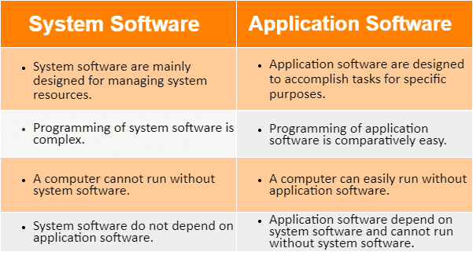
I2 2. Explain the SDLC Each face Process
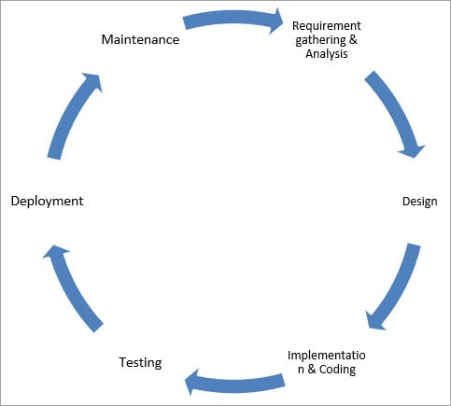

1) Requirement Gathering and Analysis
During this phase, all the relevant information is collected from the customer to develop a product as per their expectation. Any ambiguities must be resolved in this phase only.
Business analyst and Project Manager set up a meeting with the customer to gather all the information like what the customer wants to build, who will be the end-user, what is the purpose of the product. Before building a product a core understanding or knowledge of the product is very important.

2) Design
In this phase, the requirement gathered in the SRS document is used as an input and software architecture that is used for implementing system development is derived.

3) Implementation or Coding
Implementation/Coding starts once the developer gets the Design document. The Software design is translated into source code. All the components of the software are implemented in this phase.

4) Testing
Testing starts once the coding is complete and the modules are released for testing. In this phase, the developed software is tested thoroughly and any defects found are assigned to developers to get them fixed.
Retesting, regression testing is done until the point at which the software is as per the customer’s expectation. Testers refer SRS document to make sure that the software is as per the customer’s standard.

5) Deployment
Once the product is tested, it is deployed in the production environment or first UAT (User Acceptance testing) is done depending on the customer expectation.
In the case of UAT, a replica of the production environment is created and the customer along with the developers does the testing. If the customer finds the application as expected, then sign off is provided by the customer to go live.

6) Maintenance
After the deployment of a product on the production environment, maintenance of the product i.e. if any issue comes up and needs to be fixed or any enhancement is to be done is taken care by the developers.

