COMPUTER NETWORK
Touqeer Hayat 2025-SE-248

Lab 2
Task A :
Source IP at Layer 3: 192.168.1.1
Destination IP at Layer 3: 192.168.1.3
Source MAC at Layer 2: 00E0.B0B8.41B4
Destination MAC at Layer 2: 00D0.FF81.B455

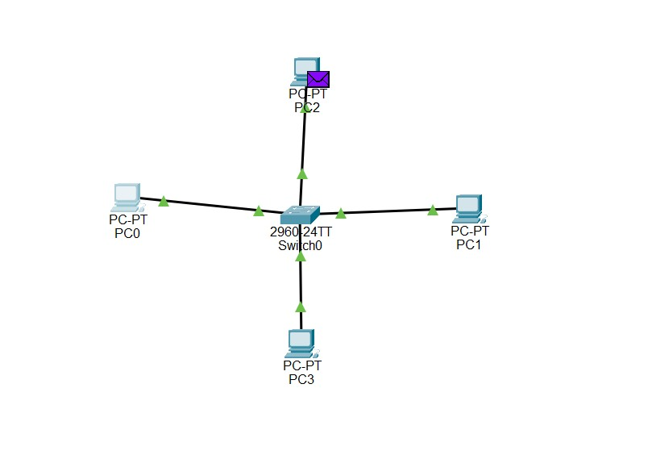

Task B:
Q1:What is the difference between a Hub and a Switch in terms of how they forward packets?
A Hub sends/floods the packet to all connected ports, while a Switch forwards the packet only to the intended destination port.

Q2: Why do modern networks use Switches instead of Hubs?
Modern networks use Switches because they intelligently forward packets to the destination device and reduce unnecessary network traffic.

TASK C:
Extended star Topology




