Software Requirement Specification

Student Manage Software

**Version v1.1**

**11/03/2018**

(Leader) Trần Tiến Đạt

Vũ Tấn Huy

Nguyễn Phan Thảo Nhi

Nguyễn Thành Phong

Update History

|  |  |  |  |
| --- | --- | --- | --- |
| **Author** | **Date** | **Note** | **Version** |
| Vũ Tấn Huy | 11/03/2018 | Create Document | v1.0 |
| Vũ Tấn Huy | 14/03/2018 | Update Software Development, Figures | V1.1 |
|  |  |  |  |
|  |  |  |  |
|  |  |  |  |
|  |  |  |  |
|  |  |  |  |

**Table of Contents**

**Table of Contents** 3

**List of Figures** 4

**1. Introduction** 5

1.1 Purpose 5

1.2 Project Scope 5

**2. Overall Description** 5

2.1 Perspective system 5

2.2 User Characteristics 5

**3. Software Requirement Specification** 5

3.1 User Requirement 5

3.1.1 Teacher Requirement 5

3.2 System Overview Requirement 6

3.3 Detail of Use Case 6

3.3.1 Teacher Use Cases 6

3.4 Software System Attribute 7

3.4.1 Performance 7

3.4.2 Maintainability 8

3.4.3 Reliability 8

3.4.4 Usability 8

**4. Development Environment** 8

4.1 Software Process Model 8

4.2 Develop Model 8

4.3 Technology 9

4.4 Hardware requirement 9

**5. Software Development** 9

5.1 Database Design 9

5.1 Entity Relationship Diagram 9

5.2 Data Dictionary 9

5.2 User Interface 10

# **List of Figures**

Figure 1 - Context Diagram 5

Figure 2 - Use Case Diagram 6

Figure 3 - Description of Use Case 6

Figure 4 - Description of Actor 6

Figure 5 - <Teacher> View List of Students Action 6

Figure 6 - Agile Model 8

Figure 7 - 3-Layers Model 8

Figure 8 - ERD Diagram 9

Figure 9 - Entity Dictionary 9

Figure 10 – View List of Students Interface 10

# **1. Introduction**

## 1.1 Purpose

This software is made to view student and it is used by teacher.

The teacher uses this program to see list of students

## 1.2 Project Scope

|  |  |
| --- | --- |
| **Term** | **Definition** |
| User | The teacher who want to view list of student |

# **2. Overall Description**

## 2.1 Perspective system

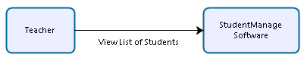

Figure 1 - Context Diagram

## 2.2 User Characteristics

Teacher want to view student.

# **3. Software Requirement Specification**

## 3.1 User Requirement

### 3.1.1 Teacher Requirement

User must be a teacher and have permission to use this software.

- As teacher, I want to view student

## 3.2 System Overview Requirement

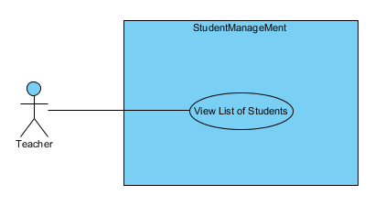

Figure 2 - Use Case Diagram

| **No** | **Actor** | **Use case** | **Description** | **Note** |
| --- | --- | --- | --- | --- |
| 1 | Teacher | View List of Students | View students |  |

Figure 3 - Description of Use Case

| **No** | **Actor** | **Description** | **Note** |
| --- | --- | --- | --- |
| 1 | Teacher | Who is teacher and has permission to use this system |  |

Figure 4 - Description of Actor

## 3.3 Detail of Use Case

### 3.3.1 Teacher Use Cases

1) View List of Students Article

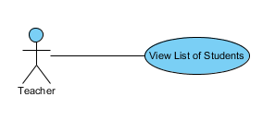

Figure 5 - <Teacher> View List of Students Action

|  |  |  |
| --- | --- | --- |
| **Number** | 001 | |
| **Name** | View List of Students | |
| **Summary** | Teacher view List of students | |
| **Priority** | 1 | |
| **Preconditions** |  | |
| **Postconditions** | View is available. | |
| **Primary Actor(s)** | Teacher | |
| **Secondary Actor(s)** |  | |
| **Trigger** | Teacher open software | |
| **Main Scenario** | **Step** | **Action** |
|  | 1 | Teacher Click program |
|  | 2 | System show list of Students |
| **Extensions** |  |  |
|  | **Step** | **Branching Action** |
|  |  |  |
| **Open Issues** |  |  |

## 3.4 Software System Attribute

### 3.4.1 Performance

All request is handle in maximum time of 10 seconds.

Low-cost.

### 3.4.2 Maintainability

Code is easy to maintain and update.

### 3.4.3 Reliability

Long MTBF: 1000hrs

Timer tasks run at configured time with 100% execution rate.

### 3.4.4 Usability

The Interface appears easy to use and easy to understand.

# **4. Development Environment**

## 4.1 Software Process Model

We decide to choose **Agile Model** because this is a software that manage student so it will have a large data that need to be viewed. And We can face-to-face to another member that we can make it easily without error.

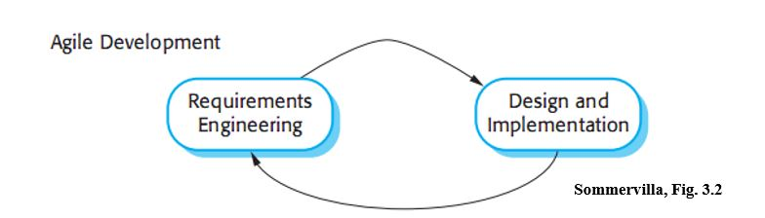

Figure 6 - Agile Model

## 4.2 Develop Model

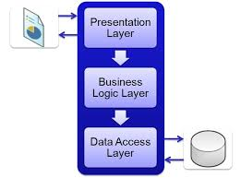We decide to choose **3-layer Model** because it will be easy to maintain and reuse. We choose name for 3 layers is:

Presentation Layers: View

Business Logic Layers: BLL

Data Access Layers: DAL

Figure 7 - 3-Layers Model

## 4.3 Technology

|  |  |
| --- | --- |
| **Technology and Tools** | |
| Database | Microsoft® SQL Server® |
| Framework | Metro modern UI |
| Modeling Tool | Bizagi Modeler v3.1, Visual Paradigm v14.2 |
| Development Tool | Visual Studio 2015,2017 |
| Source control | GitHub |

## 4.4 Hardware requirement

|  |  |
| --- | --- |
| Hardware | Minimum |
| Operating system | Window 7 or above |
| Computer Processor | Intel Core dual 2Ghz |
| Computer Memory | 5Gb |

# **5. Software Development**

## 5.1 Database Design

### 5.1 Entity Relationship Diagram

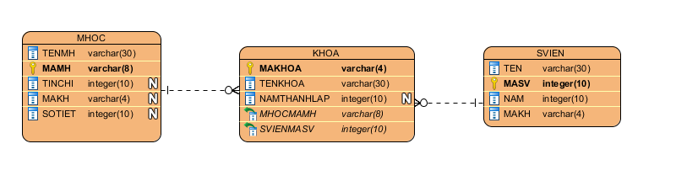

Figure 8 - ERD Diagram

### 5.2 Data Dictionary

|  |  |
| --- | --- |
| Entity | Description |
| MHOC | This is subject |
| KHOA | This a academic year that have many subjects |
| SVIEN | This is student who join KHOA |

Figure 9 - Entity Dictionary

## 5.2 User Interface

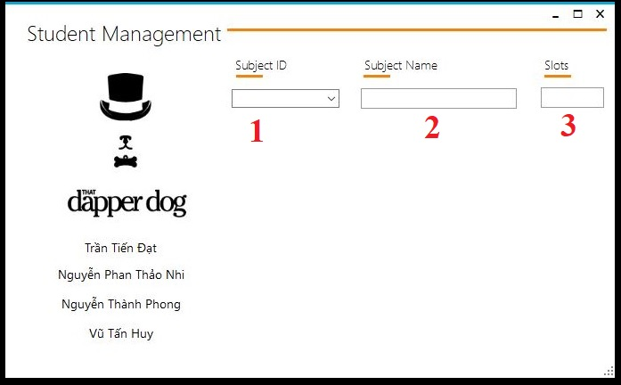

Figure 10 – View List of Students Interface

|  |  |  |  |  |  |  |  |
| --- | --- | --- | --- | --- | --- | --- | --- |
| **No** | **Field Name** | **Description** | **Read only** | **Mandatory** | **Control Type** | **Data Type** | **Length** |
| 1 | Subject ID | ID of Subject | No | Yes | ComboBox | String | N/A |
| 2 | Subject Name | Name of Subject | Yes | No | TextBox | String | N/A |
| 3 | Slots | Slots of Subject | Yes | No | TextBox | int | N/A |