PDF Split and Merge 1.5.0e tutorial
developed by Andrea Vacondio
Release 1.5.0 enhanced, 23 December 2008
http://www.pdfsam.org/

Index
What is pdfsam? 3
Why pdfsam? 3
Install and run 3
Merge/Extract 4
Page extraction 9
Export selected files 9
Split 10
Alternate Mix 13
Encrypt 14
Cover and Footer 16
Viewer options 19
Decrypt 22
Unpack 23
Environment 24
Settings 25
About 26
Log Window 27
Console 28
Tweak&Tips 35
Thanks to open source projects involved 37
License 38
Artwork License 42
Attribution-Noncommercial-Share Alike 3.0 Unported 42
Tutorial license 43
Attribution-Noncommercial-Share Alike 3.0 Unported 43

What is pdfsam?
PDF Split and Merge is a very simple, easy to use, free, open source utility to split and merge pdf files. It has a simple graphical interface to let the user choose pdf files, split or merge them. Pdfsam is written with Java Swing that is “a set of Java class libraries provided as part of Java 2 Platform, Standard Edition (J2SE) to support building graphics user interface (GUI) and graphics functionality for client applications that will run on popular platforms such as Microsoft Windows, Linux, and Mac OSX. “
Pdfsam uses some external libraries such as:

- itext-2.1.4 to manipulate pdf documents.
- dom4j-1.6.1 to deal with the xml format.
- jaxen-1.1 to deal with the xml format.
- pdfsam-jcmdline-1.0.3 to parse and validate console input arguments.
- Looks-2.2.1 to have a nice and changeable look and feel.
- log4j-1.2.15 as log framework.
- bcmail-jdk14-138.jar to deal with encrypted documents.
- bcprov-jdk14-138.jar to deal with encrypted documents.

Why pdfsam?
I needed to merge together some pdf files some years ago and it happened again since that first time. Guess what? I couldn't find an open source software to make it easily and quickly, even if there are tons of commercial software for that. This is the reason why i decided to write pdfsam, a simple, open source and free software for pdf manipulation. Actually one more thing is that i knew about the iText library; i knew the main job about the pdf manipulation was already done by iText but people need something easier, simple interface, something "click and run". And here it is, pdfsam.

Install and run
Prerequisites:
pdfsam need a working Java Runtime Environment. It has been developed using Sun Java(TM) 2 SDK, Standard Edition, Version 1.4.2 and tested on many Microsoft Windows versions and on Ubuntu versions using J2SE 5.0 and J2SE 1.4.2 .

pdfsam-1.5.0e-out.zip
Unzip the archive in a directory and double click the file pdfsam-1.5.0e.jar or type the command "java -jar INSTALL_DIR/pdfsam-1.5.0e.jar" in a console.

Merge/Extract
Here is the Merge/Extract main window:

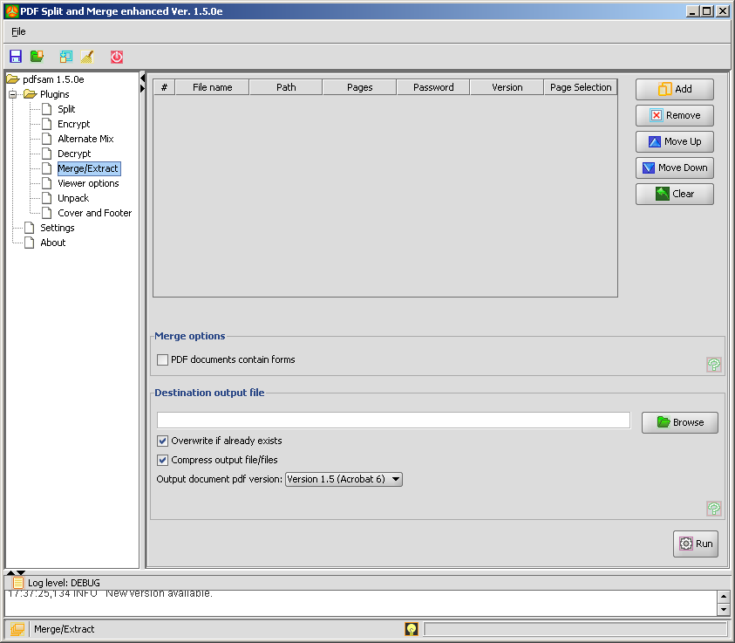
Click the "Add" button to choose the pdf files you want to merge together.

Select pdf files you want to merge; if you want to select more the one file press the "shift" or “ctrl” button on you keyboard.

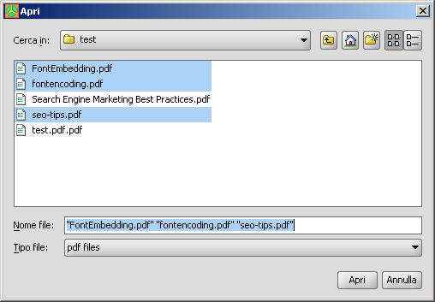
Once your files have been selected you'll see the selection table containing files details:
- Row number
- File name: The file name.
- Path: The file absolute path in the file system.
- Pages: The total number of pages of the document.
- Password: An editable field to input the password for protected documents.
- Version: Pdf Version of the document.
- Page Selection: "All" means that you want to merge the whole document, "page-topage" means you want to merge only pages between "page" and "topage" comprehensive, "page-" means you want to merge pages starting from page till the end of the document, a single page number means that page. Comma separated value are accepted. (ex 4,13-25 if you want to merge page 4 and pages between 13 and 25).
Use the buttons "Move Up", "Move Down" to change the files order or select one or more documents and drag&drop. Press "Remove" to remove unwanted files from the list. Press "Clear" to clear the selection table. Click on the columns header to have the table ordered on that column values.

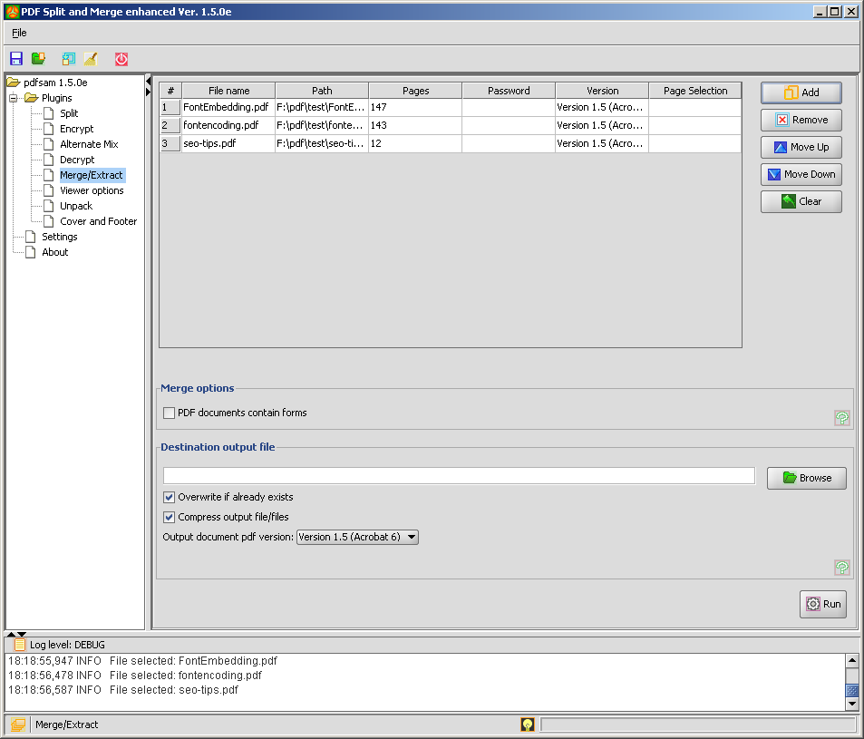
Double click the Page Selection cell if you want to merge only a subset of the document.

Fill with the pages subset you want to merge; page numbers are comprehended. You may use print notation like "2,12-16,17-" or simply "2" if you want to merge only page number 2.

Double click on the password field to set the password for protected documents. Protected documents may need you to input the password to be loaded by pdfsam. Fill the password field, right click on the table row and select "Reload".

Check the box if your documents contain pdf forms. This will tell pdfsam to use a different merge algorithm specific to deal with forms. Setting this options all the documents will be loaded into memory with a very high memory usage.

Fill the destination field with the output file name or select it using the "Browse" button. Check or uncheck "Overwrite" if you want overwrite the output pdf document if it already exists. Check or uncheck "Compress output" if you want to compress output document (Output document version 1.5 or above). Select a version for the output document.

You can automatically set a default output file by clicking with the right button on a file in the merge table and selecting "Set output file". This will fill the output filed with a default filename in the same directory as the selected file.

Click the "Run" button.

If no error occurs you'll see the progress bar growing till 100% and black messages on the log panel telling the process status, otherwise you'll find a red error message.

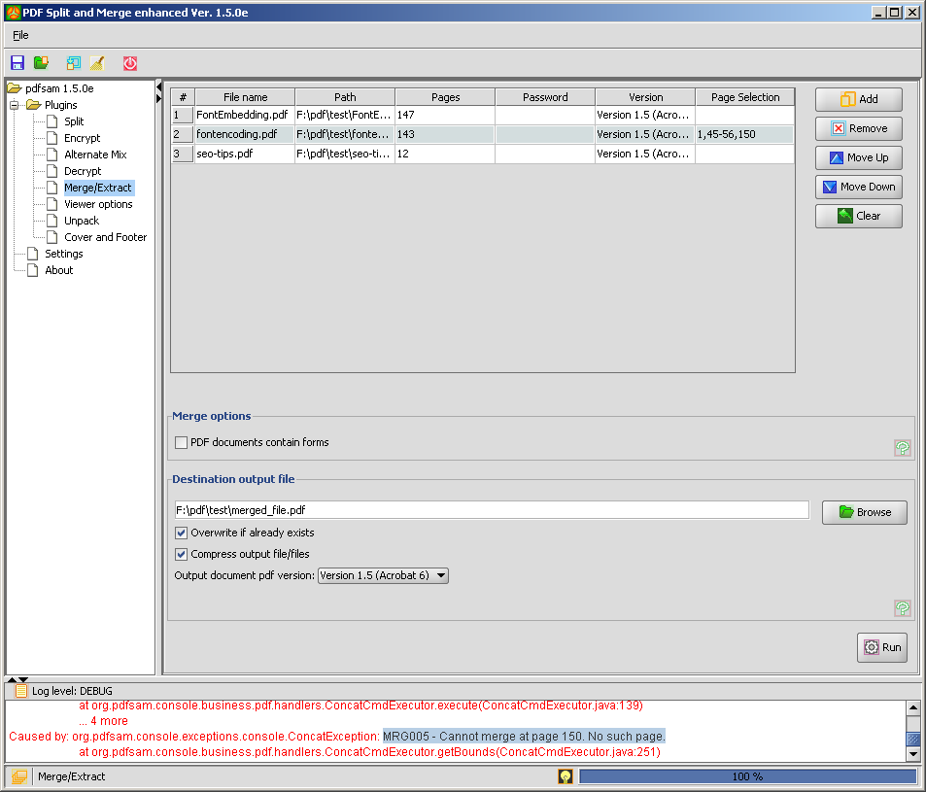
In the example above we had an error message saying we cannot merge page 150 because the document has only 143 pages.

If you don't provide a full output path for the output document pdfsam will ask you if you want to place the output document into the parent directory of the last selected input file.

Page extraction
You can extract portion of a single file:
- In merge section select only one file.
- Set a the page subset you need to extract (Ex. 12-23).
- Select an output file.
- Merge.

Export selected files
Right clicking on a selected file you can export the selected files list as an xml file that can be used as an input file for the console “concat” command, -l option.

Split
Here is the split main window:

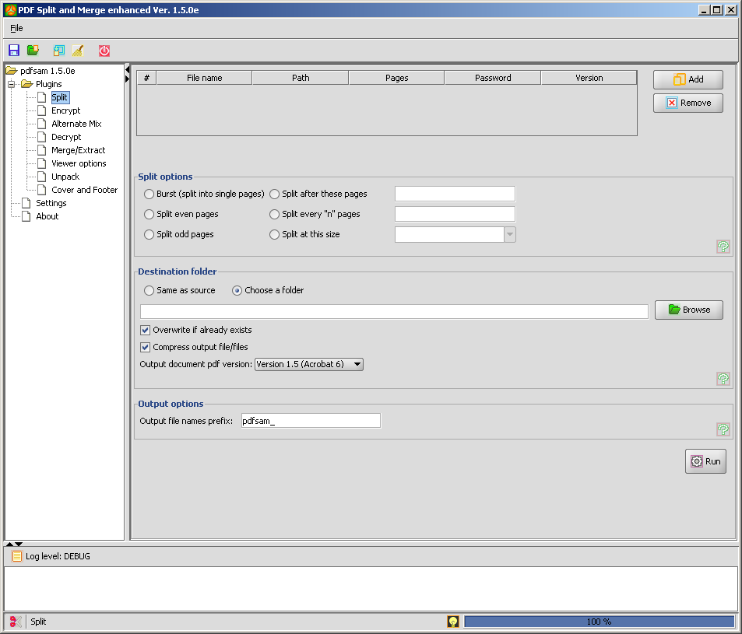
Click the "Add" button to select the pdf file to split.

Set the password for protected documents. Protected documents may need you to input the password to be loaded by pdfsam. Fill the password field, right click on the table row and select "Reload".

Select the split option you need:

- Burst splits the pdf file into single pages, one pdf file-one page.
- Split every "n" pages splits the pdf file into files made of "n" pages. (Ex. If you selected a file made of 100 pages and you split it every 25 pages, you'll have 4 pdf files made of 25 pages).
- Split even pages splits the pdf file every even page.
- Split odd pages splits the pdf file every odd page.
- Split after these pages splits the pdf file at the submitted page numbers. Numbers must be separated by "-" (Ex. 12-45-75). You may specify just one page number to split the document in two subdocuments. Note that page numbers will be ordered and zero, negative or too big numbers are pruned.
- Split at this size splits the pdf file in subfiles of the selected size (roughly).

Select the destination folder for resulting pdf files. Destination folder can be chosen clicking the "Browse" button and finding the folder on your filesystem or selecting "Same as source", with this option you'll have all output pdf files in the same directory as the source file. Check or uncheck "Overwrite" if you want overwrite the output pdf document if it already exists. Check or uncheck "Compress output" if you want to compress output document (Output document version 1.5 or above). Select a version for the output document.

Select output prefix if needed.

Output files will be named with the same name of the input pdf file and with a progressive leading number. You can specify a prefix for the output name and the final result will be something like "0_prefix_filename.pdf".
Starting from the release 0.7 pdfsam supports complex prefix. If the prefix contains one among [CURRENTPAGE], [TIMESTAMP] or [FILENUMBER] complex prefix are enabled and pdfsam perform variable substitution. Available variables are [CURRENTPAGE], [TIMESTAMP], [FILENUMBER], [BASENAME]. The variable [BASENAME] doesn't enable complex prefix because it doesn't ensure unique output filenames but it can be use together with [CURRENTPAGE], [TIMESTAMP] or [FILENUMBER]. Starting from the release 1.1.0 the two variables [CURRENTPAGE] and
[FILENUMBER] can be specified with an output number pattern using tha '#' character.
Ex: If you use something like [FILENUMBER###] you will have an output filename like 001filename. If you use something like [CURRENTPAGE##]_[FILENUMBER###]_[BASENAME] you will have an output filename like 05_001_filename.

Click "Run" and you find the operation result in the log section.
Alternate Mix
Here is the Alternate Mix main window.

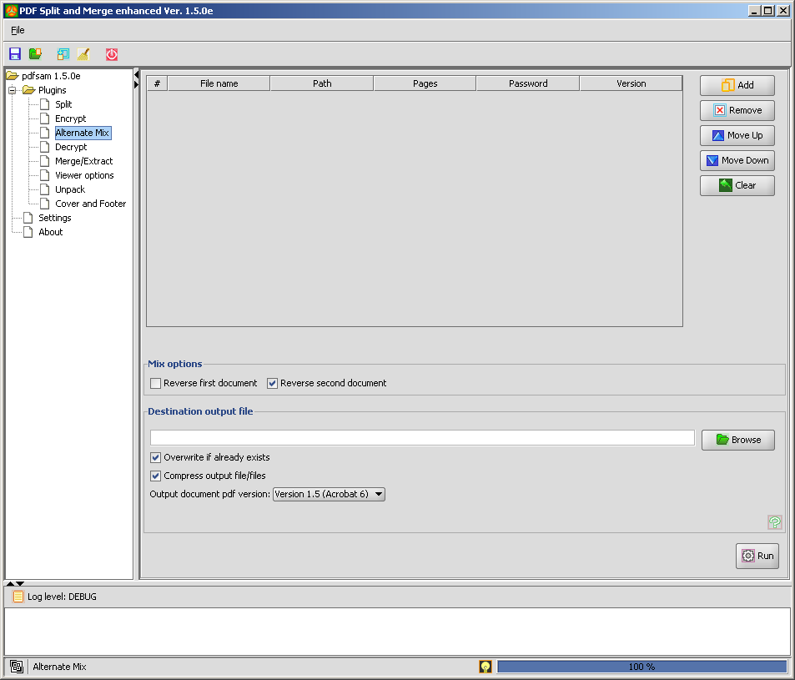
Click the Add button to select the pdf files you want to mix.
Set the password for protected documents. Protected documents may need you to input the password to be loaded by pdfsam. Fill the password field, right click on the table row and select "Reload".
Select if documents pages must be in reverse order or not.

Select a destination output file and set if it should overwrite an already existing file. Check or uncheck "Overwrite" if you want overwrite the output pdf document if it already exists. Check or uncheck "Compress output" if you want to compress output document (Output document version 1.5 or above). Select a version for the output document.

Click "Run" and you will find the operation result in the log section.
Encrypt
Here is the Encrypt main window.

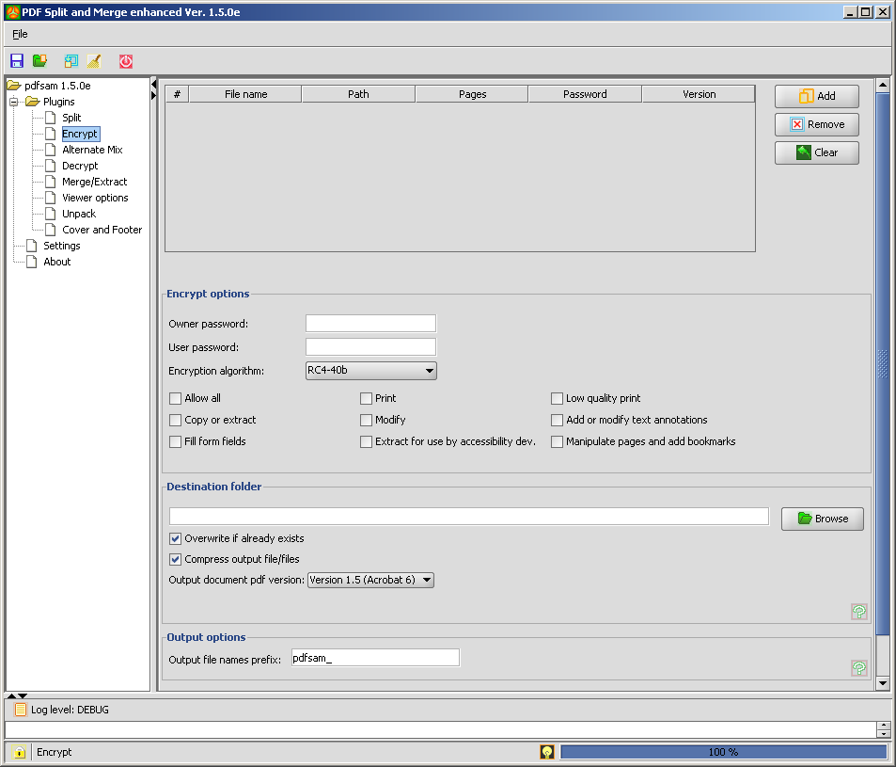
Click the "Add" button to select the pdf files you want to encrypt.
Set the password for protected documents. Protected documents may need you to input the password to be loaded by pdfsam. Fill the password field, right click on the table row and select "Reload".

Set the encrypt options:
- Owner password: The admin password to open the document with write permissions.
- User password: The user password to open the document with read permissions.
- Encryption Algorithm: The encryption type you want for your document.
Finally set the permissions for your document.

Select the destination folder for resulting encrypted pdf files. Check or uncheck "Overwrite" if you want overwrite the output pdf document if it already exists. Check or uncheck "Compress output" if you want to compress output document (Output document version 1.5 or above). Select a version for the output document.

Select output prefix if needed.

Output files will be named with the same name of the input pdf file. You can specify a prefix for the output name and the final result will be something like "prefix_filename.pdf".
Pdfsam also supports complex prefix. If the prefix contains [TIMESTAMP], complex prefix are enabled and pdfsam perform variable substitution. Available variables are [TIMESTAMP], [BASENAME]. The variable [BASENAME] doesn't enable complex prefix because it doesn't ensure unique output filenames but it can be use together with [TIMESTAMP].

Click "Run" and you find the operation result in the log section.

Cover and Footer
Here is the Cover and Footer main window.

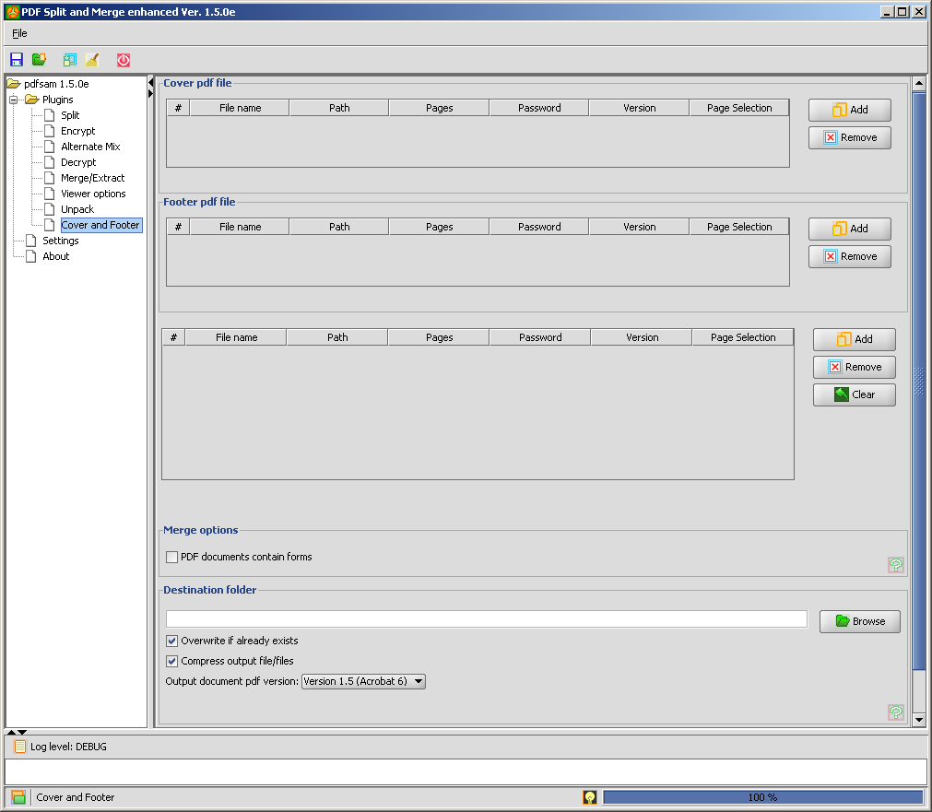
Click the "Add" button to select the pdf file you want to add as a cover.
Click the "Add" button to select the pdf file you want to add as a footer.
Click the "Add" button to select the pdf files you want to add you cover/footer.
Select pdf files; if you want to select more the one file press the "shift" or “ctrl” button on you keyboard.
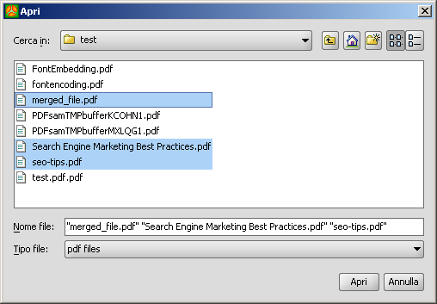

Once your files has been selected you'll see a table containing file details:
- File name: The file name.
- Path: The file absolute path in the file system.
- Pages: The total number of pages of the document.
- Password: An editable field to input the password for protected documents.
- Version: Pdf Version of the document.
- Page Selection: "All" means that you want to merge the whole document, "page-topage" means you want to merge only pages between "page" and "topage" comprehensive, "page-" means you want to merge pages starting from page till the end of the document, a single page number means that page. Comma separated value are accepted. (ex 4,13-25 if you want to merge page 4 and pages between 13 and 25).

Double click the Page Selection cell if you want to merge only a subset of the document.
Fill with the pages subset you want to merge; page numbers are comprehended.

Check the box if your documents contain pdf forms. This will tell pdfsam to use a different merge algorithm specific to deal with forms. Setting this options all the documents will be loaded into memory with a very high memory usage.

Fill the destination field with the output file name or select it using the "Browse" button. Check or uncheck "Overwrite" if you want overwrite the output pdf document if it already exists. Check or uncheck "Compress output" if you want to compress output document (Output document version 1.5 or above). Select a version for the output document.

You can automatically set a default output file by clicking with the right button on a file in the merge table and selecting "Set output file". This will fill the output filed with a default filename in the same directory as the selected file.

Click the "Run" button.

For each file in your table, if no error occurs you'll see the progress bar growing till 100% and a black message on the log panel saying "Total processed pages: xxxx-", otherwise you'll find a red error message.

Viewer options
Here is the Viewer options main window.

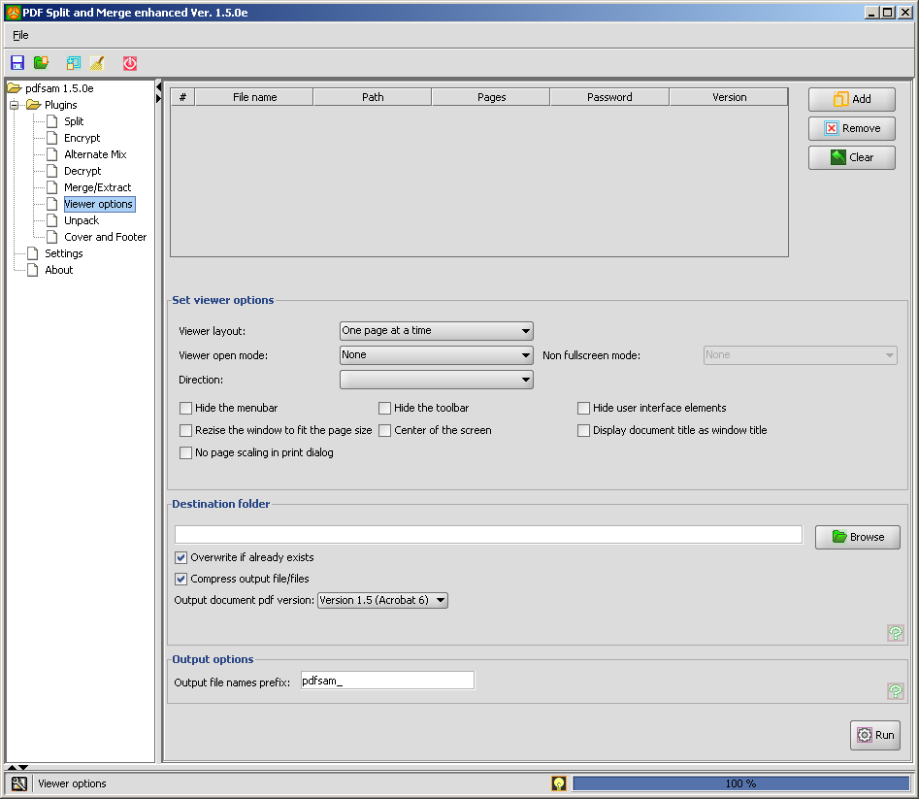
Click the "Add" button to select the pdf files you want to set viewer options.
Set the password for protected documents. Protected documents may need you to input the password to be loaded by pdfsam. Fill the password field, right click on the table row and select "Reload".

Set the viewer layout when displaying the document (one page at time, two page at time...).
Set the open mode of the viewer application (fullscreen, thumbnails panel, attachment panel ...).
Set the open mode for the document on exiting the fullscreen mode. This option is enable only when the selected open mode is “fullscreen”.
Set the predominant reading order for the text (left to right or right to left).

Set the viewer options for the input documents.

- Hide the menubar: hide the viewer application’s menubar when the document is active.
- Hide the toolbar: hide the viewer application’s toolbars when the document is active.
- Hide user interface elements:specify whether to hide user interface elements inthe document’s window (such as scroll bars and navigation controls), leaving only the document’s contents displayed.
- Resize the window to fit page size: specify whether to resize the document’s window to fit the size of the first displayed page.
- Center of the screen: specify whether to position the document’s window in the center of the screen.
- Display document title as window title: specify whether the window’s title bar should display the document title taken from the Title entry of the document.
- No page scaling in print dialog:specify that the print dialog should reflect no page scaling,

Select the destination folder for resulting pdf files. Check or uncheck "Overwrite" if you want overwrite the output pdf document if it already exists. Check or uncheck "Compress output" if you want to compress output document (Output document version 1.5 or above). Select a version for the output document.

Select output prefix if needed.

Output files will be named with the same name of the input pdf file. You can specify a prefix for the output name and the final result will be something like "prefix_filename.pdf".
Pdfsam also supports complex prefix. If the prefix contains [TIMESTAMP], complex prefix are enabled and pdfsam perform variable substitution. Available variables are [TIMESTAMP], [BASENAME]. The variable [BASENAME] doesn't enable complex prefix because it doesn't ensure unique output filenames but it can be use together with [TIMESTAMP].

Click "Run" and you find the operation result in the log section.

Decrypt
Here is the Decrypt main window.

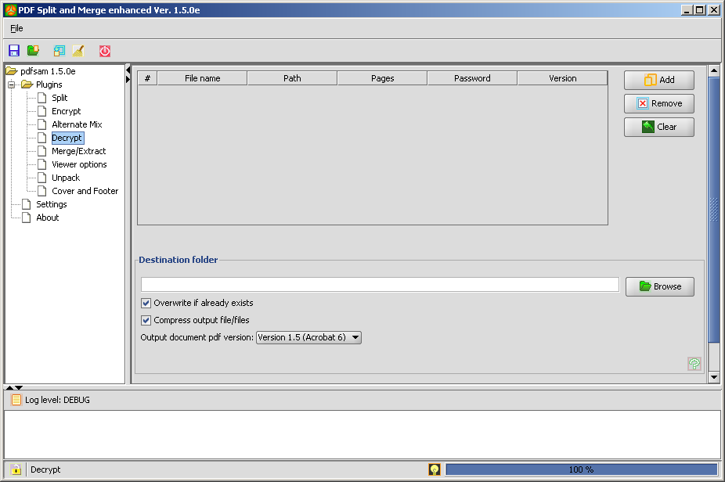
Click the "Add" button to select the pdf files you want to decrypt.
Set the password for protected documents. Protected documents may need you to input the password to be loaded by pdfsam. Fill the password field, right click on the table row and select "Reload".

Select the destination folder for resulting decrypted pdf files. Check or uncheck "Overwrite" if you want overwrite the output pdf document if it already exists. Check or uncheck "Compress output" if you want to compress output document (Output document version 1.5 or above). Select a version for the output document.

Click "Run" and you find the operation result in the log section.

Unpack
Here is the Unpack main window.

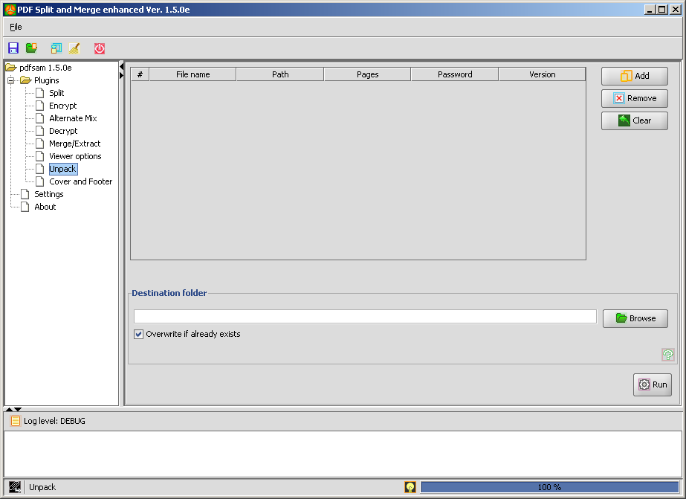
Click the "Add" button to select the pdf files you want to unpack.
Set the password for protected documents. Protected documents may need you to input the password to be loaded by pdfsam. Fill the password field, right click on the table row and select "Reload".

Select the destination folder for resulting files. Check or uncheck "Overwrite" if you want overwrite output files if they already exists. Every attachment extracted from the input documents will be saved into the destination folder.

Click "Run" and you find the operation result in the log section.
Environment
Using pdfsam you'll be able to save and load an environment.

The feature will let you save an xml file containing the current status of every pdfsam plugin. This feature is useful if you have recurrent jobs and you don't want to set plugin options every time.
Settings
Here is the Settings main window.

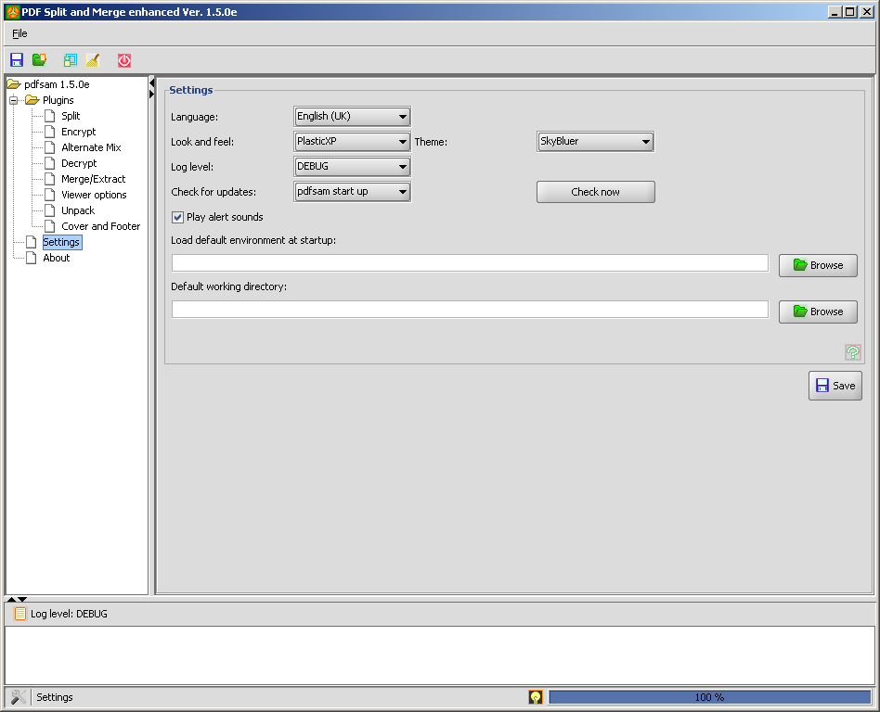
In this section you'll be able to set your preferences.
- Language: set your language
- Look and feel: pdfsam look and feel
- Log level: log messages level you want to see in the log panel.
- Check for updates: set when pdfsam should check for a new version available
- Play alert sounds: enable pdfsam to play sounds to inform about the pdf manipulation result.
- Default environment: pdfsam will load this file at start up.
- Default working directory: set the default working directory. This will tell pdfsam where to open file chooser and where to save output files if you don't set an output file or directory

Click “Save” and restart pdfsam to have your changes applied.

About
This window will give you some information about the pdfsam version you are running.

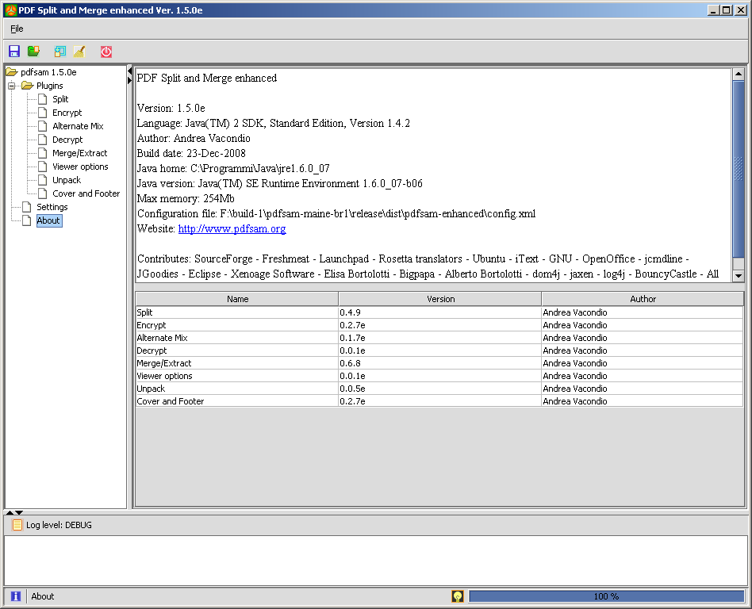
Here you'll find information about the pdfsam version, plugins version, JVM version and configuration file used. Starting from the 1.4.0 version, pdfsam looks for the config.xml in the ${user.home}/.pdfsam directory, if it doesn't find the file it looks in the pdfsam directory.
Log Window
The pdfsam log window will help you to understand how pdfsam is working. Any black message (DEBUG or INFO) is just an information about what pdfsam is doing, a blue message (WARNING) is a warning telling that there's an unexpected situation that pdfsam can handle, a red message (ERROR or FATAL) tells that there's an error that pdfsam can't handle.
Right clicking on the log window a context menu will appear. You can select and copy the log text, clear the log window or save the log text to a file.
Setting the log level to OFF using the settings panel will switch off any log message.

Console
pdfsam-console is a command line application. It uses jcmdline to parse input parameters and it executes the proper command. It's the core application and it provides pdf manipulation. The main GUI loads plugins, once clicked the plugin "Run" button (merge or split), the plugin performs input data validation and, if everything is correct, it creates an arguments array and than it sends it to the console.
To run the console use the scripts in the “bin” subdirectory or type the following command: "java -Dlog4j.configuration=console-log4j.xml -jar /PATH_TO_PDFSAM/lib/pdfsam-console-CURRENT_VERSION.jar". It's important to add the argument -Dlog4j.configuration=console-log4j.xml, this will configure the log4j framework to print log messages to the system output.
Starting from the 1.0.0 version of pdfsam (1.1.0 version of the pdfsam-console), enhanced and basic console have been unified, this mean that you can find all the enhanced feature in the basic console.

Starting from the 2.0.0 version the pdfsam-console has been dual licensed and you can choose among the GPLv2 and the LGPLv2 licenses.

Run the console with the option -h to have a generic help, run it with -h command to have a specific help on the command.

Here is a list of the console arguments:

Usage: java -Dlog4j.configuration=console-log4j.xml -jar pdfsam-console-VERSION.jar [options] command
where:
command = command to execute {[concat], [split], [encrypt], [mix], [unpack], [setviewer], [slideshow], [decrypt]} (required)

and options are:

Merge
-?
prints usage to stdout; exits (optional)
-compressed
compress output file (optional)
-copyfields
input pdf documents contain forms (high memory usage) (optional)

-f <f>
pdf files to concat: a list of existing pdf files (EX. -f /tmp/file1.pdf -f /tmp/file2.pdf:password) (optional)
-h
prints usage to stdout; exits (optional)
-help
displays verbose help information (optional)
-l <f>
xml or csv file containing pdf files list to concat. If csv file in comma separated value format; if xml file <filelist><file value="filepath" /></filelist> (optional)
-license
displays license information (optional)
-log <f>
text file to log output messages (optional)
-o <f>
pdf output file: if it doesn't exist it's created, if it exists it must be writeable (required)
-overwrite
overwrite existing output file (optional)
-pdfversion <s>
pdf version of the output document/s. (optional)
-u <s>
page selection script. You can set a subset of pages to merge. Accepted values: "all" or "num1-num2" (EX. -f /tmp/file1.pdf -f /tmp/file2.pdf -u all:all:), (EX. -f /tmp/file1.pdf -f /tmp/file2.pdf -u all:12-14:) to merge file1.pdf and pages 12,13,14 of file2.pdf. If -u is not set default behaviour is to merge document completely (optional)
-version
displays command's version (optional)

The -l option takes an xml input file as pdf document input list.
This is an example:

<?xml version="1.0" encoding="UTF-8"?>
<filelist>
<file value="f:\pdf\inputFile.pdf" />
<file value="f:\pdf\inputFile2.pdf" password="test"/>
<fileset usecurrentdir="true">
<file value="inputFile1.pdf" />
<file value="inputFile2.pdf" />
</fileset>
<fileset dir="f:\tempdir\subdir" usecurrentdir="false">
<file value="inputFile1.pdf" />
<file value="inputFile2.pdf" />
</fileset>
<fileset dir="f:\tempdir\subdir2">
<file value="inputFile1.pdf" />
<file value="inputFile2.pdf" />
<file value="inputFile3.pdf" />
</fileset>
</filelist>

There are different ways to set the files you want to concat.
- <file value="f:\pdf\inputFile.pdf" />
can be used for a single file and accept the “password” attribute if the document is password protected.
- <fileset usecurrentdir="true">
<file value="inputFile1.pdf" />
<file value="inputFile2.pdf" />
</fileset>
can be used for a set of files placed into the same directory of the xml input file.
- <fileset dir="f:\tempdir\subdir" usecurrentdir="false">
<file value="inputFile1.pdf" />
<file value="inputFile2.pdf" />
</fileset>
<fileset dir="f:\tempdir\subdir2">
<file value="inputFile1.pdf" />
<file value="inputFile2.pdf" />
<file value="inputFile3.pdf" />
</fileset>
can be both used for a set of files placed into the “dir” directory
Split
-?
prints usage to stdout; exits (optional)
-b <n>
size in bytes to split at if -s is SIZE (optional)
-compressed
compress output file (optional)
-f <f>
input pdf file to split (required)
-h
prints usage to stdout; exits (optional)
-help
displays verbose help information (optional)
-license
displays license information (optional)
-log <f>
text file to log output messages (optional)
-n <s>
page number to split at if -s is SPLIT or NSPLIT (optional)
-o <dir>
output directory (required)
-overwrite
overwrite existing output file (optional)
-p <s>
prefix for the output files name (optional)
-pdfversion <s>
pdf version of the output document/s. (optional)
-s <s>
split type {[BURST], [ODD], [EVEN], [SPLIT], [NSPLIT], [SIZE]}
(required)
-version
displays command's version (optional)

Encrypt
-?
prints usage to stdout; exits (optional)
-allow <s>
permissions: a list of permissions {[print], [modify], [copy], [fill], [assembly], [screenreaders], [modifyannotation], [degradedprinting]} (optional)
-apwd <s>
administrator password for the document (optional)
-compressed
compress output file (optional)
-etype <s>
encryption angorithm {[rc4_40], [rc4_128], [aes_128]}. If omitted it uses rc4_128 (optional)
-f <f>
pdf files to encrypt: a list of existing pdf files (EX. -f /tmp/file1.pdf -f /tmp/file2.pdf) (required)
-h
prints usage to stdout; exits (optional)
-help
displays verbose help information (optional)
-license
displays license information (optional)
-log <f>
text file to log output messages (optional)
-o <dir>
output directory (required)
-overwrite
overwrite existing output file (optional)
-p <s>
prefix for the output files name (optional)
-pdfversion <s>
pdf version of the output document/s. (optional)
-upwd <s>
user password for the document (optional)
-version
displays command's version (optional)

Mix
-?
prints usage to stdout; exits (optional)
-compressed
compress output file (optional)
-f1 <f>
first input pdf file to split (required)
-f2 <f>
second input pdf file to split (required)
-h
prints usage to stdout; exits (optional)
-help
displays verbose help information (optional)
-license
displays license information (optional)
-log <f>
text file to log output messages (optional)
-o <f>
pdf output file: if it doesn't exist it's created, if it exists it must be writeable (required)
-overwrite
overwrite existing output file (optional)
-pdfversion <s>
pdf version of the output document/s. (optional)
-reversefirst
reverse first input file (optional)
-reversesecond
reverse second input file (optional)
-version
displays command's version (optional)

Unpack
-?
prints usage to stdout; exits (optional)
-d <dir>
input directory (optional)
-f <f>
pdf files to unpack: a list of existing pdf files (EX. -f /tmp/file1.pdf -f /tmp/file2.pdf) (optional)
-h
prints usage to stdout; exits (optional)
-help
displays verbose help information (optional)
-license
displays license information (optional)
-log <f>
text file to log output messages (optional)
-o <dir>
output directory (required)
-overwrite
overwrite existing output file (optional)
-version
displays command's version (optional)

Decrypt
-?
prints usage to stdout; exits (optional)
-compressed
compress output file (optional)
-f <f>
pdf files to decrypt: a list of existing pdf files (EX. -f /tmp/file1.pdf -f /tmp/file2.pdf) (optional)
-h
prints usage to stdout; exits (optional)
-help
displays verbose help information (optional)
-license
displays license information (optional)
-log <f>
text file to log output messages (optional)
-o <dir>
output directory (required)
-overwrite
overwrite existing output file (optional)
-p <s>
prefix for the output files name (optional)
-pdfversion <s>
pdf version of the output document/s. (optional)
-version
displays command's version (optional)

Setviewer
-?
prints usage to stdout; exits (optional)
-centerwindow
center of the screen (optional)
-compressed
compress output file (optional)
-direction <s>
direction {l2r, r2l}. If omitted it uses l2r (optional)
-displaydoctitle
display document title metadata as window title (optional)
-f <f>
pdf files to set the viewer options: a list of existing pdf files (EX. -f /tmp/file1.pdf -f /tmp/file2.pdf) (required)
-fitwindow
resize the window to fit the page size (optional)
-h
prints usage to stdout; exits (optional)
-help
displays verbose help information (optional)
-hidemenu
hide the menu bar (optional)
-hidetoolbar
hide the toolbar (optional)
-hidewindowui
hide user interface elements (optional)
-layout <s>
layout for the viewer. { onecolumn, singlepage, twocolumnl, twocolumnr, twopagel, twopager} (optional)
-license
displays license information (optional)
-log <f>
text file to log output messages (optional)
-mode <s>
open mode for the viewer {attachments, fullscreen, none, ocontent, outlines, thumbs}. If omitted it uses none (optional)
-nfsmode <s>
non full screen mode for the viewer when exiting full screen mode {nfsnone, nfsocontent, nfsoutlines, nfsthumbs}. If omitted it uses nfsnone (optional)
-noprintscaling
no page scaling in print dialog (optional)
-o <dir>
output directory (required)
-overwrite
overwrite existing output file (optional)
-p <s>
prefix for the output files name (optional)
-pdfversion <s>
pdf version of the output document/s. (optional)
-version
displays command's version (optional)

Slideshow
-?
prints usage to stdout; exits (optional)
-compressed
compress output file (optional)
-dt <s>
slideshow default transition effect definition (optional)
Syntax:
transitiontype:transitiondurationinsec:pagedisplaydurationinsec.
Example:
blindv:1:3 uses a 1 second long vertical blind to display pages for 3
seconds
-f <f>
input pdf file to set the slide show options (required)
-fullscreen
open the document in fullscreen mode (optional)
-h
prints usage to stdout; exits (optional)
-help
displays verbose help information (optional)
-l <f>
xml file containing all the transitions effects definitions (optional)
-license
displays license information (optional)
-log <f>
text file to log output messages (optional)
-o <f> pdf output file: if it doesn't exist it's created, if it exists it must be writeable (required)
-overwrite
overwrite existing output file (optional)
-p <s>
prefix for the output files name (optional)
-pdfversion <s>
pdf version of the output document/s. (optional)
-t <s>
slideshow transition effect definition (optional)
Syntax:
transitiontype:transitiondurationinsec:pagedisplaydurationinsec:pagenumber.
Possible transitiontype values { blindh, blindv, wipeb2t, glitterd, dissolve,
inwardbox, glitterl2r, wipel2r, outwardbox, wiper2l, splithin, splithout,
splitvin, splitvout, glittert2b, wipet2b}
Example:
blindv:1:3:57 uses a 1 second long vertical blind to display page
number 57 for 3 seconds

-version
displays command's version (optional)

The -l option takes an xml input file as pdf document input list.
This is an example:

<?xml version="1.0" encoding="UTF-8"?>
<transitions defaulttype="type" defaulttduration=”sec” defaultduration="sec">
<transition type="type" tduration="sec" duration="sec" pagenumber="number" />
<transition type="type" tduration="sec" duration="sec" pagenumber="number" />
<transition type="type" tduration="sec" duration="sec" pagenumber="number" />
<transition type="type" tduration="sec" duration="sec" pagenumber="number" />
................
</transitions>

Tweak&Tips
1.
When you see this

move the mouse over it to have some tooltip help.

2.
If you have some trouble loading plugins try this:
- Open the file config.xml with good editor (Notepad++..) .
- Fill the tag “plugs_absolute_dir” with the absolute path to your plugins direcotry .
- Save .
pdfsam tries to find plugins directory but, if there’s some trouble, you can specify the absolute path as described.

3.
Move to the “doc/examples” subdirectory to have some examples on how run the concat command using xml or csv file input.

4.
Move to the “doc/licenses” subdirectory to have informations about licenses of pdfsam and libraries used by pdfsam.

5.
If you have to work with big pdf documents (hundreds MB) try running pdfsam setting a different Xmx value. Example: running the command “java -Xmx512m -jar pdfsam-1.4.0.jar” will run pdfsam with 512 Mb of memory instead of 64, this should prevent OutOfMemory errors (unless your documents are very very big). You can also set the Xmx value into the shell scripts provided into the bin subdirectory.

Thanks to open source projects involved
This simple tool is free software and this has been possible thanks to many other open source projects.
I'd like to thank:
Ububtu linux distro because most of the time i work on pdfsam at home, on my personal pc.
Eclipse, the development platform i used.
OpenOffice, the suite i used to write this document.
Notepad++, the editor i used many times to make changes in text files (php, txt etc) while working on win32 platform.
SourceForge because it hosts pdfsam giving me a lot of useful services.
Launchpad for the translation platform.
WordPress for the website.
phpBB for the forum.
iText, jGoodies, jcmdline, jaxen, dom4j, log4j, Bouncy Castle libraries to make pdfsam a working tool.
Elisa Bortolotti for her icons.
Bigpapa for tests and translations.
Free Software Foundation for the GPL license.
All the pdfsam community for contributions, tests, translations, support and suggestions.

License
The GNU General Public License (GPL)
Version 2, June 1991

Copyright (C) 1989, 1991 Free Software Foundation, Inc.
59 Temple Place, Suite 330, Boston, MA 02111-1307 USA

Everyone is permitted to copy and distribute verbatim copies
of this license document, but changing it is not allowed.

TERMS AND CONDITIONS FOR COPYING, DISTRIBUTION AND MODIFICATION

0. This License applies to any program or other work which contains a notice placed by the copyright holder saying it may be distributed under the terms of this General Public License. The "Program", below, refers to any such program or work, and a "work based on the Program" means either the Program or any derivative work under copyright law: that is to say, a work containing the Program or a portion of it, either verbatim or with modifications and/or translated into another language. (Hereinafter, translation is included without limitation in the term "modification".) Each licensee is addressed as "you".

Activities other than copying, distribution and modification are not covered by this License; they are outside its scope. The act of running the Program is not restricted, and the output from the Program is covered only if its contents constitute a work based on the Program (independent of having been made by running the Program). Whether that is true depends on what the Program does.

1. You may copy and distribute verbatim copies of the Program's source code as you receive it, in any medium, provided that you conspicuously and appropriately publish on each copy an appropriate copyright notice and disclaimer of warranty; keep intact all the notices that refer to this License and to the absence of any warranty; and give any other recipients of the Program a copy of this License along with the Program.

You may charge a fee for the physical act of transferring a copy, and you may at your option offer warranty protection in exchange for a fee.

2. You may modify your copy or copies of the Program or any portion of it, thus forming a work based on the Program, and copy and distribute such modifications or work under the terms of Section 1 above, provided that you also meet all of these conditions:

a) You must cause the modified files to carry prominent notices stating that you changed the files and the date of any change.

b) You must cause any work that you distribute or publish, that in whole or in part contains or is derived from the Program or any part thereof, to be licensed as a whole at no charge to all third parties under the terms of this License.

c) If the modified program normally reads commands interactively when run, you must cause it, when started running for such interactive use in the most ordinary way, to print or display an announcement including an appropriate copyright notice and a notice that there is no warranty (or else, saying that you provide a warranty) and that users may redistribute the program under these conditions, and telling the user how to view a copy of this License. (Exception: if the Program itself is interactive but does not normally print such an announcement, your work based on the Program is not required to print an announcement.)

These requirements apply to the modified work as a whole. If identifiable sections of that work are not derived from the Program, and can be reasonably considered independent and separate works in themselves, then this License, and its terms, do not apply to those sections when you distribute them as separate works. But when you distribute the same sections as part of a whole which is a work based on the Program, the distribution of the whole must be on the terms of this License, whose permissions for other licensees extend to the entire whole, and thus to each and every part regardless of who wrote it.

Thus, it is not the intent of this section to claim rights or contest your rights to work written entirely by you; rather, the intent is to exercise the right to control the distribution of derivative or collective works based on the Program.

In addition, mere aggregation of another work not based on the Program with the Program (or with a work based on the Program) on a volume of a storage or distribution medium does not bring the other work under the scope of this License.

3. You may copy and distribute the Program (or a work based on it, under Section 2) in object code or executable form under the terms of Sections 1 and 2 above provided that you also do one of the following:

a) Accompany it with the complete corresponding machine-readable source code, which must be distributed under the terms of Sections 1 and 2 above on a medium customarily used for software interchange; or,

b) Accompany it with a written offer, valid for at least three years, to give any third party, for a charge no more than your cost of physically performing source distribution, a complete machine-readable copy of the corresponding source code, to be distributed under the terms of Sections 1 and 2 above on a medium customarily used for software interchange; or,

c) Accompany it with the information you received as to the offer to distribute corresponding source code. (This alternative is allowed only for noncommercial distribution and only if you received the program in object code or executable form with such an offer, in accord with Subsection b above.)

The source code for a work means the preferred form of the work for making modifications to it. For an executable work, complete source code means all the source code for all modules it contains, plus any associated interface definition files, plus the scripts used to control compilation and installation of the executable. However, as a special exception, the source code distributed need not include anything that is normally distributed (in either source or binary form) with the major components (compiler, kernel, and so on) of the operating system on which the executable runs, unless that component itself accompanies the executable.

If distribution of executable or object code is made by offering access to copy from a designated place, then offering equivalent access to copy the source code from the same place counts as distribution of the source code, even though third parties are not compelled to copy the source along with the object code.

4. You may not copy, modify, sublicense, or distribute the Program except as expressly provided under this License. Any attempt otherwise to copy, modify, sublicense or distribute the Program is void, and will automatically terminate your rights under this License. However, parties who have received copies, or rights, from you under this License will not have their licenses terminated so long as such parties remain in full compliance.

5. You are not required to accept this License, since you have not signed it. However, nothing else grants you permission to modify or distribute the Program or its derivative works. These actions are prohibited by law if you do not accept this License. Therefore, by modifying or distributing the Program (or any work based on the Program), you indicate your acceptance of this License to do so, and all its terms and conditions for copying, distributing or modifying the Program or works based on it.

6. Each time you redistribute the Program (or any work based on the Program), the recipient automatically receives a license from the original licensor to copy, distribute or modify the Program subject to these terms and conditions. You may not impose any further restrictions on the recipients' exercise of the rights granted herein. You are not responsible for enforcing compliance by third parties to this License.

7. If, as a consequence of a court judgement or allegation of patent infringement or for any other reason (not limited to patent issues), conditions are imposed on you (whether by court order, agreement or otherwise) that contradict the conditions of this License, they do not excuse you from the conditions of this License. If you cannot distribute so as to satisfy simultaneously your obligations under this License and any other pertinent obligations, then as a consequence you may not distribute the Program at all. For example, if a patent license would not permit royalty-free redistribution of the Program by all those who receive copies directly or indirectly through you, then the only way you could satisfy both it and this License would be to refrain entirely from distribution of the Program.

If any portion of this section is held invalid or unenforceable under any particular circumstance, the balance of the section is intended to apply and the section as a whole is intended to apply in other circumstances.

It is not the purpose of this section to induce you to infringe any patents or other property right claims or to contest validity of any such claims; this section has the sole purpose of protecting the integrity of the free software distribution system, which is implemented by public license practices. Many people have made generous contributions to the wide range of software distributed through that system in reliance on consistent application of that system; it is up to the author/donor to decide if he or she is willing to distribute software through any other system and a licensee cannot impose that choice.

This section is intended to make thoroughly clear what is believed to be a consequence of the rest of this License.

8. If the distribution and/or use of the Program is restricted in certain countries either by patents or by copyrighted interfaces, the original copyright holder who places the Program under this License may add an explicit geographical distribution limitation excluding those countries, so that distribution is permitted only in or among countries not thus excluded. In such case, this License incorporates the limitation as if written in the body of this License.

9. The Free Software Foundation may publish revised and/or new versions of the General Public License from time to time. Such new versions will be similar in spirit to the present version, but may differ in detail to address new problems or concerns.

Each version is given a distinguishing version number. If the Program specifies a version number of this License which applies to it and "any later version", you have the option of following the terms and conditions either of that version or of any later version published by the Free Software Foundation. If the Program does not specify a version number of this License, you may choose any version ever published by the Free Software Foundation.

10. If you wish to incorporate parts of the Program into other free programs whose distribution conditions are different, write to the author to ask for permission. For software which is copyrighted by the Free Software Foundation, write to the Free Software Foundation; we sometimes make exceptions for this. Our decision will be guided by the two goals of preserving the free status of all derivatives of our free software and of promoting the sharing and reuse of software generally.

NO WARRANTY

11. BECAUSE THE PROGRAM IS LICENSED FREE OF CHARGE, THERE IS NO WARRANTY FOR THE PROGRAM, TO THE EXTENT PERMITTED BY APPLICABLE LAW. EXCEPT WHEN OTHERWISE STATED IN WRITING THE COPYRIGHT HOLDERS AND/OR OTHER PARTIES PROVIDE THE PROGRAM "AS IS" WITHOUT WARRANTY OF ANY KIND, EITHER EXPRESSED OR IMPLIED, INCLUDING, BUT NOT LIMITED TO, THE IMPLIED WARRANTIES OF MERCHANTABILITY AND FITNESS FOR A PARTICULAR PURPOSE. THE ENTIRE RISK AS TO THE QUALITY AND PERFORMANCE OF THE PROGRAM IS WITH YOU. SHOULD THE PROGRAM PROVE DEFECTIVE, YOU ASSUME THE COST OF ALL NECESSARY SERVICING, REPAIR OR CORRECTION.

12. IN NO EVENT UNLESS REQUIRED BY APPLICABLE LAW OR AGREED TO IN WRITING WILL ANY COPYRIGHT HOLDER, OR ANY OTHER PARTY WHO MAY MODIFY AND/OR REDISTRIBUTE THE PROGRAM AS PERMITTED ABOVE, BE LIABLE TO YOU FOR DAMAGES, INCLUDING ANY GENERAL, SPECIAL, INCIDENTAL OR CONSEQUENTIAL DAMAGES ARISING OUT OF THE USE OR INABILITY TO USE THE PROGRAM (INCLUDING BUT NOT LIMITED TO LOSS OF DATA OR DATA BEING RENDERED INACCURATE OR LOSSES SUSTAINED BY YOU OR THIRD PARTIES OR A FAILURE OF THE PROGRAM TO OPERATE WITH ANY OTHER PROGRAMS), EVEN IF SUCH HOLDER OR OTHER PARTY HAS BEEN ADVISED OF THE POSSIBILITY OF SUCH DAMAGES.

END OF TERMS AND CONDITIONS

Artwork License

Attribution-Noncommercial-Share Alike 3.0 Unported

You are free:
- to Share -- to copy, distribute, display, and perform the work
- to Remix -- to make derivative works

Under the following conditions:
- Attribution. You must attribute the work in the manner specified by the author or licensor.
- Noncommercial. You may not use this work for commercial purposes.
- Share Alike. If you alter, transform, or build upon this work, you may distribute the resulting work only under a license identical to this one.
- For any reuse or distribution, you must make clear to others the license terms of this work.
- Any of these conditions can be waived if you get permission from the copyright holder.
- Nothing in this license impairs or restricts the author's moral rights.

Tutorial license

Attribution-Noncommercial-Share Alike 3.0 Unported

You are free:
- to Share -- to copy, distribute, display, and perform the work
- to Remix -- to make derivative works

Under the following conditions:
- Attribution. You must attribute the work in the manner specified by the author or licensor.
- Noncommercial. You may not use this work for commercial purposes.
- Share Alike. If you alter, transform, or build upon this work, you may distribute the resulting work only under a license identical to this one.
- For any reuse or distribution, you must make clear to others the license terms of this work.
- Any of these conditions can be waived if you get permission from the copyright holder.
- Nothing in this license impairs or restricts the author's moral rights.

From the official http://java.sun.com

