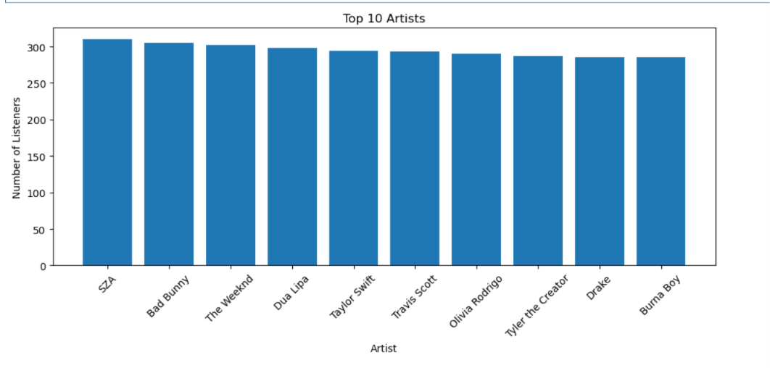
BAR CHART FOR TOP ARTISTS
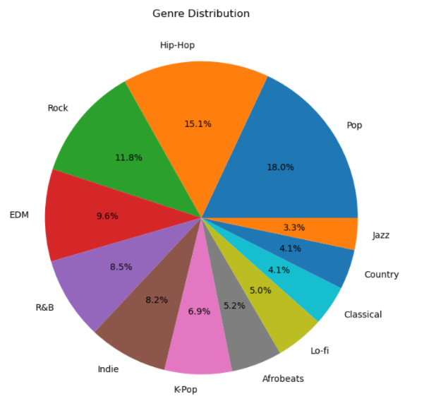
PIE CHART FOR GENRE DISTRIBUTION

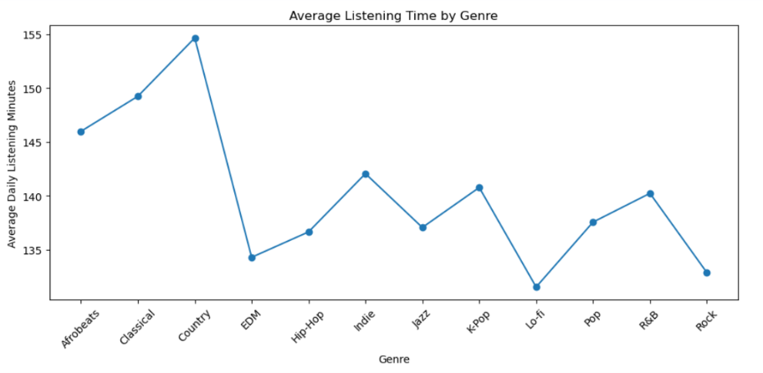
LINE CHART FOR LISTENING BEHAVIOUR

