Tugas_Modul4

Torangto Situngkir

10/10/2020

1

library(dslabs)  
data(murders)  
str(murders)

## 'data.frame': 51 obs. of 5 variables:  
## $ state : chr "Alabama" "Alaska" "Arizona" "Arkansas" ...  
## $ abb : chr "AL" "AK" "AZ" "AR" ...  
## $ region : Factor w/ 4 levels "Northeast","South",..: 2 4 4 2 4 4 1 2 2 2 ...  
## $ population: num 4779736 710231 6392017 2915918 37253956 ...  
## $ total : num 135 19 232 93 1257 ...

pop <- murders$population  
 sort(pop)[[1]]

## [1] 563626

2

order(pop)[[1]]

## [1] 51

3

which.min(pop) == order(pop)[[1]]

## [1] TRUE

4

murders$state[[order(pop)[[1]]]]

## [1] "Wyoming"

5

ranks <- rank(murders$population)  
 my_df <- data.frame(name=murders$state,peringkat=ranks)  
 my_df

## name peringkat  
## 1 Alabama 29  
## 2 Alaska 5  
## 3 Arizona 36  
## 4 Arkansas 20  
## 5 California 51  
## 6 Colorado 30  
## 7 Connecticut 23  
## 8 Delaware 7  
## 9 District of Columbia 2  
## 10 Florida 49  
## 11 Georgia 44  
## 12 Hawaii 12  
## 13 Idaho 13  
## 14 Illinois 47  
## 15 Indiana 37  
## 16 Iowa 22  
## 17 Kansas 19  
## 18 Kentucky 26  
## 19 Louisiana 27  
## 20 Maine 11  
## 21 Maryland 33  
## 22 Massachusetts 38  
## 23 Michigan 43  
## 24 Minnesota 31  
## 25 Mississippi 21  
## 26 Missouri 34  
## 27 Montana 8  
## 28 Nebraska 14  
## 29 Nevada 17  
## 30 New Hampshire 10  
## 31 New Jersey 41  
## 32 New Mexico 16  
## 33 New York 48  
## 34 North Carolina 42  
## 35 North Dakota 4  
## 36 Ohio 45  
## 37 Oklahoma 24  
## 38 Oregon 25  
## 39 Pennsylvania 46  
## 40 Rhode Island 9  
## 41 South Carolina 28  
## 42 South Dakota 6  
## 43 Tennessee 35  
## 44 Texas 50  
## 45 Utah 18  
## 46 Vermont 3  
## 47 Virginia 40  
## 48 Washington 39  
## 49 West Virginia 15  
## 50 Wisconsin 32  
## 51 Wyoming 1

6

ind = order(my_df$peringkat)  
 my_dff = data.frame(name=(sort(murders$state))[ind],Populasi = sort(murders$population),Peringkat = sort(ranks))  
 my_dff

## name Populasi Peringkat  
## 1 Wyoming 563626 1  
## 2 District of Columbia 601723 2  
## 3 Vermont 625741 3  
## 4 North Dakota 672591 4  
## 5 Alaska 710231 5  
## 6 South Dakota 814180 6  
## 7 Delaware 897934 7  
## 8 Montana 989415 8  
## 9 Rhode Island 1052567 9  
## 10 New Hampshire 1316470 10  
## 11 Maine 1328361 11  
## 12 Hawaii 1360301 12  
## 13 Idaho 1567582 13  
## 14 Nebraska 1826341 14  
## 15 West Virginia 1852994 15  
## 16 New Mexico 2059179 16  
## 17 Nevada 2700551 17  
## 18 Utah 2763885 18  
## 19 Kansas 2853118 19  
## 20 Arkansas 2915918 20  
## 21 Mississippi 2967297 21  
## 22 Iowa 3046355 22  
## 23 Connecticut 3574097 23  
## 24 Oklahoma 3751351 24  
## 25 Oregon 3831074 25  
## 26 Kentucky 4339367 26  
## 27 Louisiana 4533372 27  
## 28 South Carolina 4625364 28  
## 29 Alabama 4779736 29  
## 30 Colorado 5029196 30  
## 31 Minnesota 5303925 31  
## 32 Wisconsin 5686986 32  
## 33 Maryland 5773552 33  
## 34 Missouri 5988927 34  
## 35 Tennessee 6346105 35  
## 36 Arizona 6392017 36  
## 37 Indiana 6483802 37  
## 38 Massachusetts 6547629 38  
## 39 Washington 6724540 39  
## 40 Virginia 8001024 40  
## 41 New Jersey 8791894 41  
## 42 North Carolina 9535483 42  
## 43 Michigan 9883640 43  
## 44 Georgia 9920000 44  
## 45 Ohio 11536504 45  
## 46 Pennsylvania 12702379 46  
## 47 Illinois 12830632 47  
## 48 New York 19378102 48  
## 49 Florida 19687653 49  
## 50 Texas 25145561 50  
## 51 California 37253956 51

7

population_in_millions <- log10(murders$population)  
 total_gun_murders <- murders$total  
 plot(population_in_millions,total_gun_murders)

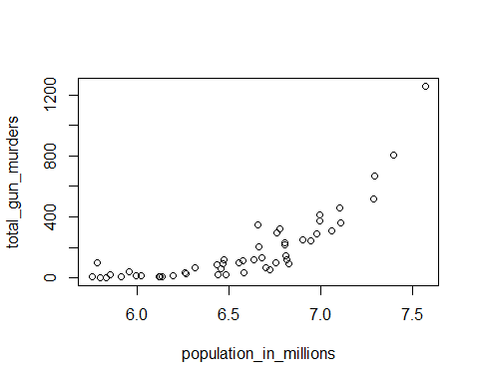

8

population <- murders$population/100000  
 hist(population)

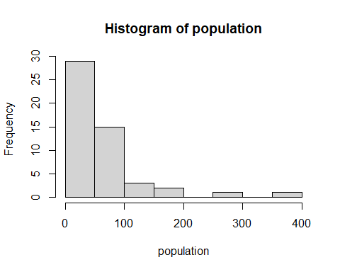

9

popstate=murders$population/10^5  
 boxplot(popstate~region,data=murders)

